

Computer MAGIC
Premium Software for the Hospitality Industry

Phone: (02) 6494 3131
eMail: peter@commagic.com

Computer MAGIC

CASH
MANAGEMENT

Windows Version
Revision : 2.0

Computer MAGIC Support: Ph. 02 6494 3131

TABLE OF CONTENTS

INTRODUCTION Page

- Company Overview and Other Products from Computer MAGIC 6
- Brief Summary of the System 7
- Special Keys, Icons, Mouse instructions 8
- Special Routines – Account Lookup Screen, Calendar 9

FILE
- Change Clients 11
- Exit 11

TRANSACTIONS
    - Creditor and Payment
        - Creditor Invoice 12
- Manual Cheque 15
- Immediate Cheque 17
- Creditor Contra Invoice 18
- Write Cheques Auto 19
- Write Cheques Manual 21
- Cancel Cheques 21
- Edit Invoice Due Date 21
- Change Cheque Number 22
    - Creditor Imports
        - Setup Standard Invoices 23
        - Import Standard Invoices 24
    - Debtor and Receipts
- Receipts 25
- Invoices / Credits 27
- Automatic Charges 28
- Automatic Invoices
        - New Automatic Invoice 29
        - Delete Automatic Invoice 30
        - Post Automatic Invoices 30
- Function Deposits Transfer 31
- Tills Input 32
- Post Tills as Deposit 34
- Debtors Invoicing
        - Create and Post Invoices 35
        - Print Invoices 36
        - Edit Quick Invoice Text 36
- Cancel Deposit 37
    - Bank Statement 38
    - Electronic Funds Transfer
- Pay Creditors 41
- Change Processing Date 41
- Cancel EFT Payment 42
- EFT Globals 42
- Create EFT Test Disk 43
- Print BSB Numbers 43
    - Journals
- General Journal 44
- Standing Journal Maintenance 45
- Standing Journal Processing 47
- Process Reversing 47
    - Business Activity Statement 48

MAINTENANCE
  - Accounts
- Account Maintenance 49
- Account Listing 51

MAINTENANCE (cont..)
  - Creditors
- Creditors Maintenance 52
- Creditors Listing 54
  - Debtors
- Debtors Maintenance 55
- Debtors Listing 57
  - Tills 58
  - Budgets 60
  - Forms Layout
        - Debtor Statements 65
        - Debtor Invoices 70
        - Creditor Statements 71
        - Creditor Cheque / Remittance 71
        - Trading / P+L / Bal Sheet 72
        - Management Reports Rows 79
        - Management Reports Columns 79
        - Till Summary Layout 82
  - System
                - Period Dates 83
    - Control Accounts 84
    - Setup Print Groups 85
    - Budget Descriptions 85
    - Global Settings General 86

REPORTS

Cash

Bank Reconciliation 88

Bank Balances 89

General Ledger

Trial Balance 90

Display Summary 91

Trading / P+L / Balance Sheet 92

Management Reports 93

Summary Data

General Ledger 94

Receipts – Payments 96

Payments 96

Receipts 96

Purchases 96

Sales 96

Blank Budget Form 96

Display Summary Data 96

Expenditure / Creditors

Creditor Reports
          - Creditor ABNs 97
          - Trial Balance 97
          - Display Statement 98
          - Print Statements 98
          - Control Balances 99
          - Monthly Purchases 100
          - Overdue Payments 100
          - Due for Payment 100

Purchases by Account 101

Purchases by Creditor 102

Cheque Listing 103

Unpaid Invoices 105

Unpresented Cheques 106

D) REPORTS (cont..)
  - Income / Debtors

a) Debtors Reports

Aged Trail Balance 107

Display Statements 108

Print Statements 109

Control Balances 109

Debtors by Month 109

Debtors with a Balance 110

Debtors Date of Last Sale 110

Sales by Account 111

Sales by Debtor 111

Receipts by Debtor 112

Deposit Listing 113

Deposits not Credited 115

Daily Sales 115

Daily Trading Summary 115

Outstanding Function Deposits 115

Till Summary 116

General Journal 117

Labels / Documents 117

STATUS

Status 118

SUPERVISION

Password Maintenance 119

Rebuild Summary Data 120

Add Old Cheques 120

Modify Open GL Balances 120

Untick Cheques 121

Untick Deposits 121

Modify Debtor Balances 122

Modify Prior Years 122

Function Deposit Maintenance

Undo Function Transfer 123

Remove old Transfers 123

Modify Bank Balances 124

Alter Account Dissection 124

END OF PERIOD

Accounting 125

Physical 126

End of Year 127

BACKUP & RESTORE DATA FILES 128

INITIAL INSTALLATION – GETTING STARTED 129

THE “HOW TO……..” GUIDE

How to - Add a new General ledger Account 134

Add a new Creditor (Supplier) 134

Add a new Debtor (Customer) 134

Add a new Bank Account 134

How to - Enter Creditor (Supplier) invoices 134

Pay Creditor invoices 134

Enter Debtor invoices (credit sales) 134

Enter Cash and Debtor receipts 135

Process Function Deposits 135

Process the Bank Statement and complete a Bank Reconciliation 135

Process General and Standing Journal entries 135

THE “HOW TO……..” GUIDE (cont..)

How to - Correct a Payment allocated to the wrong Account 135

Correct a Receipt allocated to the wrong Account 136

Cancel a Cheque 136

Correct a Cheque entered as the wrong amount 136

Correct a Deposit entered as the wrong amount 136

How to - Set up the Print Group facility for Reporting 136

Set up Financial Reporting (P&L, Balance Sheet) 137

Set up Management Reports 137

Set up Opening Stock, Closing Stock and Cost of Goods Sold 137

Set up a Budget 138

Set up the Tills Input facility 138

Set up Electronic Funds Transfer (EFT) facility 138

How to - Run an End of Month 138

Run an End of Year 138

INTRODUCTION – COMPANY OVERVIEW & OTHER Computer MAGIC PRODUCTS

a) COMPANY OVERVIEW

CLUB INDUSTRY FOCUS:
Computer MAGIC is a company dedicated to the development and support of a comprehensive range of software and hardware products for the club industry.

CLUB EXPERIENCE:
A key element of the success of the company over the years has been the depth of experience the employees of the company have in the accounting field and the club industry. This experience emanates from working with numerous clubs and the involvement in the actual financial management of clubs.

SUPPORT:
The basic philosophy of Computer MAGIC that sets it apart from other suppliers is the commitment to a long-term relationship with the club and the provision of the highest level of support. Support is provided via dedicated support lines with phone, fax and e-mail access.

FUTURE DEVELOPMENTS:
The club industry is forever evolving and with changes to technology and legislative requirements there is a constant need to continually update and enhance the systems. Computer MAGIC directs a substantial proportion of its revenue to the ongoing development of each of the products so that users can be assured of always being up to date with the current requirements. They can feel confident that, regardless of future developments in the club industry and computer technology, their software supplier is already planning for them.

b) OTHER PRODUCTS FROM Computer MAGIC

The other software products (in addition to Cash Management) developed, marketed and supported by Computer MAGIC are as follows:

- CLUB MEMBERSHIP

- POKER MACHINE ANALYSIS

- POKER MACHINE GRAPHICS INTERFACE

- CLUB PAYROLL

- FIXED ASSETS

- STOCK CONTROL

- FUNCTIONS MANAGEMENT

- GOLF HANDICAPPING

- MEMBERS DRAW/RAFFLES

- MEMBERS GAMES

- FOYER UNIT SYSTEM

The hardware products marketed and supported by Computer MAGIC are as follows:

- PC-BASED TILLS (for Bars & Bistro)

- MEMBER FOYER UNITS

INTRODUCTION – BRIEF SUMMARY OF THE SYSTEM

The control and management of cash are the critical elements in any business environment. Cash Management, however, involves a number of transactions such as Sales, Receipts, Purchases, and Payments along with the recording of summary data in the General Ledger and the associated reconciliation with Bank Accounts. Unless each of these elements is addressed completely, then the effective management of the organisation's cash resource will never be achieved.

With the release of CASH MANAGEMENT, Computer MAGIC now provides the optimum management tool for Business Managers. This extremely complete package incorporates Creditors, Debtors, General Ledger and Bank Reconciliation facility, all in a simple to operate, menu-driven system.

For clubs, the system is unique in its ability to access the data in both the accounting form and the form required for completion of Form 24.

Some of the features of the CASH MANAGEMENT system include:

Ledger and System Details

- storage of all relevant details relating to Debtors, Creditors, General Ledger and Bank accounts.
- allows up to 13 accounting periods with the facility to continue posting to the current month even though posting to the previous period has not been completed.
- Allows the processing of transactions up to period 15 giving a 3 period “grace period” into the next Financial Year while you finalise the End of Year for the current Financial Year.
- can customise the layout of Cheques and Remittance Advices produced on the system as well as Debtor Statements and Invoices.
- details of all transactions for the financial year are retained allowing unlimited access to past period data in detailed form.
- the facility to store budgets and past year balances gives a number of options in comparative reports.
- integrates with Stock Control for stock purchases.
- integrates with Fixed Assets for asset purchases and sales.

Data Input

- handles all entries relative to Sales, Receipts, Purchases, Payments and General Ledger.
- cheques can be produced automatically on the system or prepared manually with the cheque details recorded.
- payments can also be made via Electronic Funds Transfer (EFT)
- reconciliation of Tills and the recording of Sales by Account on the Tills is an integral part of the system
- Bank statement input for complete Bank Reconciliation on multiple Bank Accounts.
- processes and reports on Function Deposits and allows transfer to the Debtors system when required
- window selection routine for look-up of Account, Creditors, Debtors, etc
- handles the complete range of Journals (General, Auto-Reversing, Standing, Closing)

Reporting

- Creditors Reports - including Purchase Journal, Payments Journal, Cheque Listing, Purchases by Creditor Report, Unpaid Invoices Report and a Creditors Trial Balance, which can be generated for any period.
- Debtors Reports - including Sales Journal, Debtors Trial Balance, Statements, Daily Sales Report. Daily Trading Summary
- Cash Flow - including reports for each account and each accounting period for Receipts Only, Payments Only or Cash Movement
- Bank Reconciliation Report listing unpresented deposits and cheques
- General Ledger - Trading Statements, Profit/Loss, Balance Sheet

A user-defined Report Writer allowing customising of Management Reports specific to each client's requirements.

Till Summary reporting highlighting cash variances by Till and Location.

Daily Trading Summary to provide a quick “snapshot” of the business.

Complete preparation of monthly or quarterly Business Activity Statements.

INTRODUCTION – SPECIAL KEYS, ICONS & MOUSE INSTRUCTIONS

The Computer MAGIC Cash Management system has been written in a manner that is consistent with Windows technology but we have attempted to retain some of the more efficient data entry features of the DOS system.

a) SPECIAL KEYS

Enter key - as with the DOS system, when you are entering transaction details, you can terminate the entry of each field with the Enter key. As with other Windows applications you can also use the Tab key but most operators do not find this as efficient.

In some windows where values need to be entered, it is often safer to use the Tab key or the mouse to move from field to field as pressing the Enter button may result in the OK button being activated and the routine finishing prematurely.

F8 key - as with all Computer MAGIC applications, the F8 key is used as the Lookup key. Depending on which field you are processing, pressing the F8 key or selecting the F8 icon with the mouse, results in the relevant data options being displayed, e.g. Creditors, Debtors, Accounts, etc. Further details on the use of the “Lookup” facility are described in the Special Routines section on Page 9.

Calendar - whenever you are on a date field in the system, the option is provided to click on the Calendar icon. This takes you into the Calendar routine – full details on this option are provided in the Special Routines section on Page 10.

b) MENU ICONS

For frequently used routines the system has available icons that can be selected instead of menu options. An example of the Main Menu icons is shown below. All you need to do is click the icon to enter the routine.

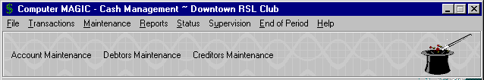

Menu Icons

c) MOUSE INSTRUCTIONS

Whenever the manual instructs you to click an item with the mouse, it should be assumed that this means the left button of the mouse and that a single-click is all that is required. If you need to double-click or use the right button on the mouse, then you will be specifically instructed to do so.

The manual will often instruct you to “Select” an item from a window or screen. You would complete this instruction by single-clicking the required selection with the mouse, using the left button.

If you are unfamiliar with the use of the mouse in a Windows application or with text boxes, scroll bars, option boxes, etc. then we suggest you either complete a Windows tutorial or read a book such as the “Windows for Dummies” series of publications.

INTRODUCTION – SPECIAL ROUTINES

a) ACCOUNT LOOKUP SCREEN

As mentioned previously, the system provides a variety of Lookup screens by accessing the F8 option. The Lookup screens that are displayed are relevant to the field you are processing and may be Creditor Number, Debtor Number, Till Number, etc. On most occasions, it is simply a matter of highlighting the selection you require and clicking the “OK” button.

The “Lookup Account” screen does provide some further options.

The Account Number Lookup screen is available by selecting the F8 key (or icon), anywhere on the system where you are prompted to enter an “Account Number”. You are able to access the Account Number by one of three means:
- Account Number
- Alternate Number (short key)
- Account Description

After selecting the F8 key, a screen similar to that shown below will be displayed.

The only selection needed is the “Sort Sequence” that you wish to use. If you select the Account Number sort sequence (the default) then the Accounts are displayed in Account Number sequence; if Alternate Number is selected then the Accounts are displayed in Alternate Number sequence, and so on.

Select the option button required. In the example shown below the “Description” option has been selected.
You then have the option to type part of the required selection in the text box.

In the example to the right, with the “Description” sort sequence selected, part of the Account Description has been typed in, i.e. POK

The system then displays the Accounts that match the details entered and completes the most likely entry in the text box, i.e. POKER MACHINES @ COST

It then highlights the Account, as shown. You can use the Up & Down arrow keys to move the Account required, if it is not highlighted.

Select the “OK” button when the required Account is highlighted.

The same option is provided with the Account and Alternate Number sort sequence, however; in these cases you would enter the Account or Alternate Number in the text box. Note, that the Account and Alternate Numbers can be alpha or numeric.

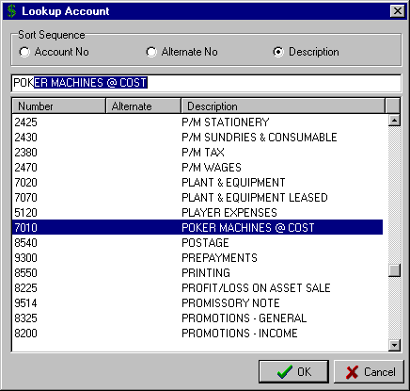

Note: to use the Page Up & Page Down keys in the “Lookup Account” screen, click on any Account in the window and then use the Page Up & Page Down keys to search through the list of Accounts.

INTRODUCTION – SPECIAL ROUTINES

b) CALENDAR

The Calendar feature is available for any field on the system that requires a date to be entered.

By clicking on the Calendar icon to the right of the date text box, the calendar window opens as shown below. If the date text box has a date already in it when you select the Calendar icon, then the calendar will start at that date. If the date text box has no date in it when you select the Calendar icon, then the calendar will start at today’s date.

The current date is displayed in the top left corner.

To change the day within the displayed month, click on the required day.

To change the month, click on either the “Prev. Month” or “Next Month” icons at the top of the screen.

To change the year, click on either the “Prev. Year” or “Next Year” icons at the top of the screen.

Select the OK button when you have highlighted the required date.

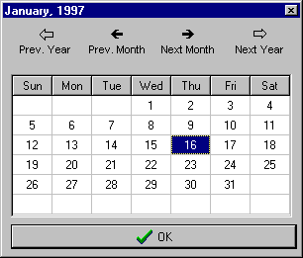

A further option exists to quickly locate the required month or year. Rather than continue to click on the “Prev. Year” or “Next Year” icon to locate the required year, you can right click on either of the two icons and the system will display the current and previous (or next) 9 years. The example below shows the window that appears after right clicking on the “Next Year” icon.

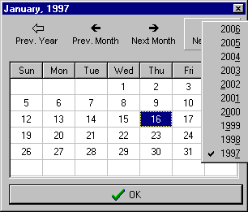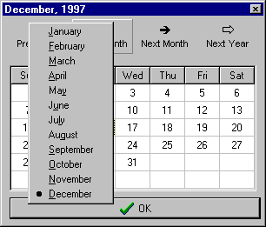

In the same way, if you right click on the “Prev. Month” or “Next Month” icons, then the system displays the 12 months for you to select the one you want. The example above shows the window that appears after right clicking on the “Prev. Month” icon.

A1) FILE MENU – CHANGE CLIENTS

By selecting “File” from the Main Menu, the following menu appears.
Change Clients

Exit

By selecting “Change Clients” from the File Menu, a screen is displayed similar to that shown below.

The system enables the set up of multiple sets of Cash Management data (datasets). This may be useful if you run separate sets of Accounts for different businesses and they are reported on separately. You can also set up copies of previous year’s data files for historical reference. You may also wish to set up a practice set of data files for training and testing purposes.

When the system is installed, a file is set up in the Programs directory named CM.INI. This file is used to specify the location of the data directory (or directories) and allows for multiple sets of data files.

In the example below, there are five sets of data files. It is suggested that the most accessed data files are set up at the top as this makes entry to the system more efficient.

Simply highlight the required set of data files and select the OK button.

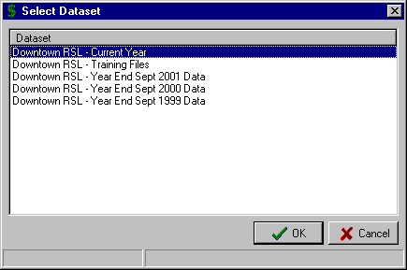

A2) FILE MENU – EXIT

Selecting “Exit” from the File Menu will exit you from the Cash Management system.

An alternative means of exit is to click the  (Close) button in the top right corner of the screen. This option can be used to exit from any routine.

B1) TRANSACTIONS – CREDITOR AND PAYMENT

By selecting “Transactions” from the Main Menu, the menu below is displayed.

Creditor and Payment
Creditor Imports
Debtor and Receipts

Bank Statement
Electronic Funds Transfer
Journals

Creditor Invoice
Manual Cheque
Immediate Cheque

Creditor Contra Invoice
Write Cheques Auto
Write Cheques Manual

Cancel Cheques
Edit Invoice Due Date
Change Cheque Number

Selecting “Creditor and Payment” from the Transactions Menu, results in the sub-menu to the right being displayed.

a) CREDITOR INVOICE

This routine allows for the entry of Creditor (Supplier) invoices that will be paid on the system at a later date via the "Write Cheques Auto", "Write Cheques Manual" or Creditor EFT routines.

Enter the "Creditor" number or use the F8 option to access the “Lookup Creditor” window and select the required one. The Creditor Name and ABN number are displayed.

The “Lookup Creditor” window also provides you with the option to Add a new Creditor or Edit the details of an existing Creditor. Complete instructions on adding and editing Creditor details are set out in the “Creditor Maintenance” routine on Page 52.

Enter the invoice "Number" (10 characters). This typically is the Creditor's reference number but it may also be used as a descriptive reference for the transaction. Pressing the F8 key at this point will display outstanding invoices previously entered for this Creditor. This helps you check that you are not entering the invoice twice.

Enter the “Invoice Date" or use the Calendar option to select the required date.

Select whether the “GST” is “Included” in the amount to be entered or will be entered as a “Separate” amount.

The system displays the "Due Date" based on the credit terms as set up for this Creditor. Accept the default due date for this invoice or modify as required.

Enter the Period the transaction is to be posted to, in the "This Period" field. Depending on the “Invoice Date” of the transaction as entered above, the system defaults to either the current “Physical” (Calendar) Period or the current Accounting Period. You have the option to override the default, as required, or Press the Enter key to accept the default Period.

If the Standard Account feature has not been set up for the Creditor, then enter the General Ledger Account "Number" or Press the F8 key to display the Accounts on the system and select the required one. If Standard Accounts have been set up for this Creditor, then the option exists to Press the F7 key to display the “Preset Accounts” window. Highlight the Account required and select the “OK” button. The name of the selected Account is displayed along with the standard setting for GST for this Account.

If the ”Included” option was selected in the “GST” field, then the system takes you to the “Incl GST” column. Enter the "Amount" of the invoice (including GST) to be dissected to this Account. The system calculates and displays the GST amount and moves the line of input to the bottom section of the screen.

If the ”Separate” option was selected in the “GST” field, then the system takes you to the “Excl GST” column. Enter the "Amount" of the invoice (excluding GST) to be dissected to this Account. The system calculates and displays the GST as a separate amount at the bottom of the Creditor Invoice screen and moves the line of input to the bottom section of the screen.

The cursor returns to the Account “Number” field for further dissection of the invoice. The Invoice Total is displayed at the bottom of the screen to allow checking that the invoice has been fully dissected.

B1) TRANSACTIONS – CREDITOR AND PAYMENT

a) CREDITOR INVOICE (cont..)

 TIP : If you have entered a line of input that contains the wrong Amount, is allocated to the wrong General Ledger Account or you need to override the GST setting for the Account, then you are able to recall the input and edit it.

With the line of input in the bottom section of the screen, double click on the line to be edited. This returns the line of input to the edit line, allowing you to change any of the details, as required.

Once the Invoice has been fully dissected to the appropriate Accounts click on the “Comments” line at the bottom left of the screen. This “Comments” line can be used to record relevant details about the transaction.

Click the “Save” button to complete the entry of the Creditor Invoice. The system returns to the “Creditor” number field for the entry of more invoices.

A completed “Creditor Invoice” screen would appear similar to that shown below.

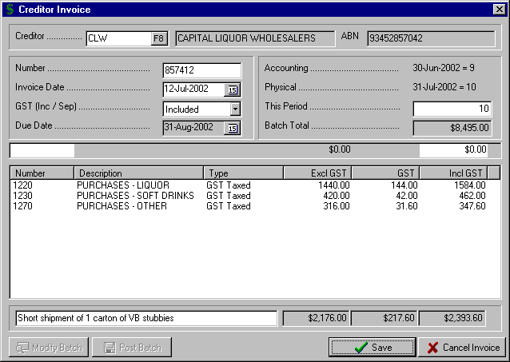
Note the individual entries of GST for each line of input. This is because the “Included” option was selected in the “GST” field.
Note the use of the “Comments” line for recording relevant details about the transaction

Note the display of the “Batch Total” in the top right of the screen to allow you to check the total of your input.

Once you have selected the “Save” button to complete a Creditor Invoice, two other options are displayed at the bottom left corner of the screen.

The first option is to “Post Batch”.

You would check that the “Batch Total” is correct before selecting this option. Once you have checked that the batch total is correct then select the “Post Batch” option to save away the invoices and print an audit trail on the selected printer.

B1) TRANSACTIONS – CREDITOR AND PAYMENT

a) CREDITOR INVOICE (cont..)

The second option is to “Modify Batch”. If the batch total is not correct and you need to edit an invoice in the current batch, then click on the “Modify Batch” button at the bottom of the screen to display the invoices already entered. Highlight the invoice and select “OK” to retrieve an invoice for editing or the “Delete” button to delete an invoice from the batch.

A sample “Lookup Batch” window is shown below.

The invoice for MMI Insurance has been highlighted. The options then are to select either the “OK” button to return the invoice to the Creditor Invoice screen for editing or the “Delete” button to remove the invoice from the batch. The “Cancel” button provides the option to exit the screen without changing the details.

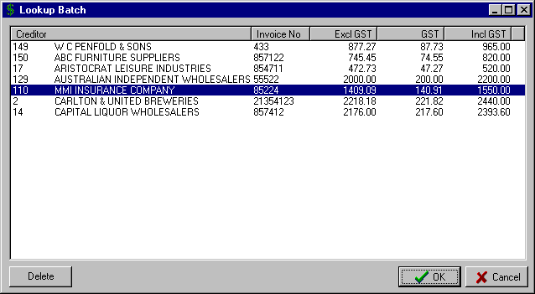
Select the “OK” button to return this invoice to the Creditor Invoice screen for editing.
Select the “Delete” button to remove this invoice from the batch.

B1) TRANSACTIONS – CREDITOR AND PAYMENT

b) MANUAL CHEQUE

This routine is used to enter the Creditor Invoice and the Payment details in the one operation. It is ideal for internal cheques (e.g. Wages, Petty Cash reimbursement, etc). It is also used when you want to pay a Creditor Invoice for a “one-off” Creditor or a Creditor that requires immediate payment upon delivery of invoice.

This routine assumes that you are processing the cheque manually (i.e. not printing it on the system). Do not use this routine if the invoice details for the transaction have already been entered via "Transactions – Creditor and Payment – Creditor Invoice" as then you will have entered the invoice details twice.

On entry to the routine, the “Select Bank Account” window is displayed. Select the bank account from which the payments will be made and click the “OK” button.

Enter the "Creditor" number or use the F8 option to display the “Lookup Creditor” window and select the required one. The Creditor Name and ABN number are displayed.

The “Lookup Creditor” window also provides you with the option to Add a new Creditor or Edit the details of an existing Creditor. Complete instructions on adding and editing Creditor details are set out in the “Creditor Maintenance” routine on Page 52.

If you want to process the invoice and cheque details for a “one-off” Supplier and it does not warrant setting them up as a Creditor on the system (e.g. Poker Machine winners, Entertainers, etc.) then enter the number 1 (one) in the “Creditor” field. This then allows you to enter the Payee Name, Address and ABN for this transaction. The Payee Name will be retained with the transaction and included in all reporting.

 TIP : If you do not enter an ABN for the Payee then the system will not allow the recording of any GST. The Withholding Tax Clearing A/C will be included in the Account dissection in the bottom section of the screen, and by law, you must deduct the highest tax rate (currently 48.5%).

Enter the invoice "Number" (10 characters). This typically is the Creditor's reference number but it may also be used as a descriptive reference for the transaction. Pressing the F8 key at this point will display outstanding invoices previously entered for this Creditor. This helps you check that you are not entering the invoice twice.

Enter the “Invoice Date" or use the Calendar option to select the required date.

Select whether the “GST” is “Included” in the amount to be entered or will be entered as a “Separate” amount.

Enter the Period the transaction is to be posted to, in the "This Period" field. Depending on the “Invoice Date” of the transaction as entered above, the system defaults to either the current “Physical” (Calendar) Period or the current Accounting Period. You have the option to override the default, as required, or Press the Enter key to accept the default Period.

If the Standard Account feature has not been set up for the Creditor, then enter the General Ledger Account "Number" or Press the F8 key to display the Accounts on the system and select the required one. If Standard Accounts have been set up for this Creditor, then the option exists to Press the F7 key to display the “Preset Accounts” window. Highlight the Account required and select the “OK” button.

If the ”Included” option was selected in the “GST” field, then the system takes you to the “Incl GST” column. Enter the "Amount" of the invoice (including GST) to be dissected to this Account. The system calculates and displays the GST amount and moves the line of input to the bottom section of the screen.

If the ”Separate” option was selected in the “GST” field, then the system takes you to the “Excl GST” column. Enter the "Amount" of the invoice (excluding GST) to be dissected to this Account. The system calculates and displays the GST as a separate amount at the bottom of the Creditor Invoice screen and moves the line of input to the bottom section of the screen.

The cursor returns to the Account “Number” field for further dissection of the invoice. The Invoice Total is displayed at the bottom of the screen to allow checking that the invoice has been fully dissected.

B1) TRANSACTIONS – CREDITOR AND PAYMENT

b) MANUAL CHEQUE (cont..)

Once the Invoice has been fully dissected to the appropriate Accounts click on the “Comments” line at the bottom left of the screen. This “Comments” line can be used to record relevant details about the transaction.

A completed “Manual Cheque” screen will appear similar to the example below.

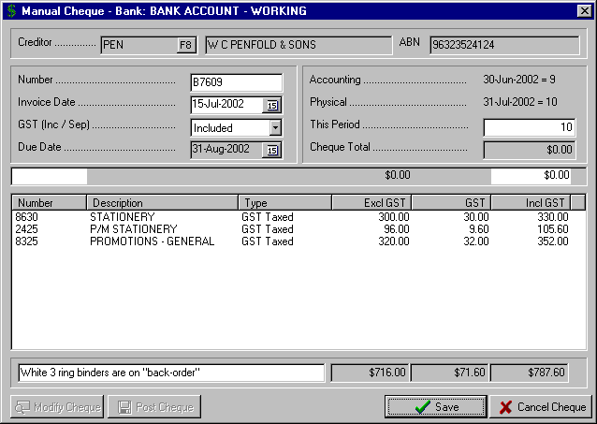

Click the “Save” button to complete the entry of the Creditor Invoice. The system returns to the Invoice “Number” field for the entry of more invoices to be included in this cheque payment. (You are able to process as many invoices as you require for the same Creditor and then pay them all on the one cheque)

Once you have selected the “Save” button to complete a Creditor Invoice, three other options are displayed at the bottom left corner of the screen.

The first option is to “Modify Cheque”. If the details of the invoice(s) entered for this cheque are incorrect and you need to edit an invoice, then click on the “Modify Cheque” button at the bottom of the screen to display the invoices already entered. Highlight the invoice and select “OK” to retrieve an invoice for editing or the “Delete” button to delete an invoice from the batch.

The second option is to “Cancel Cheque”.

The system displays the “Confirm” prompt:

“There are invoices in the batch, are you sure you want to cancel the cheque”

A “Yes” response will clear all the details and return you to the “Creditor” field.

B1) TRANSACTIONS – CREDITOR AND PAYMENT

b) MANUAL CHEQUE (cont..)

The third option is to “Post Cheque”.

You should verify that the “Cheque Total” is correct before selecting this option. Once you have checked that the cheque total is correct then select the “Post Cheque” option.

This then displays the “Cheque Details” screen as shown below.

The date of the last cheque processed on the system is displayed in the “Cheque Date” field. Enter to accept the date or edit as required.

The system displays the next “Cheque Number”. Enter to accept this cheque number or change it as required.

The “Cheque Value” and the selected “Bank Account” are displayed.

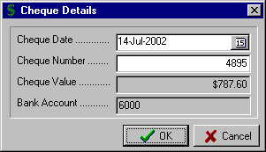

Once the correct details are completed in the “Cheque Details” screen, select the “OK” button to process the cheque.

c) IMMEDIATE CHEQUE

This routine is used to enter the Creditor Invoice and the Payment details in the one operation and print a cheque on the system. It is ideal for internal cheques (e.g. Wages, Petty Cash reimbursement, etc). It is also used when you want to pay a Creditor Invoice for a “one-off” Creditor or a Creditor that requires immediate payment upon delivery of invoice.

This routine assumes that you are printing the cheque on the system. You will need to have set up a layout for your cheque stationery in the routine “Maintenance – Forms Layout – Creditor Cheques / Remittance”, refer to Page 71 for full instructions.

Do not use this routine if the invoice details for the transaction have already been entered via "Transactions – Creditor and Payment – Creditor Invoice" as then you will have entered the invoice details twice.

The instructions for the remainder of the routine are identical to those for “Manual Cheque” as set out above on Page 15. The only additional step is to insert the cheque stationery and select the allocated Printer for printing the cheque.

B1) TRANSACTIONS – CREDITOR AND PAYMENT

d) CREDITOR CONTRA INVOICE

This routine allows for the removal of corresponding debit and credit entries in the Creditor file. The need for this routine arises when an invoice has been entered for a Creditor and at a later stage a reversal of the input is required. This could be because the invoice was entered incorrectly or posted to the wrong Creditor. The reversal of an invoice is done via the "Transactions – Creditor and Payment - Creditor Invoice" routine with all amounts entered as a negative.

Enter the "Creditor" number or use the F8 option to display the “Lookup Creditor” window and select the required one. The Creditor Name is displayed along with any outstanding invoices for the selected Creditor in the “Include in Contra” window.

If the "Value" figure in the top right section of the screen is zero then selecting the “Save” button will complete the routine. If the "Value" figure is not zero then you need to move transactions from the “Include in Contra” window that are not to be included in this contra. The system will not let you complete the transaction unless the “Value” field is zero.

To exclude an Invoice from the contra, highlight the required one in the right window (Include in Contra) and click the < button. This moves the selected item to the left window (Exclude from Contra). Use the > button to move a selected item from the “Exclude from Contra” to the “Include in Contra” window.

To move multiple items, select the ones required by using the Ctrl + Mouse buttons. Then select the < or > options to move all the selected items from one window to the other. Use the << or >> buttons to move all the items in one window to the other window.

The contra is in a position to be processed when the “Value” is zero.

A completed “Creditor Contra Invoice” screen will appear similar to that shown below.

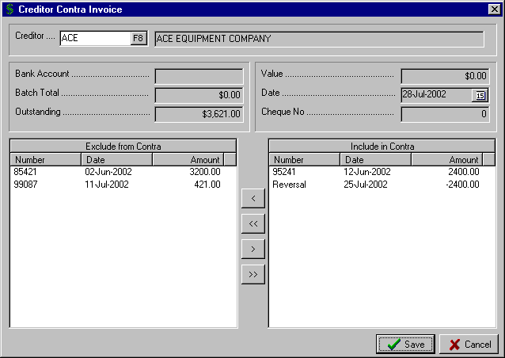
This “Value” must be zero for the Contra to be processed.
Note that the two transactions included in the Include in Contra window balance to zero.
Any combination of transactions that total to zero can be included in the Contra transaction.
These two transactions are still out-standing for the Creditor and have been excluded from the Contra transaction.
Their total is shown as the amount “Outstanding” in the top section of the screen.

B1) TRANSACTIONS – CREDITOR AND PAYMENT

e) WRITE CHEQUES AUTO

This routine allows the payment of invoices previously entered via the routine "Transactions – Creditor and Payment – Creditor Invoice” and prints the cheques on the system. Normally, the report "Unpaid Invoices" will have been printed so that the decision as to which invoices will be paid can be made (see details on Page 105).

On entry to the routine, the “Select Bank Account” window is displayed. Select the bank account from which the payments will be made and click the “OK” button.

The “Write Cheques Auto” screen is then displayed along with the date of the last cheque produced on the system and the next available cheque number.

Enter the cheque “Date” and either accept or modify the “Cheque No.” for the first cheque in this payment run.

Enter the "Creditor" number or use the F8 option to display the “Lookup Creditor” window and select the required one. The Creditor Name is displayed. The Creditor's name is displayed along with any unpaid invoices in the "Payment" window.

To exclude an Invoice from the cheque payment, highlight the required one in the right window (Payment) and click the < button. This moves the selected item to the left window (Don’t Pay).

Use the > button to move a selected item from the “Don’t Pay” to the “Payment” window.

To move multiple items, select the ones required by using the Ctrl + Mouse buttons. Then select the < or > options to move all the selected items from one window to the other.

Use the << or >> buttons to move all the items in one window to the other window.

You are able to check that you have the total “Value” of the Invoices that will be included in the cheque.

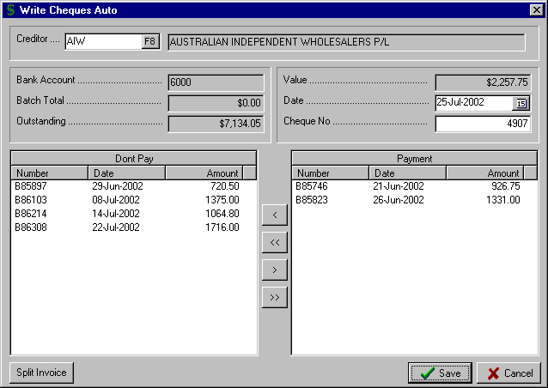
These invoices have been excluded from the Payment.
These invoices have been included in the Payment. The total of these Invoices is shown as the “Value” of the cheque.

Click the “Save” button to complete the transaction and print the cheque on the selected printer.

B1) TRANSACTIONS – CREDITOR AND PAYMENT

e) WRITE CHEQUES AUTO (cont..)

A very useful feature of this routine is the “Split Invoice” option. Some examples of when this may be used are:
- The full amount of a Supplier invoice is in dispute and you only want to part-pay the invoice.
- You want to pay an invoice but a credit for part of the invoice has not yet been received from the Supplier
- The Creditor has allowed you payment terms that provides for a series of partial payments over time.

In the example below, there is an invoice for $88,000 that is outstanding. The payment terms arranged with the Creditor is that the invoice will be paid in four installments of $22,000. Rather than set up four invoices (which may not be practical if the purchase involves a single Fixed Asset), you can enter the invoice in total and then when the payments fall due, you split the invoice for the amount of the quarterly payment.

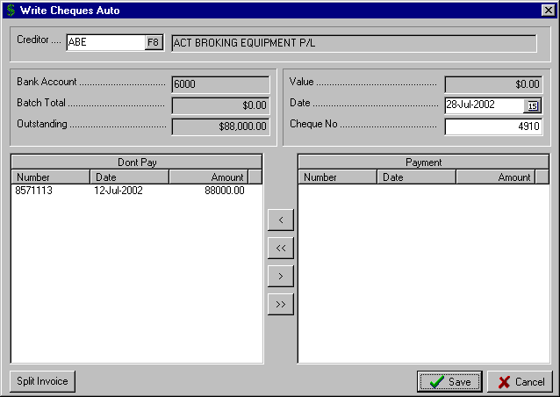
Initially the Invoice would have been in this window. You highlight the invoice and click the < button. This moves it to the “Don’t Pay” window.
Once the Invoice to be split is in the “Don’t Pay” window you highlight the Invoice and click the “Split Invoice” button.

The first step is to move the invoice to be split from the “Payment” window to the “Don’t Pay” window. Highlight the Invoice to be split and select the “Split Invoice” button. The “Split Invoice” window is displayed allowing you to allocate the amount for payment to the correct Account dissection. The result of then clicking the “Split” button will be an invoice for $66,000 in the “Don’t Pay” window and an invoice for $22,000 in the “Payment” window.

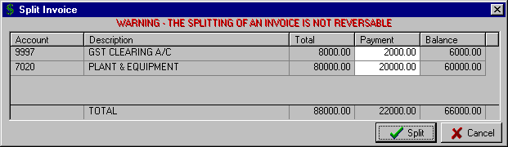

** Note the warning that splitting an Invoice is not reversible **

B1) TRANSACTIONS – CREDITOR AND PAYMENT

f) WRITE CHEQUES MANUAL

This routine is very similar to that described above in the section "Write Cheques Auto" with the only difference being that the cheques are written manually rather than printed on the system. The invoices to be paid via this routine would have been entered via the routine "Transactions – Creditor and Payment – Creditor Invoice".

Please refer to the section “Write Cheques Auto” on Page 19 for full instructions for this routine.

g) CANCEL CHEQUES

This routine allows a cheque to be cancelled and effectively unpay an invoice that has been previously paid, i.e. the invoice is returned to the Unpaid Invoice file. It also provides the facility to completely reverse the invoices that were paid by the cancelled cheque.

The need for this routine could result from:

- a cheque being lost by a Supplier and you need to issue another cheque for the same invoice(s) and for the same amount
- the wrong invoices for the Creditor were included in the payment (i.e. the invoices were correct but the wrong ones were selected for payment)
- the wrong amount was processed for a particular cheque (i.e. the invoices included in the payment have the incorrect amount)
- the invoice and hence the cheque was processed to the wrong Creditor

In the first and second examples, where the invoice details are correct, then cancel the cheque and via either the "Write Cheques Auto" or "Write Cheques Manual" routines, raise another cheque for the outstanding invoice(s). In this case you would not “Reverse all transactions”

In the third and fourth examples above, it would be advisable to cancel both the cheque and reverse all the transactions associated with the cheque and then re-process the invoice and cheque details again.

On entry to the routine, the “Select Bank Account” window is displayed. Select the bank account from which the cheque was made and click the “OK” button.

The unpresented cheques for the selected Bank Account are displayed. Use the scroll bar to the right of the window to display all the cheques.

Highlight the cheque to be cancelled. If you would like to reverse all the invoices that make up this cheque (see explanation above) then click the “Reverse all transactions” check box. Then select the “OK” button.

The system then displays the warning “Are you sure you want to cancel this cheque?” A “Yes” response completes the routine; a “No” response returns you to the “Cancel Cheques” window without canceling either the cheque or the transactions.

h) EDIT INVOICE DUE DATE

The system stores a “Due Date” for each invoice entered via the “Transactions – Creditor and Payment – Creditor Invoice” routine. The “Due Date” is determined by the “Days Credit” setting for each Creditor in the “Creditors Maintenance” routine. The “Due Date” is used for the preparation of the “Overdue Payments” (see Page 100) and the “Due for Payment” (see Page 100) reports.

On entry to the routine, enter the “Creditor” number, or use the F8 option to display the “Lookup Creditor” window and select the required one. The system lists the unpaid invoices for the selected Creditor.

Highlight the invoice to be changed and click the “Edit Date” button. The system then displays the “Creditor Invoice Due Date” window showing the “Previous Due Date” for the selected invoice.

Enter the required date in the “New Due Date” field and select the “OK” button to complete the routine.

B1) TRANSACTIONS – CREDITOR AND PAYMENT

i) CHANGE CHEQUE NUMBER

This routine allows you to change a cheque number previously allocated to a payment.

The need for this may arise if the wrong cheque number was allocated in the “Manual Cheque”, “Immediate Cheque”, “Write Cheques Auto” or “Write Cheques Manual” routines. You may identify the problem while processing the Bank Statement input or when you produce a Cheque Listing.

Rather than have to cancel the cheque and re-process the cheque payment when a simple error has been made, this option is provided to simply enter the correct cheque number.

** It is important that you do not use this routine when a cheque has been lost or needs to be cancelled. In this situation, you must use the “Cancel Cheques” routine as described on Page 21. **

On entry to the routine, the “Change Cheque Number” screen is displayed listing all the cheques entered on the system for the current financial year.

Highlight the cheque with the wrong cheque number and click the “OK” button.

The window for the selected cheque is then displayed as shown below, with the old Cheque Number and Cheque Date shown at the top.

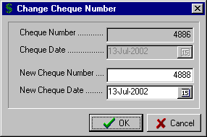

Enter the “New Cheque Number” and “New Cheque Date”, as required, and click the “OK” button.

B2) TRANSACTIONS – CREDITOR IMPORTS

By selecting “Transactions” from the Main Menu, the menu below is displayed.

Creditor and Payment
Creditor Imports
Debtor and Receipts

Bank Statement
Electronic Funds Transfer
Journals

Setup Standard Invoices
Import Standard Invoices

Selecting “Creditor Imports” from the Transactions Menu, results in the sub-menu above being displayed

a) SETUP STANDARD INVOICES

This routine is used to set up standard invoices that can be imported into the system on a periodic basis. It is used for Creditor Invoices that are the same each Period and it simply reduces the need to enter the same invoice details each month. Examples of transactions set up in this routine would be payments for sponsorship to sporting bodies; rent paid to another organisation, e.g. RSL Sub-Branch; set payments to external contractors.

On entry to the routine the system displays any Standard Invoices already set up on the system. The options are:
- select the “Add” button to set up a new Standard Invoice
- highlight an existing Standard Invoice and select the “Change” button to edit the details
- highlight an existing Standard Invoice and select the “Delete” button to remove it from the system

Selecting the “Add” or “Change” options, the “Creditor Standard Invoices Edit” window is displayed.

Enter the “Creditor” number, the General Ledger “Account” number the expense is to be dissected to, and the invoice “Value”.

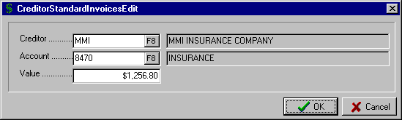
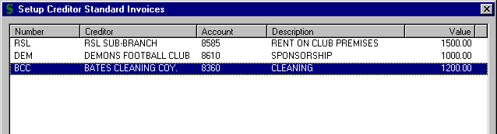
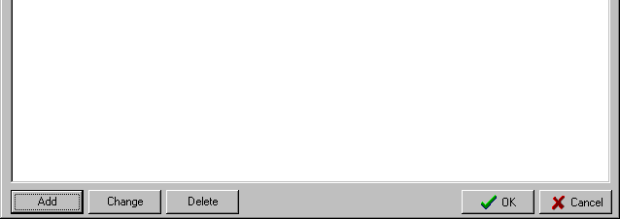
This Standard Invoice is being added to the Setup Standard Creditor Invoices window.

 TIP : Standard payments made from your Bank Account (i.e. periodic payments), should not be set up via this routine. Periodic payments are processed directly via the “Bank Statement” input routine.

B2) TRANSACTIONS – CREDITOR IMPORTS

b) IMPORT STANDARD INVOICES

This routine is used to process the Standard Invoices set up via the routine “Setup Standard Invoices” as detailed on Page 24.

Standard Invoices included in this routine are those invoices that will be processed for payment via the “Write Cheques Manual”, “Write cheques Auto” or “Creditor EFT” routines.

As noted previously, this routine is not used for the processing of periodic payments made directly from the Bank Account. These transactions are processed via the “Bank Statement” routine as detailed on Page 38.

On entry to the routine the “Import Standard Invoices” screen is displayed, as shown below.

Enter the “Reference” to be recorded for the Standard Invoices.

Enter the “Date” of posting the Standard Invoices.

Enter the “Period” to which the Standard Invoices apply.

Select the “OK” button when the input is complete.

The system displays the message “Standard invoices imported” once the posting has been completed.

A sample “Import Standard Invoices” screen is shown below.

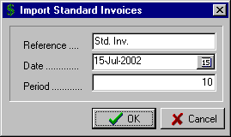

B3) TRANSACTIONS – DEBTOR AND RECEIPTS

By selecting “Transactions” from the Main Menu, the menu below is displayed.

Receipts
Invoices / Credits
Automatic Charges
Automatic Invoices
Function Deposit Transfer
Tills Input
Post Tills as Deposit
Debtors Invoicing
Cancel Deposit

Creditor and Payment
Creditor Imports
Debtor and Receipts

Bank Statement
Electronic Funds Transfer
Journals

Selecting “Debtor and Receipts” from the Transactions Menu displays the sub-menu to the right.

a) RECEIPTS

This routine is for the entry of all receipts of Cash, Cheques, Debtor’s payments, and Function Deposits. It effectively mirrors the details listed on the Bank Deposit slip and creates the deposit that will be later checked off in the Bank Reconciliation. It is strongly recommended that a separate Cash Receipt entry be completed for each deposit made to the Bank Account as this significantly simplifies reconciliation with the bank statement.

If outstanding Deposits exist, then on entry to the routine, the system provides the option to add to an outstanding Deposit for the current month or create a new Deposit. From the prompt:

"Do you want to add to an existing Deposit?"

A “No” response will create a new deposit.

A “Yes” response displays a window of outstanding deposits. Select the deposit to be added to. The value of the outstanding deposit is transferred to the "Progressive Total", along with the Transaction “Date" allowing the addition of further input. Note that the previously entered lines of input are displayed in red and cannot be edited.

Enter the "Date", if entering a new deposit. The system then moves you to the edit line for entry of transactions.

Enter the transaction “Type” with the options being:

- "C" for Cash Sales

- "D" for a Debtor Receipt (this would be a payment of an account entered previously via "Invoices / Credits"

- "F" for a Function Deposit

Enter the "Reference". This is a 10-character alpha/numeric field. If the “Reference” number is numeric (e.g. receipt number) then it will automatically increment for each subsequent line of input The option is also available at this point to press the F8 key and enter a “Comments” line for this line of input. This “Comments” line is ideal for recording explanatory details for uncommon transactions (e.g. Asset Sales, Sundry Income items, etc.)

If "C" for Cash Sale has been entered the cursor then moves to the “Account” column. Enter the General Ledger "Account" number or use the F8 option to display the “Lookup Account” window and select the required one. There is also the option to use the two character "Alternate No" as set up for the Accounts in the routine "Account Maintenance", e.g. SM for SALES – MAIN BAR.

If "D" for Debtor Receipt has been entered the cursor moves to the "Account" column. Enter the "Debtor" number of the Debtor the payment is from or use the F8 option to display the “Lookup Debtor” window and select the required one. If the "Debtor" is not on the system then the option to add the Debtor is provided. Refer to the section "Debtor Maintenance" on Page 55 for instructions on adding a new Debtor.

If "F" for Function Deposit has been entered the cursor moves to the "Account" column. Enter the "Debtor" number of the Debtor the deposit is from or use the F8 option to display the “Lookup Debtor” window and select the required one. If the "Debtor" is not on the system then the option to add the Debtor is provided. Refer to the section "Debtor Maintenance" on Page 55 for instructions on adding a new Debtor.

B3) TRANSACTIONS – DEBTOR AND RECEIPTS

a) RECEIPTS (cont..)

The option is then provided to enter the amount of the receipt in either the “Excl GST” or the “Incl GST” column. Which option you choose will depend on whether the amounts you are entering exclude or include GST. In both options, the amount of GST for the transaction is displayed in the “GST” column.

Once you have entered the General Ledger Account number or the Debtor number, the cursor moves to the “Excl GST” column. Either enter the amount of the receipt excluding GST or enter across to the “Incl GST” column and enter the amount including GST.

Once all the receipts have been entered the "Progressive Total" at the bottom of the screen should equal the Bank Deposit slip for the day.

If, after checking the “Progressive Total”, you find that an error has been made in the input, the option exists to edit the transactions. Simply double click on the transaction to be edited. This restores the transaction to the edit line allowing you to change any of the details, as required.

Select the “OK” button to complete the input and post the deposit.

A sample “Receipts” screen is shown below.

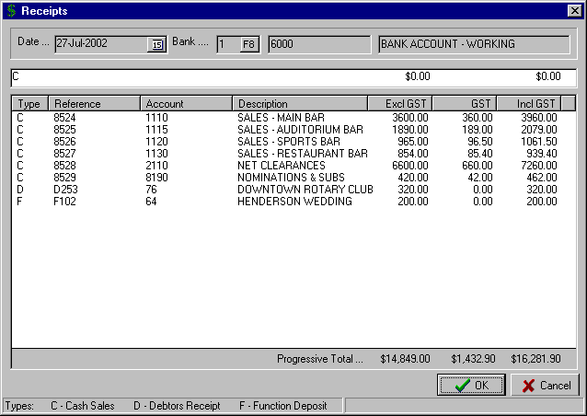
Note the transactions with Type “D” for Debtor Receipt and “F” for Function Deposit.

These transactions do not include GST as the GST will be calculated when the actual sale is processed.
This “Total” should match your Bank Deposit. If not, edit the details before posting the input.

 TIP : If you need to edit a deposit that has been previously posted, then answer “Yes” to the “Do you want to add to an existing Deposit” prompt, and then enter the adjustment to the applicable Account as either a positive or negative amount.

B3) TRANSACTIONS – DEBTOR AND RECEIPTS

b) INVOICES / CREDITS

This routine allows the input of Invoices and Credit Notes for Debtors stored on the system. The transactions for this routine are normally sales made to a member or client that will be paid for at a later date.

On entry, you are prompted to enter the "Debtor" number or use the F8 option to display the “Lookup Debtor” window and select the required one. If the entered "Debtor" is not on the system then the option to add the Debtor is provided. Refer to the section "Debtor Maintenance" on Page 55 for instructions on adding a new Debtor.

Enter the invoice "Number" which can be alpha-numeric up to 10 characters. Enter the "Invoice Date".

The system then moves to the edit line to allow dissection of the invoice to the appropriate sales accounts. Enter the General Ledger Account "Number" or use the F8 option to select the required one.

You can enter the amount in either the “Excl GST” or the “Incl GST” column. Which option you choose will depend on whether the amounts you are entering exclude or include GST. Either enter the amount of the invoice excluding GST or enter across to the “Incl GST” column and enter the amount including GST. (You would enter the amount as a negative for a Credit Note or an Invoice adjustment)

Once all the Account dissections have been entered, check the total at the bottom of the screen to ensure that the input is correct. If you find that an error has been made, the option exists to edit the input by double clicking on the input line. This restores the input line to the edit line allowing you to change any of the details, as required.

You are able to insert a “Comment” line for the transaction at the bottom left of the screen.

A completed “Debtor Invoice” screen would appear similar to that shown below.

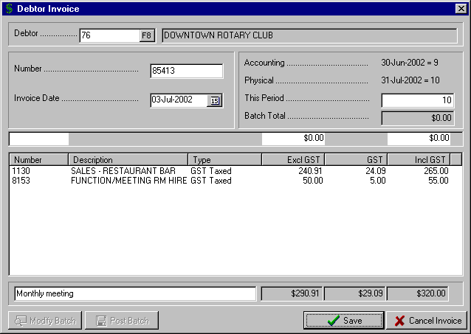
This is the line where you can record any relevant Comments relating to the transaction
You should check this Total before saving the input.

Select the “Save” button to complete the input of the Debtor Invoice or Credit Note.

B3) TRANSACTIONS – DEBTOR AND RECEIPTS

b) INVOICES / CREDITS

The system returns to the “Debtor” field for the entry of more invoices.

Note the display of the “Batch Total” to allow you to check the total of your input.

Once you have selected the “Save” button to complete a Debtor Invoice, two other options are displayed at the bottom left corner of the screen.

The first option is to “Modify Batch”. If the batch total is not correct and you need to edit an invoice in the current batch, then click on the “Modify Batch” button at the bottom of the screen to display the invoices already entered. Highlight the invoice and select “OK” to retrieve an invoice for editing or the “Delete” button to delete an invoice from the batch.

The second option is to “Post Batch”.

You would check that the “Batch Total” is correct before selecting this option. Once you have checked that the batch total is correct then select the “Post Batch” option to save away the invoices and print an audit trail on the selected printer.

 TIP : You can suppress the printing of an audit trail for the Debtor Invoices and Credit Notes processed via this routine by selecting the appropriate setting in the “Maintenance – System – Global Settings General” routine, as detailed on Page 86.

c) AUTOMATIC CHARGES

This routine allows the automatic charging of certain items to Debtors accounts, previously set up for each individual Debtor.

Examples of this type of charge would be Account Keeping Fees, Interest on Overdue Amounts, etc. The charges can be either a $ amount or a % of the account balance.

The details of the charges are initially set up via the routine "Maintenance – System - Auto Charge Parameters”.

On entry to the routine, the system displays the “Auto Charge” window with the preset charge transactions listed.

Enter the “Transaction Date” for the Auto Charge transactions and select the “OK” button to post.

B3) TRANSACTIONS – DEBTOR AND RECEIPTS

d) AUTOMATIC INVOICES

This routine provides the facility to automatically invoice specified Debtors at regular intervals. It will be applicable to service industries where a set service fee is charged each month or where a club invoices a Debtor or Contractor a set amount each Period (e.g. kitchen rent for a Catering Contractor).

Selecting “Automatic Invoices” from the “Debtor and Receipts” menu displays a further set of options

d1) New Automatic Invoice

This routine is used to initially set up the Automatic Invoices that can be selected for processing via the “Post Automatic Invoices” routine detailed below.

On entry to the routine you are prompted to enter the Debtor “Number” or use the F8 option to display the “Lookup Debtor” window and select the required one.

Enter a “Comment” line for the invoice, if required.

Enter the “Description” for each line of the invoice along with the associated “Amount”.

Once you have completed all the invoice lines, you then allocate the amount in the top section of the screen to the appropriate General Ledger Accounts in the bottom section of the screen.

Enter the Account “Number” or use the F8 option to display the “Lookup Account” window and select the required one.

Enter the amount excluding GST in the “Excl GST” column or the amount including GST in the “Incl GST” column. The system will not allow you to save the transaction unless both sections of the screen are in balance.

A sample “Automatic Invoice” screen is shown below.

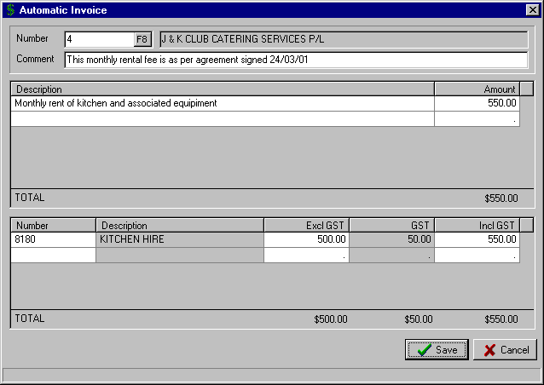
The invoice details in this section are then dissected to the appropriate General Ledger Accounts in the section below.

B3) TRANSACTIONS – DEBTOR AND RECEIPTS

d) AUTOMATIC INVOICES (cont..)

d2) Delete Automatic Invoices

This routine is used to delete Automatic Invoices previously set up in the routine “New Automatic Invoice” as detailed above.

On entry to the routine, the system displays the Automatic Invoices set up on the system. To select the Automatic Invoices for deletion, simply tick the check box next to the invoice to be deleted.

Once all the Automatic Invoices for deletion have been ticked, select the “OK” button.

d3) Post Automatic Invoices

This routine is used to process the Automatic Invoices previously set up in the routine “New Automatic Invoice” as detailed above.

On entry to the routine, the system displays the Automatic Invoices set up on the system as shown in the example below. To select the Automatic Invoices for processing, simply tick the check box next to the invoice to be posted.

Once all the Automatic Invoices for posting have been ticked, select the “OK” button.

A sample “Post Automatic Invoices” screen, with two invoices marked for posting, is shown below.

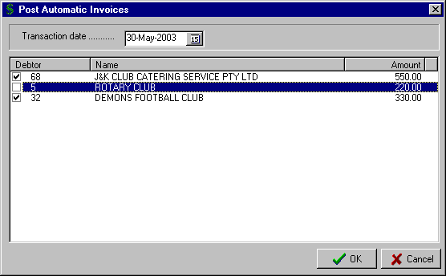

B3) TRANSACTIONS – DEBTOR AND RECEIPTS

e) FUNCTION DEPOSIT TRANSFER

The Cash Management system provides for the efficient handling of deposits paid by members for a Function that is to occur in the future (e.g. a wedding). Function Deposits can be processed in the “Receipts” or “Tills Input” routines in the “Transactions – Debtor and Receipts” menu.

The system retains these Function Deposits until the Function occurs and the final amount owing by the Debtor (Member) is calculated. At this point there is a need to transfer the Deposit from Function Deposits and apply it to the Debtor (Member) account. This is done via this routine.

On entry to the routine “Function Transfer” screen is displayed. Enter the Debtor "Number" or use the F8 option to select.

Enter the "Date” for the transfer.

Any "Outstanding Deposits” for the selected Debtor are displayed in the left window. Highlight the deposit to be transferred and select the > button. This moves it to the "Transfer to Debtors" window. The details of the total "Outstanding" and the total marked for "Transfer" are displayed at the top right of the screen.

A completed ”Function Transfer” screen is shown below.

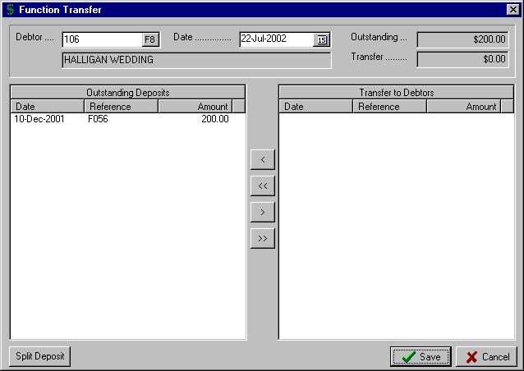
To transfer this deposit, highlight the entry and then click the > button.

This will move it to the “Transfer to Debtors” window.
If you need to transfer only part of a deposit then highlight the deposit, and select the “Split Deposit” button.

This will allow you to specify how much of the deposit you want to “Transfer to Debtors”.

Use the arrow keys to move all (<< and >>) or
selected (< and >)
deposits from one window to another.

The option also exists to split the deposit and only transfer part of the amount. Highlight the deposit to be split and select the “Split Deposit” button. This opens the “Split Function” screen allowing you to designate how much of the deposit you want to transfer. This amount is then displayed in the “Transfer to Debtors” window with the balance of the deposit left in the “Outstanding Deposits” window.

Select the “Save” button when all the input is completed.

B3) TRANSACTIONS – DEBTOR AND RECEIPTS

f) TILLS INPUT

This routine is designed for clubs to efficiently process the Till Reconciliation sheets for each Till or ‘Receipting Location’ (e.g. Reception, Poker Machines, etc.). It provides for the input of daily Sales and Receipts on a Till by Till basis and records any cash discrepancies by location. It forms the basis of the daily Bank Deposit.

The types of Transaction handled by this routine include Function Deposits, Debtor Sales, Debtor Receipts, Expenses paid by cash, and Cash Sales. The Tills used in this routine must firstly be set up via the "Maintenance – Tills” routine as described on Page 58.

On entry to the routine, the “Input Till” screen is displayed. Enter the “Input Date”. This date will be within the current Physical Period.

Enter the “Till Number” or use the F8 option to display the Tills on the system and select the required one. If an input has already been made for the selected Till on the specified Input Date, then the details are displayed.

Enter the “Tape CASH” amount from the Till tape. This is the amount of cash sales as recorded on the Till.

Enter the actual cash count for the Till in the “CASH in Till” field. The system displays the cash “Discrepancy”.

The system then allows you to move to the CREDIT column for dissection of the sales to the appropriate Sales Accounts. The standard Accounts to be used for this Till are displayed. Enter the “Amount” for each Account. As you move down the Accounts the Account Description is displayed at the bottom of the screen.

If you need to include an Account not set up for this Till, then select the first blank line and enter the Account No. or use the F8 option to select the required one. If you enter an Account that already has a value entered against it for the Till on that day, then the system takes you to that Account and allows you to modify the previous value.

Once you have completed the entries for the CREDIT column, you can move to the DEBIT column to dissect any Expenses that are applicable. Commonly used Expense Accounts can be set for each Till. The same options then exist as described above for the CREDIT column.

There are four further transaction options that can be included in the Input Till screen. They are:

- Function Transfer - this routine allows you to transfer a Function Deposit to the Debtors account. This would be used if, for example, a wedding party had a Dry Till and they had previously paid a deposit for the function. You would need to transfer the deposit to the Debtor’s account so that a net figure could be billed to the client.

Full instructions on the “Function Deposit Transfer” routine are set out on Page 31.

- Function Deposit - this routine allows you to process a Function Deposit, e.g. the deposit required to book a function room for a wedding at a future date.

The details required for the processing of a Function Deposit are the Debtor “Number”, the “Reference” and the “Amount”. The instructions are identical as for a “Debtors Sale” as shown below on this page.

- Debtors Receipt - this routine allows you to process a Debtor Receipt. This could be for a function previously held at the club that was processed via the “Invoices / Credits” routine.

The details required for the processing of a Debtors Receipt are the Debtor “Number”, the “Reference” and the “Amount”. The instructions are identical as for a “Debtors Sale” as shown on the following page.

- Debtors Sale - this routine allows you to process a Debtor Sale. This could be for a function held at the club where the client has had a Dry Till and will be issued with an invoice at a later time. It would also be used for organisations (e.g. sub-clubs) that have a credit arrangement with the club.

The only information required is the Debtor “Number”, the “Reference” and the “Amount”.

B3) TRANSACTIONS – DEBTOR AND RECEIPTS

f) TILLS INPUT (cont..)

A sample “Debtor Sales” screen is shown below. The information entered for this routine is identical for the “Function Deposit” and “Debtors Receipt” options described above.

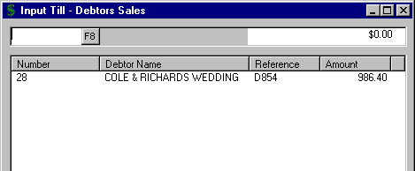
This Debtors Sales input screen is the same for the “Function Deposit” and “Debtor Receipt” options described on the previous page.
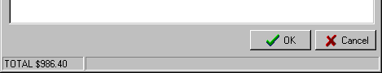

Once all the Till Input is completed, the “TOTAL CREDITS” must equal the “TOTAL DEBITS”. If they don’t,
then there is an error in your input and it must be resolved before you save away the posting.

The sample “Till Input” screen below includes a Function Deposit, Debtor Receipt and Debtor Sales.

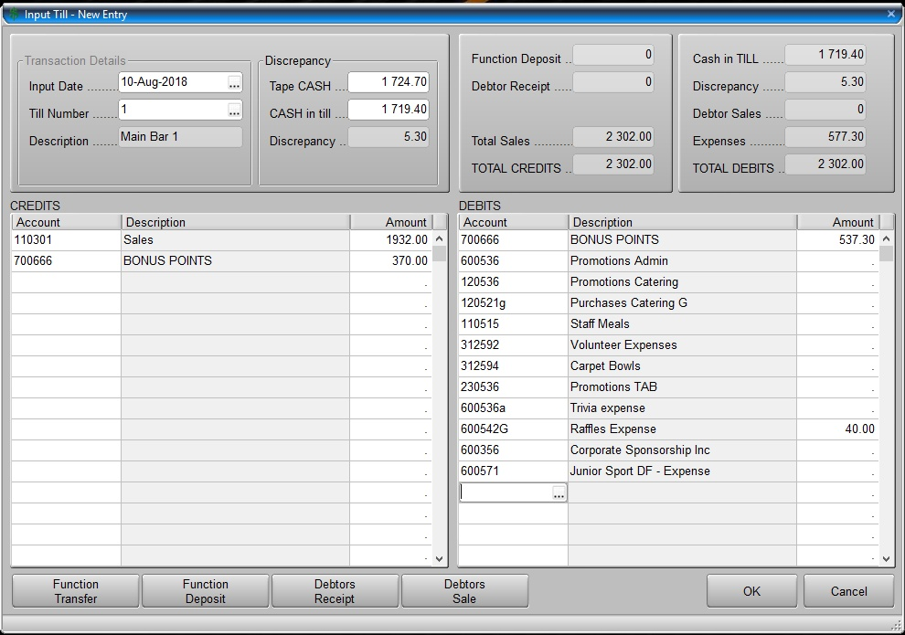
These are the Sales Accounts
These are the Expense Accounts

B3) TRANSACTIONS – DEBTOR AND RECEIPTS

g) POST TILLS AS DEPOSIT

This routine posts the transactions entered via the routine "Tills Input" and creates a new or adds to an existing Deposit. The normal procedure would be to enter the input for all the Tills via "Tills Input" and then post them as the Deposit for the day.

On entry to the routine you are prompted:

"Create a NEW deposit"

This provides the option to add to an existing Deposit. A “No” response will display all unpresented deposits allowing the selection of the required one. A “Yes” response will create a new deposit.

Enter the "Date" of the Tills input to be posted to the Deposit. The date must be within the current Physical Period.

The totals for each of the Tills for the date specified are displayed and this should be checked before posting. If the posting is adding to an existing deposit then the value of the existing deposit is shown in the field "Previous Deposit Value". (In the example below, a new deposit was created and hence the “Previous Deposit Value” is zero).

The "Deposit total" should match the deposit banked for the day.

A sample “Post Till Deposit” screen is shown below. Note the Account Dissections in the bottom left window. You are able to view the complete details by using the scroll bar.

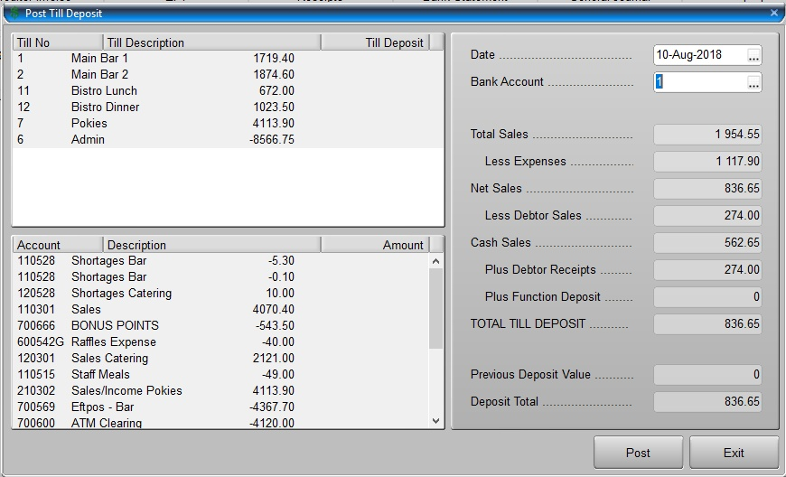
These Till totals should reconcile with the Till Reconciliation sheets
This “Deposit Total” must reconcile with your banking deposit for the day.
This is a summary of the Account dissections for all the Tills Input for this deposit.

Select the “OK” button to complete the input.

B3) TRANSACTIONS – DEBTOR AND RECEIPTS

h) DEBTORS INVOICING

This routine provides the facility to enter invoices for Debtors set up on the system. The layout for the invoices that are subsequently printed is set up in the “Maintenance – Forms Layout – Debtor Invoices” as detailed on Page 70.

Selecting “Debtors Invoicing” from the “Debtor and Receipts” menu displays a further set of options

h1) Create and Post Invoices

On entry to the routine you are prompted to enter the Debtor “Number” or use the F8 option to display the “Lookup Debtor” window and select the required one.

Enter the “Invoice” number and the invoice “Date”. Enter a “Comment” line for the invoice, if required.

Enter the “Description” for each line of the invoice along with the associated “Amount”. The option is provided from the “Description” field to press the F8 key, which displays the “Quick Invoice Text” lines that have been previously set up for standard invoice descriptions. Highlight the one required and select the “OK” button. (Refer to Page 36 for instructions on how to set up the “Quick Invoice Text” lines).

Once you have completed all the invoice lines, you then allocate the amount in the top section of the screen to the appropriate General Ledger Accounts in the bottom section of the screen.

Enter the Account “Number” or use the F8 option to display the “Lookup Account” window and select the required one.

Enter the amount excluding GST in the “Excl GST” column or the amount including GST in the “Incl GST” column. The system will not allow you to save the transaction unless both sections of the screen are in balance.

A sample “Debtors Invoice” screen is shown below.

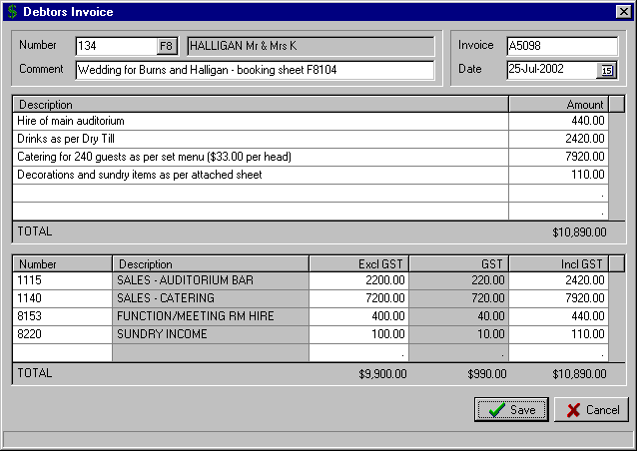

B3) TRANSACTIONS – DEBTOR AND RECEIPTS

h) DEBTORS INVOICING (cont..)

h2) Print Invoices

This routine is used to print the invoices entered via “Create and Post Invoices’ routine as detailed above.

On entry to the routine, the system displays the prompt “Only unprinted Invoices”.

A “Yes” response will result in the system only displaying those invoices that have yet to be printed.

A “No” response will result in all invoices on the system being displayed. This is useful if you need to reprint a particular invoice that has been lost or misplaced by the Client.

The “Debtors Print Invoices” screen is displayed allowing you to select the invoices to print by ticking the check box next to the required invoice.

Select the “Print” button to print the selected invoices.

h3) Edit Quick Invoice Text

This routine allows you to set up standard “Description” lines for the “Create and Post Invoices” routine as detailed above. It is intended to make the entry of invoices more efficient and reduce the need to enter repetitive lines of description.

On entry to the routine the “Invoice Quick Text” screen is displayed, with the options being:

- New - allows you to enter another “Quick Text” line
- Modify - allows you to highlight an existing “Quick Text” line and change as required
- Delete - allows you to highlight an existing “Quick Text” line and remove it from the window

Select the “Save” button to complete the maintenance.

The sample “Invoice Quick Text” screen below shows the lines that were used for the invoice shown in the “Create and Post Invoices” routine detailed on Page 35. The third line provides for the input of variable details in the invoicing routine.

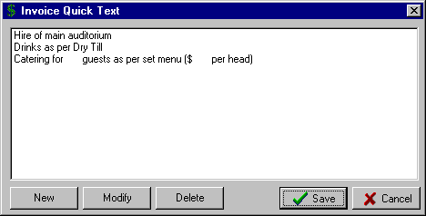

B3) TRANSACTIONS – DEBTOR AND RECEIPTS

i) CANCEL DEPOSIT

This routine is used to cancel a deposit that has been previously entered via the “Receipts” or “Post Tills as Deposit” routines.

The need to cancel a deposit may result from a deposit being posted to the wrong Bank account, to the wrong Period or to incorrect Account allocations. It provides the option to reverse all the transactions from the previous input and re-enter the deposit again.

On entry to the routine the “Cancel Deposit” screen is displayed.

Enter the “Bank” account that the deposit to be cancelled was posted to or use the F8 option to display the Bank accounts set up on the system and select the required one.

Select the “Period From” and “Period To”. In the example below the Period range selected was Period 10.

The outstanding deposits for the selected Period are then displayed. Highlight the deposit to be canceled and click the “OK” button.

In the example below, the deposit for the 10th July 2002 from Bank account 1, has been selected.

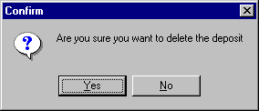
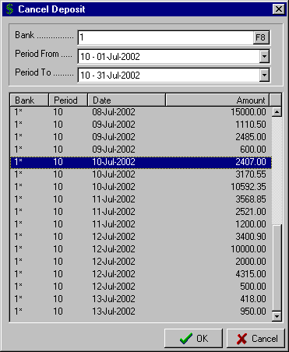

The option is then provided for you to “Confirm” the deletion of the highlighted deposit by selecting the “Yes” button.

B4) TRANSACTIONS – BANK STATEMENT

By selecting “Transactions” from the Main Menu, the menu below is displayed.

Creditor and Payment
Creditor Imports
Debtor and Receipts

Bank Statement
Electronic Funds Transfer
Journals

Selecting “Bank Statement” from the Transactions Menu takes you into the Bank Statement input routine. This routine allows the entry of all Bank Statement items so that a full Bank Reconciliation can be completed for each Bank Account on the system. All items on the Bank Statement including deposits, cheques, account charges, direct debits, account transfers, and debtor receipts direct to your bank account, are processed via this routine.

On entry to the routine, you are prompted to enter the required "Bank Account" number (1-9). You can use the F8 option to display the Bank Accounts set up on the system.

The "Statement Balance" as at the completion of the last input is displayed in the top right corner of the screen. This should be the same as the opening balance on the Bank Statement to be entered. Unless this is the case, it will be impossible to verify the accuracy of the Bank Statement input.

 TIP : The procedure to follow is to move down the Bank Statement processing each line item as it appears. This allows you to verify that your input is correct by progressively checking the Statement Balance on the bank statement.

** It is strongly suggested that you DO NOT move down the bank statement entering all the Cheques, then all the Deposits, then all the Charges, etc. **

This will make the detection of any input errors, unnecessarily difficult and time consuming.
.

There are basically five options for the “Bank Statement” routine and they appear at the bottom of the screen:

- Account - this option is used for the entry of Expense or Income items that appear directly on the Bank Statement. Examples of expense items would be Bank Charges, Direct Debits (e.g. lease payments, insurance premiums, etc.). Examples of income items would be Interest Received, EFTPOS reimbursement by the bank, etc.

By selecting the “Account” button, the “Bank Statement Account” window is displayed.
Enter the General Ledger “Account” number that you wish to post the transaction to or use the F8 option to display the “Lookup Account” window and select the required one. The option is provided to add a new General Ledger Account from the “Lookup Account” window. The Account Description and Type (Income or Expense) are displayed.

Enter the “Reference” you would like to record for this transaction.

Select the appropriate option for the “GST” field.

If you select GST “Included” then enter the amount in the “Value Incl GST” field. If you select GST “Separate” then enter the amount in the “Value Excl GST” field. Depending on the GST setting for the Account, the applicable amount of GST is calculated and displayed in the “GST Value” field.

Selecting the “OK” button will move the amount to the “Bank Statement “ input screen.

If the Account has been set up as an Expense account in the Account Maintenance routine, the amount will be displayed in the “Expense” column. If the Account was set up as Income account then the amount will be moved to the “Income” column.

B4) TRANSACTIONS – BANK STATEMENT

A typical “Bank Statement Account” window is shown below. Note that because the Bank Charges Account has been set up in Account Maintenance with a GST setting of “Input Taxed”, there is no GST calculated with the entry.

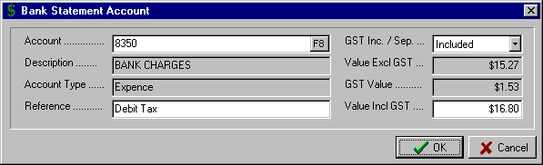

- Debtor Rec - this option allows you to directly post a receipt from a Debtor. This could arise if the Debtor pays his account, via EFT, directly to your bank account.

By selecting the “Debtor Rec.” button, the “Bank Statement Debtor Receipt” window is displayed.

Enter the “Debtor No.” that you wish to post the receipt to or use the F8 option to display the “Lookup Debtor” window and select the required one. The Debtor Name is displayed.

Enter the “Value” of the receipt and select the “OK” button to return to the “Bank Statement” screen. The amount of the Debtor Receipt will be displayed in the “Income” column.

- Cheque - this option allows you to present cheques entered on the system through the Creditor and Payment routines.

By selecting the “Cheque” button, the “Bank Statement Cheque” window is displayed with the unpresented cheques listed in cheque number order.

Highlight the cheque to be presented and click the “OK” button to move the cheque to the “Cheque” column of the “Bank Statement” screen. This will result in the Statement Balance decreasing by the amount of the cheque and should equal the running balance on the actual printed Bank Statement.

- Deposit - this option allows you to present deposits entered on the system through the Debtor and Receipts routines.

By selecting the “Deposit” button, the “Bank Statement Deposit” window is displayed with the unpresented deposits listed in date order.

Highlight the deposit to be presented and click the “OK” button to move the deposit to the “Deposit” column of the “Bank Statement” input screen. This will result in the Statement Balance increasing by the amount of the deposit and should equal the running balance on the actual printed Bank Statement.

- Delete - this option allows you to remove incorrect entries in the “Bank Statement” input screen. These could be any of the four different types of entries detailed above.

If you delete a cheque or deposit, the routine does not delete the cheque or deposit from the system, it simply moves them back to the relevant unpresented window and adjusts the “Statement Balance” accordingly.

To remove an entry from the “Bank Statement” input screen, highlight the entry and select the “Delete” button. The “Statement Balance” will be adjusted by the amount deleted.

B4) TRANSACTIONS – BANK STATEMENT

The procedure then for input is to move down each line of the Bank Statement selecting the Cheque, Deposit, Account or Debtor Receipt options, as appropriate. Progressively check the Statement Balance at the top of the screen to ensure the input is in balance with the actual printed Bank Statement.

If you find a Deposit or Cheque that differs from the actual Bank Statement you can either abort the input completely by selecting the “Cancel” button or only enter the details up to the point where the discrepancy exists. Post the details up to the point where they balance with the Bank Statement and then you can return to finish the input once the problem is resolved.

Once all entries from the Bank Statement have been completed and the “Statement Balance” at the top of the screen is correct, select the “OK” button at the bottom of the “Bank Statement” input screen to post the input.

A sample of a “Bank Statement” input screen is shown below.

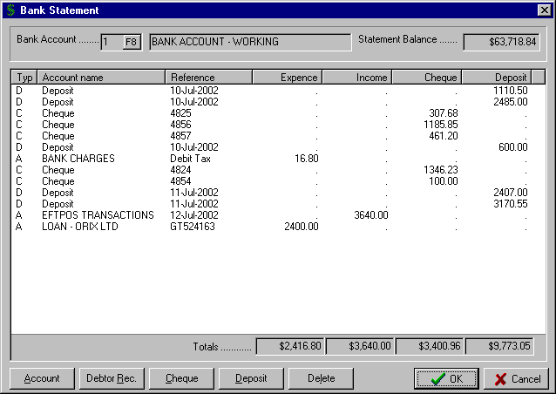
Note the combination of transaction “Types” entered in the order in which they appear on the Bank Statement
Depending on the transaction “Type”, the system allocates the amounts to the appropriate column.

B5) TRANSACTIONS – ELECTRONIC FUNDS TRANSFER

By selecting “Transactions” from the Main Menu, the menu below is displayed.

Pay Creditors
Change Processing Date
Cancel EFT Payment

EFT Globals
Create EFT Test Disk
Print BSB Numbers

Creditor and Payment
Creditor Imports
Debtor and Receipts

Bank Statement
Electronic Funds Transfer
Journals

Selecting “Electronic Funds Transfer” from the Transactions Menu, results in the sub-menu to the right being displayed.

a) PAY CREDITORS

This routine is used to pay outstanding creditor invoices by Electronic Funds Transfer (EFT).

You must set up the Creditor’s BSB Number in the Creditor Maintenance routine before you can process an EFT Payment for a Creditor in this routine.

The instructions for this routine are very similar those for “Transactions – Creditor and Payment – Write Cheques Auto” as detailed on Page 19. The only difference is that you do not need to select the “Bank Account” the payment is to come from as you enter the routine (this is set in the “EFT Globals” routine).

Once you have processed the creditor invoices that are to be included in the EFT Payment, when you exit the routine the system prompts you to ensure the directory is available for writing away the EFT file. The location of this directory is set up in the “EFT Globals” routine as detailed on Page 42. This directory may be on the hard drive of your computer or a diskette drive.

The EFT audit trail is printed as you exit the routine and this is the source document that is signed by an authorised representative of the club

b) CHANGE PROCESSING DATE

This routine allows you to change the processing date of the EFT file that is ready for processing in the directory that is set up in the “EFT Globals”.

The need for this may arise if the necessary authorisation has not been finalised on the originally designated processing date and the EFT Payment is to be processed at a later date.

On entry to the routine the “Change EFT Processing Date” is displayed with the “Current Date” displayed.

Enter the “New Date”, as required and select the “OK” button.

In the example below, the EFT processing date has been changed from 26th July 2002 to the 27th July 2002.

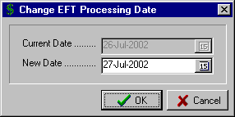

B5) TRANSACTIONS – ELECTRONIC FUNDS TRANSFER

c) CANCEL EFT PAYMENT

This routine allows you to cancel an EFT Payment that is ready for processing in the directory that is set up in the “EFT Globals”. This may be required if a change needs to be made to the creditor payments listed on the EFT audit trail. On entry to the routine, you are prompted to select the “Bank Account” from which the EFT Payment was made. The payments for the selected Bank Account are displayed.

Highlight the EFT Payment to be cancelled. If you would like to reverse all the invoices that make up this payment then click the “Reverse all transactions” check box. (This would only be done if you wanted to reverse both the payment and the invoices that make up the payment). Then select the “OK” button.

The system then displays the warning “Are you sure you want to cancel this cheque?” A “Yes” response completes the routine; a “No” response returns you to the “Cancel Cheques” window without canceling either the EFT Payment or the transactions.

d) EFT GLOBALS

This routine sets up the global details required for the processing of EFT (Electronic Funds Transfer) Payments on the system. The settings are unique to each financial institution and so you should contact your Bank to ensure that the correct global settings are entered.

The fields required are as follows:

- Club BSB - the number of the Bank & Branch for the Account to be used for EFT payments
- Club Account - the number of the Bank Account to be used for EFT payments
- Club ID - this is a unique number supplied by the Bank to each of its clients
- Clubs Bank No - the Bank Account set up on the system that will be used for EFT payments
- Bank Short Name - the name supplied by the Bank to be used for your club
- Exclude EOF Marker - the Bank will advise if an “End of File Marker” is required or not
- Self Balancing - the Bank will advise whether or not the EFT file needs to have a self balancing entry
- Data Filename - the Bank will advise the name of the EFT file to be prepared. The complete path will be determined by which directory you want to access when processing the EFT file in the Bank EFT software. This could be a networked directory, a local directory on the computer or a diskette drive.

Once the “EFT Globals” details are completed, select the “OK” button. A sample screen is shown below.

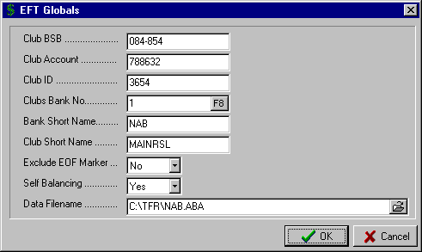

B5) TRANSACTIONS – ELECTRONIC FUNDS TRANSFER

e) CREATE EFT TEST DISK

This routine allows you to test the settings in your EFT Globals and check also that you have valid BSB numbers set up for your Creditors.

This routine writes a test file with a 1-cent payment for all Creditors with a BSB Number. This test file can then be checked by your Bank. They will advise you if there are any problems with the Globals setup or with invalid Creditor BSB Numbers and BSB Descriptions.

On entry to the routine you are prompted to ensure that you have a disk in the drive that you have specified for the “Filename” in the EFT Globals routine. This may be your local C drive or a diskette drive (e.g. A drive)

Once you select the “OK” button to the prompt, the file is written away to the directory set up in the EFT Globals.

f) PRINT BSB NUMBERS

This routine displays, and alternatively prints, the BSB Numbers and Descriptions set up for the Creditors on your system.

On entry to the routine, the “Creditor BSBs” window is displayed. It lists the Creditor Number, Creditor Name, BSB Number and BSB Description.

Select the “Print” button to produce a hard copy of the listing.

B6) TRANSACTIONS – JOURNALS

By selecting “Transactions” from the Main Menu, the menu below is displayed.

Creditor and Payment
Creditor Imports
Debtor and Receipts

Bank Statement
Electronic Funds Transfer
Journals

General Journal
Standing Journal Maintenance
Standard Journal Processing

Processing Reversing

Selecting “Journals” from the Transactions Menu, results in the sub-menu to the right being displayed.

a) GENERAL JOURNAL

This routine allows for the input of Debit and Credit Journal entries to the appropriate General Ledger Accounts set up on the system.

The type of transactions entered via this routine would always be non-cash transactions such as write-offs for Bad Debts, adjustments to Provision Accounts, reallocation of expenses or income from one Account to another, postings from Clearing Accounts to Expense accounts, etc.

General Journal entries do not attract GST as they relate to transactions within the business.

It should be noted that you cannot post to a Control Account as set up in the routine "Maintenance – System – Control Accounts” (see Page 84 for details). Examples would be the Creditors Control, Debtors Control, Bank Account, etc.

On entry to the routine the “General Journal” screen is displayed.

Enter the "Period" that the journal entry will relate to.

 TIP : The system does allow for journal entries to prior Periods, however, this should be treated with some caution by non-accounting staff, as certain Journal entries will affect the calculated Net Profit.

This may cause the system to be out of line with the figures reported previously to the Board in the prior Period.
.

Enter the “Date” of the journal entry.

If the Journal is to be reversed in the next Period then you can indicate this by ticking the “Reversing” check box. The reverse of this journal would be included in the “Transactions – Journals – Process Reversing” routine for he following Period, as described on Page 47.

Enter the “Reference” for the journal entry. This would be your General Journal reference number and is normally allocated by the accounting staff. Enter any relevant “Comment” you would like to record with this journal entry.

Enter the General Ledger Account "Number" or use the F8 option to display the “Lookup Account” window and select the required one. The selected “Account” Description is displayed.

The cursor moves to the "Debit" column to allow input of the value. Press the Enter key to move to the "Credit" column if the posting is a Credit transaction. (You can alternatively click on the required input box with the mouse)

Enter the value for this posting. The system returns to the "Number" column for further dissection of the transaction. Multiple Debit and Credit entries can be entered with the only proviso being that the Debits equal the Credits. The progressive balance of the Debit and Credit values are displayed at the bottom of the screen.

B6) TRANSACTIONS – JOURNALS

a) GENERAL JOURNAL (cont..)

A completed “General Journal” transaction may appear similar to that below.

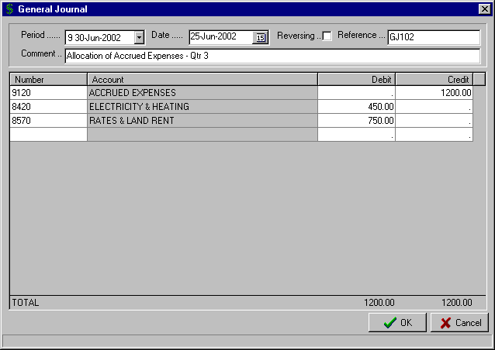
This General Journal is a simple single Credit entry and multiple Debit entries. It has not been flagged as a “Reversing” journal
Note that the Total Debits and Total Credits must be in balance for the system to post the General Journal

Once you have completed the input and the “Total Debits” equal the “Total Credits”, then select the “OK” button to complete the posting of the General Journal.

b) STANDING JOURNAL MAINTENANCE

This routine is used to set up Standing Journals that are to be processed on a monthly (Period) basis. Standing Journals are used for the General Journal entries that are consistent each month. Having a routine that allows you to set them up once and then process them each Period saves time with input, minimises errors in postings to the wrong Account, and ensures that important journal entries are not missed.

On entry the routine, the “Standing Journals” screen is displayed with the Period End dates (1-15) along the top of the columns.

The first step is to set up the Account details for the journals in the “Account” column. Select the first available blank input box and enter the Account Number or use the F8 option to display the “Lookup Account” window and select the required one. Continue this process until you have entered all the required Accounts for the Standing Journal.

The next step is to set up the amounts for each Account. Select the input box under the Period to be included and enter the value as a positive amount for a Debit entry or as a negative number for a Credit entry. Repeat this process for each Period that you want to establish the Standing Journal for.

B6) TRANSACTIONS – JOURNALS

b) STANDING JOURNAL MAINTENANCE (cont..)

The option is provided to duplicate the entries for the previous Period. This simplifies the set up of the Standing Journals and reduces the possibility of errors. Simply, select a blank cell in the next Period and click the “Duplicate” button at the bottom left corner of the screen.

Once you have completed the input and selected the “OK” button the system will display a warning if the Standing Journal is not balanced. It will identify which Period is not balanced and the amount. This makes checking and correcting the journal, a very simple process.

You are able to edit any unprocessed Period and these are shown as white input boxes in the “Standing Journals” screen. As can be seen in the example below, the Standing Journal has been processed for Periods 1 to 5 (the input boxes are grey), whereas Period 6 is white and can be still edited.

You will notice that you can add extra Accounts as you move progressively through the year, as seen in Period 3 where an additional two Accounts were included.

A typical “Standing Journal” screen is shown below.

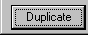
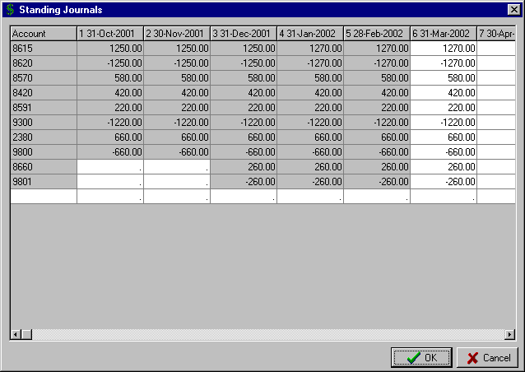
These are the Account Numbers for the journal entries
The Standing Journals already posted are in grey
These journal entries have been added as of Period 3
This Period has not yet been posted and so can be edited

You can use the “Duplicate” button to repeat the entries for the previous Period.

B6) TRANSACTIONS – JOURNALS

c) STANDING JOURNAL PROCESSING

This routine posts the Standing Journal entries set up in the “Standing Journal Maintenance” routine described above.

On entry to routine the current Accounting Period is displayed as the “Period” the Standing Journal will be posted to.

Enter the “Date” and the “Reference” for the Standing Journal posting.

Enter a “Comment” line for the Standing Journal, if required.

The system displays the details of the Standing Journal as set up in the Standing Journal Maintenance routine.
You are able to edit the values for any of the entries and include additional Account entries. The only proviso is that the Debit entries must equal the Credit entries before the system will allow you to post the Journal.

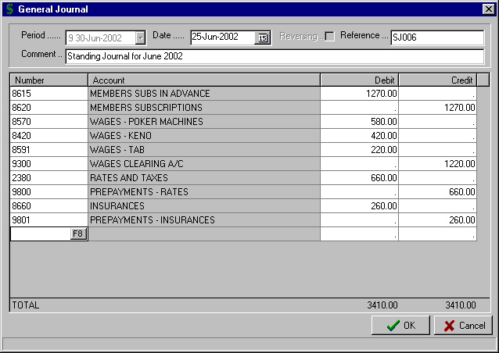
You can add additional entries to the Standing Journal
You can edit the details of the displayed Standing Journal

Once you are happy with the contents of the Standing Journal, select the “OK” button to post.

d) PROCESS REVERSING

This routine processes the Journal entries flagged as “Reversing” in the “Transactions – Journals – General Journal” routine as described on Page 44.

On entry to the routine, the system lists the Journals to be reversed. The details shown are the “Date”, “Reference” and “Value” of each of the Journals.

Select the “OK” button to process the Reversing Journals.

B7) TRANSACTIONS – BUSINESS ACTIVITY STATEMENT

This procedure calculates and prints the Business Activity Statement.

You must complete both the Physical and Accounting Periods for the period included in the Business Activity Statement (BAS). For example, if you are preparing the club’s BAS on a Quarterly basis and the Periods to be included are 7, 8 & 9 then you need to have the Accounting Period in Period 10.

On entry to the routine the “Business Activity Statement” screen is displayed. Select the “Calculate” button to prepare the report. The fields shaded white can be edited, as required, as they are not fields automatically calculated by the system and relate to abnormal items or adjustments.

You are able to select the tabs for “Purchases Actual”, “Sales Actual”, “Purchases Exceptions”, “Sales Exceptions” and calculated “Withholding” tax to see how the system arrived at the summarised totals.

Once you have checked the “Summary” and everything is correct, select the “OK” button to print the Business Activity Statement and associated audit trails and complete the routine.

The system will automatically post an invoice for the calculated amount to the Creditor set up for the Australian Tax Office in the “Maintenance – System – Global Settings General” routine as detailed on Page 86.

A completed ““Business Activity Statement” is shown below.

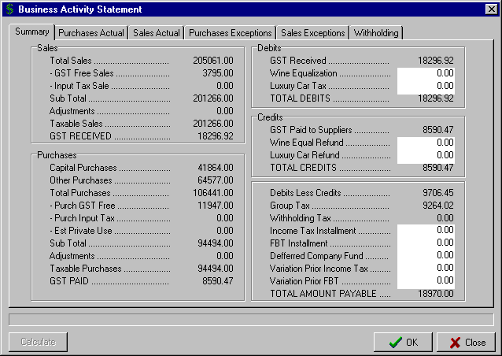
These fields can be edited, as required. They are not fields that are automatically completed by the system

C1) MAINTENANCE – ACCOUNTS

By selecting “Maintenance” from the Main Menu, the menu below is displayed.

Accounts
Creditors
Debtors

Tills
Budgets
Forms Layout
System

Account Maintenance
Account Listing

Selecting “Accounts” from the Maintenance Menu, results in the sub-menu to the right being displayed.

a) ACCOUNT MAINTENANCE

This routine is used to Add, Change or Delete the General Ledger Accounts. The system provides considerable flexibility in the formatting of Account numbers and should cater for most Chart of Account formats. On entry to the routine, the “Account Maintenance” screen is displayed. It is from this screen that you determine the type of maintenance to be performed.

- Add Account

To ADD a General Ledger Account, from the blank “Account Maintenance” screen click the “Add” button.

Enter the Account "Number". This field is alphanumeric up to 8 characters. Examples of valid Account Numbers are:
54320 5241.01 A1001/01 154-01 A

Enter the "Alternate Number" for this Account. This is an optional two-character key that can greatly simplify the entry of Account numbers when entering transactions. It is especially useful for commonly used Accounts e.g. SB for SALES - BULK BEER, or BC for BANK CHARGES. You would not attempt to set up an Alternate Number for every Account, only the Accounts that you use most often.

Enter the Account "Description" (maximum of 25 characters).

Select the “Account Type” for this Account with the options being “Income” or "Expense". Use the Up & Down arrow to make your selection or click on the  button to bring up the available options. You can also simply Press the letters “I” for Income or “E” for Expense. The only time this field is used is during the Bank Statement input routine and it dictates whether postings to this Account from the Bank Statement would appear in the Income or Expense part of the system.

Select the “GST Type” for this Account with the options being:

GST Taxed - this is the setting for all Accounts that are taxable supplies (i.e. incur GST)

GST Free - this would be used for those items designated as GST-free, e.g. water, sewerage, international mail, food (but not restaurant, takeaway or prepared food), etc.

Input Taxed - this would be used for those items designated as Input Taxed, e.g. financial supplies, bank charges, residential rent, etc.

Non BAS - this would be used for Accounts that do not incur GST and yet do not fit the other two categories, e.g. Clearing Accounts, Control Accounts (Bank, Creditors, Debtors) and non-cash transactions such as Depreciation Accounts.

Use the Up & Down arrow to make your selection or click the  button to bring up the available options. You can also Press the letters “G” for GST Taxed, “G” again for GST Free, “I” for Input Taxed or “N” for Non BAS.

 TIP : The option exists within the transaction routines to override this default GST setting for Accounts that have a combination of GST Taxed and GST Free or Input Taxed transactions.

C1) MAINTENANCE – ACCOUNTS

a) ACCOUNT MAINTENANCE (cont..)

Select the “Trading Type” for the Account with the options being:

Trading - use this type for Expense and Income Accounts that appear in the Profit & Loss Statement

Once you have selected “Trading” the further option is provided to designate the Account as a “Stock Account”. This is only relevant if you are using the Computer MAGIC Stock Control system and this Account is for the purchase of stock items, e.g. Purchases – Bulk Beer, Purchases – Soft Drink, etc.

Non Trading - use this type for Asset and Liability Accounts that appear in the Balance Sheet.

Once you have selected “Non Trading” the further option is provided to designate the Account as an “Asset Account”. This is only relevant if you are using the Computer MAGIC Fixed Assets system and this Account is a Fixed Asset Account, e.g. Poker Machines @ Cost, Plant & Equipment, etc.

The option is then provided to enter the ”Balances” for this Account with the options being:

Opening Balance - this would only apply to Non Trading (Balance Sheet) Accounts and is the balance of the Account at the beginning of the current Financial Year. Normally, you would only need to enter this Opening Balance when initially setting up the system.

Last Year Balance - this would apply to both Trading and Non Trading Accounts and is the balance of the Account at the end of the last Financial Year. Normally, you would only need to enter this Last Year Balance when initially setting up the system.

Note that Debit Balances are entered as a positive amount and Credit Balances as a negative amount.

Select the "Print group" for this Account. Use the Up & Down arrow to make your selection or click the  button to bring up the available options. The Print Group names are set up in the routine “Maintenance – System – Setup Print Groups” as detailed on Page 85.

Print Groups are used in the Summary Data reporting as described on Page 94. The system provides you with up to 255 different Print Groups and so the option is available to set up quite detailed report layouts and selective exports to other systems such as Spreadsheets (e.g. Excel).

Once all the input is completed, select the “OK” button to save the Account details.

A completed “Account Maintenance – Add” screen would appear similar to that shown below.

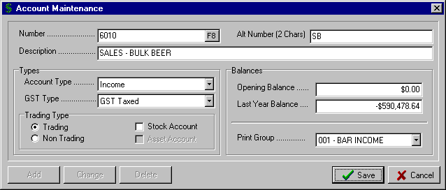

C1) MAINTENANCE – ACCOUNTS

a) ACCOUNT MAINTENANCE (cont..)

- Change Account

To CHANGE the details stored for a General ledger Account, from the blank “Account Maintenance” screen enter the Account “Number” or use the F8 option to display the “Lookup Account” window and select the Account to be changed. The details of the selected Account are displayed.

Click the “Change” button. This then allows you to change each of the fields described in the Add Account section above on Pages 49-50.

 TIP : Caution should be taken with changes to the “Opening Balance” and “Last Year Balance” fields. These should only be changed if the balances stored in the system do not correspond with the published accounts of the club. If they are changed then you should reconcile the balances when completed with the published figures.

A completed “Account Maintenance – Change” screen would appear similar to that shown below. Note that this Account has been set up as an “Asset Account” for use with the Fixed Assets system.

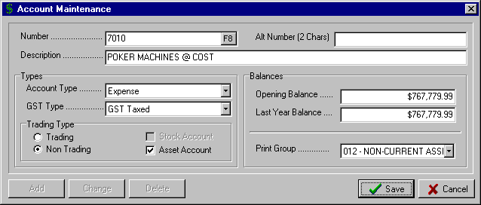

- Delete Account

To DELETE a General ledger Account, from the blank “Account Maintenance” screen enter the Account “Number” or use the F8 option to display the “Lookup Account” window and select the Account to be deleted. The details of the selected Account are displayed.

Click the “Delete” button. A “Yes” response to the “Delete Account?” prompt will delete the Account.

Note that you are not able to delete an Account with transactions in the current Financial Year or with entries in the “Balances” fields.

b) ACCOUNT LISTING

This routine allows you to print the Chart of Accounts set up on the system in either Account Number or Account Name order.

Select either “Account Number” or “Account Name” sort sequence from the “Account Listing” window.

Click the “OK” button to print the listing. Select the required printer from the Windows “Print” screen.

C2) MAINTENANCE – CREDITORS

By selecting “Maintenance” from the Main Menu, the menu below is displayed.

Accounts
Creditors
Debtors

Tills
Budgets
Forms Layout
System

Creditors Maintenance
Creditor Listing

Selecting “Creditors” from the Maintenance Menu, results in the sub-menu to the right being displayed.

a) CREDITORS MAINTENANCE

This routine is used to Add, Change or Delete the Creditor details held on the system. Creditors are those suppliers that your business has an ongoing relationship with.

 TIP : There is no need to set up Creditor details for ‘one-off’ suppliers or a Miscellaneous or Sundry Creditor. The system handles all these type of transactions through Creditor Number 1 (see below for details)

On entry to the routine, the “Creditor Maintenance” screen is displayed. It is from this screen that you determine the type of maintenance to be performed.

- Add Creditor

To ADD a Creditor, from the blank “Creditor Maintenance” screen click the “Add” button.

Enter the Creditor "Number". This field is alphanumeric up to 8 characters.

Enter the Creditor "Name".

From the “General” tab, enter the Address details for the Creditor in the “Address 1”, “Address 2”, “Town”, “State” and “Postcode” fields.

Enter the Creditor’s “Telephone” and “Fax” numbers.

Enter the "Days Credit” that usually apply with this Creditor. The number of days entered will dictate the due date of invoices when entered via the Creditor and Payment routines. For example, for a Creditor with a setting of 7 “Days Credit”, an invoice that is dated the 10th June will be allocated a due date of the 17th June.

If you enter 30 “Days Credit” for a Creditor then this assumes that you have one month to pay the invoice form the end of the month the invoice was dated. For example, for a Creditor with a setting of 30 “Days Credit”, an invoice that is dated the 10th June will be allocated a due date of the 31st July.

Enter the “ABN” of the Creditor. This is an important field as if an invoice is processed for a Creditor with no ABN then the system will automatically allocate 48.5% (or the top marginal rate plus the Medicare Levy) to the designated Withholding Tax Clearing Account.

Enter the “BSB” number and “Bank Account No” for the Creditor. This is only required if you are paying this Creditor via the Electronic Funds Transfer (EFT) routine (see Page 41 for details)

Enter the “BSB Description” for the Creditor. This is only required if you are paying this Creditor via EFT. This field stores the specific Reference that you as an organisation have been allocated by the particular Creditor, e.g. your organisation's Reference with the Australian Tax Office or your Customer number with the breweries. If you don't set up a specific BSB Description for the Creditor via this routine then the default reference used in the EFT payment process will be the Creditor Number.
C2) MAINTENANCE – CREDITORS

a) CREDITORS MAINTENANCE (cont..)

A completed “Creditor Maintenance” screen showing the “General” tab is shown below.

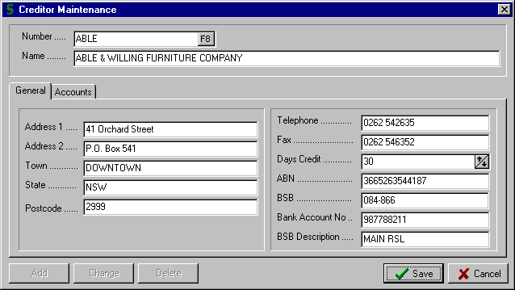

The option exists via the “Accounts” tab in the “Creditor Maintenance” screen, to set up standard General Ledger Accounts that are displayed when invoices are processed in the Creditor and Payment routines. This helps minimise incorrect allocation of expenses to Accounts and makes processing Creditor invoices more efficient.

Click on the “Accounts” tab to activate this option.

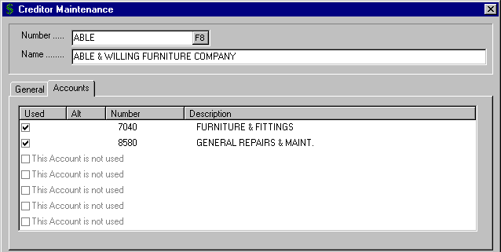

Click the check box in the “Used” column to display the “Lookup Account” window. Select the required Account. Repeat for as many Accounts as you want to set up for this Creditor (maximum of 7).

Click the “Save” button once all the details for the Creditor have been entered.
C2) MAINTENANCE – CREDITORS

a) CREDITOR MAINTENANCE (cont..)

- Change Creditor

To CHANGE the details stored for a Creditor, from the blank “Creditor Maintenance” screen enter the Creditor “Number” or use the F8 option to display the “Lookup Creditor” window and select the Creditor to be changed. The details of the selected Creditor are displayed.

Click the “Change” button. This then allows you to change each of the fields described in the Add Creditor section above on Pages 52-53.

- Delete Creditor

To DELETE a Creditor, from the blank “Creditor Maintenance” screen enter the Creditor “Number” or use the F8 option to display the “Lookup Creditor” window and select the Creditor to be deleted. The details of the selected Creditor are displayed.

Click the “Delete” button. A “Yes” response to the “Delete Creditor?” prompt will delete the Creditor.

Note that you are not able to delete a Creditor with transactions in the current Financial Year or with an outstanding balance.

b) CREDITOR LISTING

This routine allows you to print the Creditors set up on the system in either Creditor Number or Creditor Name order.

Select either the “Creditor Number” or “Creditor Name” sort sequence from the “Creditor Listing” window.

Click the “OK” button to print the listing. Select the required printer from the Windows “Print” screen.

C3) MAINTENANCE – DEBTORS

By selecting “Maintenance” from the Main Menu, the menu below is displayed.

Accounts
Creditors
Debtors

Tills
Budgets
Forms Layout
System

Debtors Maintenance
Debtors Listing

Selecting “Debtors” from the Maintenance Menu, results in the sub-menu to the right being displayed.

a) DEBTORS MAINTENANCE

This routine is used to Add, Change or Delete the Debtor details held on the system. Debtors are those members or customers that you extend credit to, i.e. you supply goods or services with payment made at a later date.

 TIP : For a club, a Debtor record can be set up for sub-clubs, members who book functions (e.g. weddings) and pay a deposit, organisations that regularly use your club (e.g. Community Clubs). This helps to control deposits held and procedures can be implemented to ensure outstanding debts are followed up.

On entry to the routine, the “Debtor Maintenance” screen is displayed. It is from this screen that you determine the type of maintenance to be performed.

- Add Debtor

To ADD a Debtor, from the blank “Debtor Maintenance” screen click the “Add” button.

Enter the Debtor "Number". This field is alphanumeric up to 8 characters. Enter the Debtor "Name".

From the “General” tab, enter the Address details for the Debtor in the “Address 1”, “Address 2”, “Town”, “State” and “Postcode” fields. Enter the Debtor’s “Telephone” and “Fax” numbers.

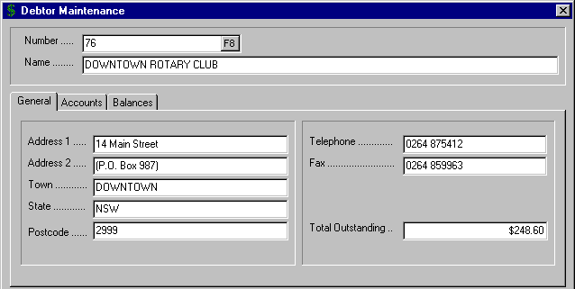

A completed “Debtor Maintenance” screen showing the “General” tab is shown above.
C3) MAINTENANCE – DEBTORS

a) DEBTORS MAINTENANCE (cont..)

The "Total Outstanding” balance for the Debtor is displayed in the “General” tab. This field cannot be modified in the normal maintenance routine. Corrections would be normally processed as a “Credit Note” or an “Invoice” via the “Transactions – Debtor and Receipts – Invoices / Credits” routine as set out on Page 27.

The option exists via the “Accounts” tab in the “Debtor Maintenance” screen, to set up standard General Ledger Accounts that are displayed when invoices are processed in the Debtor and Receipt routines. This helps minimise incorrect allocation of income to Accounts and makes processing Debtor invoices and credits more efficient. Click on the “Accounts” tab to activate this option.

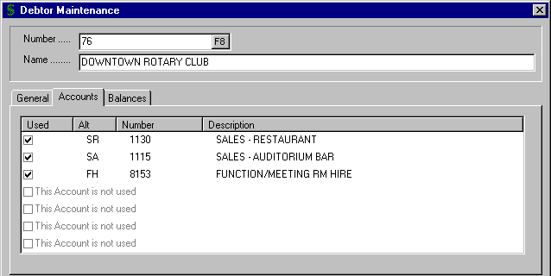

Click the check box in the “Used” column to display the “Lookup Account” window. Select the required Account. Repeat for as many Accounts as you want to set up for this Debtor (maximum of 7).

You are also able to view the aging of the “Total Outstanding” balance by clicking on the “Balances” tab.

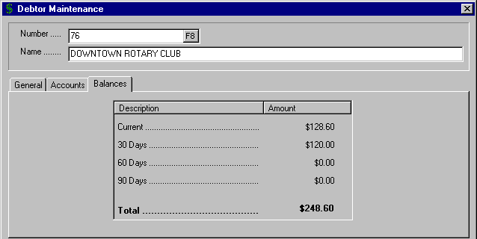

Click the “Save” button once all the details for the Debtor have been entered.
C3) MAINTENANCE – DEBTORS

a) DEBTOR MAINTENANCE (cont..)

- Change Debtor

To CHANGE the details stored for a Debtor, from the blank “Debtor Maintenance” screen enter the Debtor “Number” or use the F8 option to display the “Lookup Debtor” window and select the Debtor to be changed. The details of the selected Debtor are displayed.

Click the “Change” button. This then allows you to change each of the fields described in the Add Debtor section above on Pages 55-56.

- Delete Debtor

To DELETE a Debtor, from the blank “Debtor Maintenance” screen enter the Debtor “Number” or use the F8 option to display the “Lookup Debtor” window and select the Debtor to be deleted. The details of the selected Debtor are displayed.

Click the “Delete” button. A “Yes” response to the “Delete Debtor?” prompt will delete the Debtor.

Note that you are not able to delete a Debtor with transactions in the current Financial Year or with an outstanding balance.

b) DEBTOR LISTING

This routine allows you to print the Debtors set up on the system in either Debtor Number or Debtor Name order.

Select either the “Debtor Number” or “Debtor Name” sort sequence from the “Debtor Listing” window.

Click the “OK” button to print the listing. Select the required printer from the Windows “Print” screen.

C4) MAINTENANCE – TILLS

By selecting “Maintenance” from the Main Menu, the menu below is displayed.

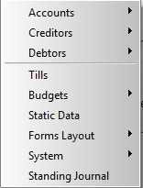

You need to set up details of your Tills if you plan to use the “Transactions – Debtor and Receipts – Tills Input” routine as described on Page 32.

 TIP : Tills as set up in this routine, do not necessarily have to be actual physical Tills. You can also set up Tills for Poker Machines, Raffles / Bingo, the Office. The Office Till would capture such items as Membership Renewals, Room Hire, Function Tickets, etc.

Selecting “Tills” from the Maintenance Menu, results in the “Till Maintenance” screen being displayed. It is from this screen that you determine the type of maintenance to be performed (i.e. Add , Change or Delete).

- Add Till

To ADD a Till, from the blank “Till Maintenance” screen click the “Add” button.

Enter the "Till Number" that will be used to identify the Till. This would logically match up with the Till numbers you use in your Stock Control system.

Enter the “Till Description”. The description should include some detail of the Till location to minimise errors during “Tills Input”.

The “GST Account” is displayed as set up in the “Maintenance – System – Control Accounts” routine detailed on Page 84.

Enter the Cash “Discrepancy” Account for this Till or use the F8 option to display the “Lookup Account” window and select the required one. During “Tills Input” any variation in the “Tape CASH” and the “CASH in Till” will be automatically allocated to this Account.

The next step is to enter the “Income Accounts” that would typically relate to the Till. For a ‘Bar Till’ you would list the appropriate Sales (Income) Accounts and these may be product based (i.e. Bulk Beer, Spirits, etc) or location based (i.e. Main Bar, Sports Bar, Restaurant, etc.).

For a ‘Poker Machine Till’ you would set up Clearances as an Income Account. For an ‘Office Till’ you would list Members Renewals, Joining Fees, Green Fees, Room Hire and any other sources of income processed through the Office. Your current Till Reconciliation sheet should give you an indication as to which Accounts relate to the different Tills.

You are able to either enter the “Income Accounts” or use the F8 option to access the “Lookup Account” window and select the required ones.

Once you have listed all the main “Income Accounts” you then set up any “Expense Accounts” that may be processed as part of the Tills Input for this Till. Again, your current Till Reconciliation sheet should give you an indication as to which Expense Accounts relate to the different Tills.

 TIP : It is not imperative that every possible Account that may ever be used for this Till is set up in the Income and Expense Accounts columns. All you need to do is include the most common Accounts as you are able to include “one-off” Income and Expense Accounts while you are in the “Tills Input” routine.

C4) MAINTENANCE – TILLS

- Add Till (cont..)

A completed “Till Maintenance” screen is shown below.

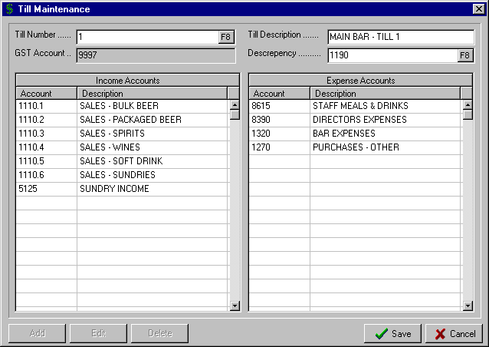
These are the main Income Accounts that are applicable to this Till. Having them listed already during Tills Input reduces errors and improves the speed of input of the daily Till Reconciliation
These are the main Expense Accounts that are applicable to this Till. You do not have to include every possible Account as you are able to add “one-off” Accounts during Till Input

- Edit Till

To EDIT the details stored for a Till, from the blank “Till Maintenance” screen enter the “Till Number” or use the F8 option to display the “Lookup Till” window and select the Till to be changed. The details of the selected Till are displayed.

Click the “Edit” button. This then allows you to change each of the fields described in the Add Till section above.

- Delete Till

To DELETE a Till, from the blank “Till Maintenance” screen enter the “Till Number” or use the F8 option to display the “Lookup Till” window and select the Till to be deleted. The details of the selected Till are displayed.

Click the “Delete” button. A “Yes” response to the “Are you sure you want to delete this Till?” prompt will delete the Till.

C5) MAINTENANCE – BUDGETS

By selecting “Maintenance” from the Main Menu, the menu below is displayed.

Accounts
Creditors
Debtors

Tills
Budgets
Forms Layout
System

This routine is used to set up Budgets on the system. You need to set up Budgets if you plan to include budget comparisons in the Summary reports or Management reports. The system allows up to 10 different budgets

The first step in entering a Budget into the system is to set up the name to be used for the budget in the routine “Maintenance – System – Budget Descriptions” as detailed on Page 85.

On entry to this routine the following functions are displayed:

- New  - This option allows you to set up a completely new Budget.

- Open  - This option is used to open an existing Budget previously saved. By clicking on this icon, the “Select Budget” window is displayed allowing you to select the Budget Description you have previously set up via “Maintenance – System – Budget Descriptions”.

Simply highlight the Budget Description to be used and click the “OK” button. The first Account numerically in your Chart of Accounts is then displayed allowing you to either enter the details in the appropriate fields or use the “Previous” and “Next” buttons to select different Accounts (see details below for automated options for entering the Budget)

- Save  - This routine allows you to save a new Budget for future use, or to retain the changes to an existing Budget. If the Budget you are to save is a “New” Budget then the “Select Budget” window is displayed allowing you to select the Budget Description to be used. If you want to save the changes to a Budget that you have opened then the prompt “Are you sure that you wish to overwrite this file” is displayed. Select “Yes” to save the changes.

- Globals - This routine allows you to define the Global Budget parameters that will apply for the selected Budget.

  - Default percentage Expense paid in month of Purchase - this is required to allow automatic calculation of the Payments budget based on the level of Purchases. The percentage entered here is the default entry and can be varied for individual Accounts as required. In the example below, 70% of Purchases are paid in the month of Purchase, with the remaining 30% assumed to be paid in the next month.

  - Default percentage Sales on Credit – this is required to accurately calculate the Receipts budget. It allows you to define the percentage of total Income that is sold on Credit, and the percentage of the Credit Income collected in the Current, 30 day, 60 day and 90 day periods. It effectively allows you to detail, for each Income Account, your expected cash flow based on the level of sales entered in the Income column.

In the example below, 10% of the club’s Income is sold on Credit, with 30% collected in the Current month, 55% in 30 days, 10% in 60 days and 5% in 90 days.

C5) MAINTENANCE – BUDGETS

A sample “Budget Global Maintenance” screen is shown below:

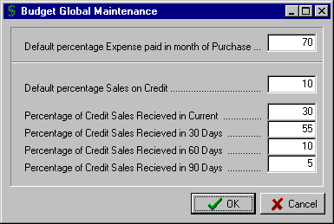

- Previous - This allows you to display the details of the previous Account (in numerical order) in your Chart of Accounts

- Next - This allows you to display the details of the next Account (in numerical order) in your Chart of Accounts

Once an Account has been selected, there are a number of options available for the entry of the budget figures. The obvious option is the manual entry of the details in the required fields, however, the system does provide for a number of more efficient and advanced procedures.

The “Budget Maintenance” screen displays the five columns available for the entry of budget details for each Account e.g. Income, Expenditure, Journal, etc. The options vary depending on which column is selected. Set out below is the instructions for:

a) Income and Expenditure columns
b) Receipts column
c) Payments column
d) Journal column

a) Income and Expenditure Columns

By clicking on the “Income” or “Expenditure” column headings the system displays a menu with the following options for entry of the budget:

- Equal Period Values

This option is convenient where the budgeted amount for each Period is a set figure. Enter the Period “Value" as required. The system will enter the value in each of the Periods for the selected column. For example, entering 2000 as the "Value" will result in 2000 being inserted for each Period.

- Annual Value

This option is used where you want to enter the Annual Budget for the Account and have the system divide the budget equally over the number of Accounting Periods set. Enter the total “Value" as required. The system will divide the total “Value" by the number of Periods and insert the Period value for the selected column. For example, entering 36000 as the "Value" will result in 3000 being inserted for each Period, assuming a 12-month budget.

C5) MAINTENANCE – BUDGETS

a) Income and Expenditure Columns (cont..)

Further options available by clicking on the “Income” or “Expenditure” column headings include:

- Percentage of Income of Other Accounts

This option allows a budget to be set for an Account based on the level of Income of another Account, or series of Accounts. For example, the budget for Cleaning Wages may be based on a fixed element per month plus a percentage based on the Income through Private Functions.

In the example shown below, the budget for Cleaning Wages is made up of a "Fixed Value" of 1000 per Period with a "Percentage of Value of above accounts” of 5. This "Percentage" is calculated on the level of Income in the Sales - Private Functions Account budget.

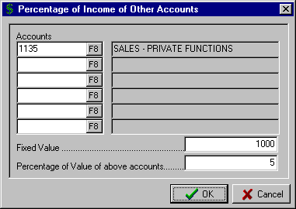
Access the Accounts to be included by entering the Account Number or by using the F8 option.

You can specify up to six different Accounts in the calculation

- Percentage of Expenditure of Other Accounts

This option allows a budget to be set for an Account based on the level of Expenditure of another Account, or series of Accounts.

For example, the budget for Bar Wastage may be based on a fixed value per Period plus a percentage based on the Bar Purchases for Bulk Beer, Soft Drink, and Wines & Spirits. The instructions for this option are identical to the one above.

- Increment Period Values by Percentage

This option is relevant when you want to set a budget for the first Period and then have it increase by a set percentage for each subsequent Period. Enter the "Base Value" as required. Enter the "Increment” percentage you want the system to increment for each Period.

An example would be where you set the Bar Sales for Period 1 at 100000 and have the system add say 1% for each Period thereafter.

- Increment Period Values by Set Amount

This option is relevant when you want to set a budget for the first Period and then have it increase by a set value for each subsequent Period. Enter the "Base Value" as required. Enter the value "Increment" you want the system to add for each Period.

An example would be where you set the Bar Sales for Period 1 at 100000 and have the system add say 10000 for each Period thereafter

C5) MAINTENANCE – BUDGETS

a) Income and Expenditure Columns (cont..)

Further options available by clicking on the “Income” or “Expenditure” column headings include:

- Ratio of Income of Other Accounts

This option allows a budget to be set for an Account based on the level of Income of another Account, or series of Accounts. For example, the budget for Wages may be based on a fixed element per month plus a value based on the Bar Sales and Poker Machine Takings.

In this example the budget for Wages is made up of a "Fixed element" of 20000 per Period with a "Value to ratio" of 100000. This "Value to ratio" will be apportioned on the basis of the level of Income in the two Income Accounts (i.e. Bar Sales and Poker Machine Takings)

- Ratio of Expenditure of Other Accounts

This option allows a budget to be set for an Account based on the level of Expenditure of another Account, or series of Accounts. For example, the budget for Bar Freight may be based on a fixed element per month plus a value based on Bar Purchases for Bulk Beer, Package Beer, Wine & Spirits.

In this example the budget for Bar Freight is made up of a "Fixed element" of 200 per Period with a "Value to ratio" of 1500. This "Value to ratio" will be apportioned on the basis of the level of budgeted Purchases in the three Bar Purchase Accounts.

b) Receipts Column

By clicking on the “Receipts” column heading the system displays the “Receipts Collection” window and allows you specify for the selected Account, the “Percentage of Sales on Credit” and the percentage breakup of when the sales made on credit are received. The details are the same as described in the “Globals” option described above on Page 60.

c) Payments Column

By clicking on the “Payments” column heading the system displays a menu with the following options for entry of the payment details in the budget:

- Use Global Default

Selecting this option, which is the default option, will set up the Payments budget based on the "Default percentage Expense paid in month of Purchase" as specified in the "Globals” parameters as described on Page 60.

- Period Input

Allows you to enter the Payments for each Period as required, overriding the "Globals” parameters set for this budget.

- Payments as Ratio This Month and Last Month

Allows you to specify the percentage of the Purchases for this Account that will be paid in the current month with the balance paid in the next month. This option applies when you want to override the "Globals” parameters percentage, only for selected Accounts.

d) Journal Column

The only option for the Journal column is to manually enter the budget details for each Period.

C5) MAINTENANCE – BUDGETS

SETTING UP A BUDGET

The steps involved in the initial set up or maintenance of an existing Budget are as follows:

- For a new Budget, via the routine “Maintenance – System – Budget Descriptions” as detailed on Page 85, enter the name to be used for the new Budget.

- Then via this routine, select the “Open” option to display the “Select Budget” window and select the required Budget.

- If required, you should next set up the “Globals” parameters for this Budget (see above for an explanation of the options on Page 60)

- The first Account in the Chart of Accounts is then displayed. You are then able to enter the relevant Budget details in the “Income”, “Receipts”, “Expenditure”, “Payments” or “Journal” fields for the different Periods. Alternatively, use the automated option by clicking the relevant column headings as described above.

- Use the “Previous” or “Next” buttons to display the required Account and edit the details.

- The option exists to select a specific Account from the Chart of Accounts by using the F8 option in the “Account” field. This then displays the full Chart of Accounts allowing you to select the required Account. You will notice that Accounts that have budget details entered are shown in black and those with no budget details shown in red. This helps to quickly identify Accounts that require budget details to be entered.

- The last step in the setting up of a Budget is to select the “Save” button. If you are setting up a new Budget then the “Select Budget” window is displayed allowing you to select the relevant Budget Description. If you are saving an existing Budget then the prompt “Are you sure that you wish to overwrite this file” is displayed. Select “Yes” to save the changes.

A sample “Budget Maintenance” screen is shown below for an Income Account with the parameters for Sales on Credit and the percentage of Credit Sales Received by Period, as per the example in the “Globals” area.

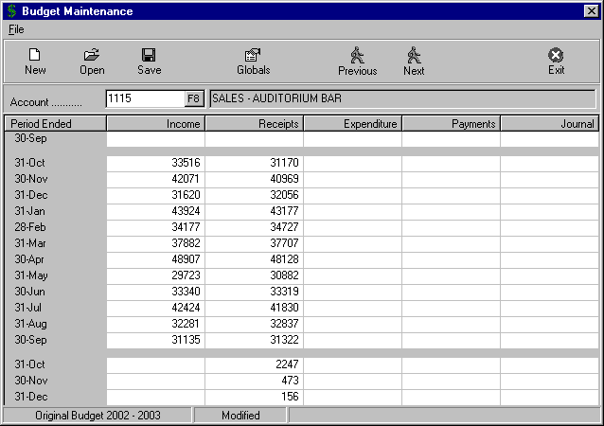
Name of Budget
The Receipts budget was calculated automatically based on the setting in the “Globals” parameters.

C6) MAINTENANCE – FORMS LAYOUT

By selecting “Maintenance” from the Main Menu, the menu below is displayed.

Debtor Statements
Debtor Invoices

Creditor Statements
Creditor Cheques / Remittance
Trading / P+L / Bal Sheet
Management Reports Rows
Management Reports Columns

Till Summary Layout

Accounts
Creditors
Debtors

Tills
Budgets
Forms Layout
System

Selecting “Forms Layout” from the Maintenance Menu, results in the sub-menu to the right being displayed.

a) DEBTOR STATEMENTS

This routine provides the facility to set up the layout to be used for Debtor's Statements printed on the system. With the various options to include fields, text and images you are able to design professional looking Statements without going to the expense of pre-printed forms.

To be able to set up and maintain a Debtors Statement in the “Design” screen, you will need to understand the icons at the top of the screen. Detailed explanations for each icon are provided below.

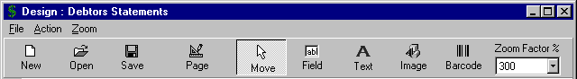

The functions available in the “Design” screen are as follows:

- New  - On entry to the routine, the system sets up a new Design. You may have attempted to set up a Design and decided not to save it and start again. Selecting the “New” icon gives you the chance not to save the existing one and to start with a blank design.

- Open  - This option is used to open an existing Design previously saved. By clicking on this icon, the “Open” window is displayed allowing you to select the file you require. Highlight the file required and click the “Open” button to retrieve the design to your “Design” screen.

- Save  - This routine allows you to save a new Design for future use, or to retain the changes to an existing file. The procedure is similar to saving a file in any Windows product. Once you click on the icon, you are prompted to confirm the location “Save in” (e.g. Data) and then to enter the “File name” that you want to call the Design (e.g. Debtor Statement 1, DebtStat, etc.). Click on the “Save” button to finish.

- Page - This routine allows you to define the size of your document and the margins you want to set. The actual Page Size and the Orientation is set up in your Printer Setup routine. In the example below, the “Document Size” has been left as the default, (i.e. A4 Portrait – 190mm x 277mm). The “Margins” have been set at 10mm Across and 10mm Down.

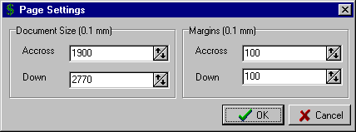

C6) MAINTENANCE – FORMS LAYOUT

a) DEBTOR STATEMENTS (cont..)

Additional functions included in the “Design” screen are as follows:

- Move  - The “Move” icon is used to position Fields, Text and Images in the design screen. When you click on this icon you are effectively in change mode and so can click on a Field, Text or Image and after highlighting it, you can drag it to another position in the design screen.

Another option in this mode is to highlight a Field or Text and then right click with the mouse. This then allows you to “Edit” a Field/Text or “Delete” it.
Edit
Delete

Send to Back
Bring to Front

Cancel

This is useful if you inadvertently included more than the required number of a certain Field or Text and want to delete the ones not needed. Also it is handy if you need to change the wording of a Text. It is simpler to edit the Text rather than deleting it and then adding a new one. You are also able to use the “Send to Back” and “Send to Front” options to have certain Text or Fields more prominent than others or for special background effects.

- Field - The “Field” icon is used to create new Fields for insertion into the Design in both the Heading section and the Transaction section. Fields in this case are those stored in the Debtors to be included in the Debtor Statement. In the example on Page 70, all the Fields available have been included.

To activate this option, firstly click on the “Field” icon at the top of the screen. Then click on the Heading section of the “Design” screen you want to position the Field. The “Field Properties” screen for Headings, as shown below, is then displayed.

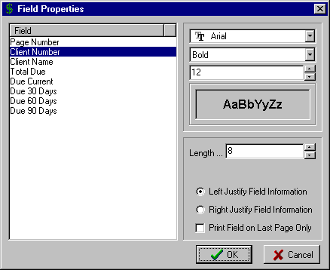

With the above screen displayed, click on the Field to be included in the “Design” screen.
In the above example the Client Number Field has been selected.

You then have the option to select the Font (e.g. Arial, Times Roman, etc), Text Effects (e.g. Bold, Italic) and the Size of the Font. Use the  button to display the options.

The system displays the maximum “Length” of the selected Field. If you need to shorten the number of characters printed for this Field then click in the “Length” text box and type in the required number or use the and  buttons to adjust.

C6) MAINTENANCE – FORMS LAYOUT

a) DEBTOR STATEMENTS (cont..)

Additional functions included in the “Design” screen are as follows:

- Field (cont..) - The option is then provided to “Left or Right Justify Field Information”. This is useful if you want the Field to always start printing from a particular position on your Statement regardless of the length of the Field (e.g. the Client Number). The default setting is Left Justified and you can change this if required.

The final option in the “Field Properties” screen is the option to “Print Field on Last Page Only”. This would be used for example for the “Total Due” Field as if there were more than one page for a particular Debtor’s Statement then you would only want the Total Due to print on the last page.

Finalise the input for the above screen, select the “OK” button and the Field is inserted in the “Design” screen. Use the “Move” option to position the Field, as required.

To insert Fields in the Transaction section of the “Design” screen, click on the first line of the Transaction table (it is shown as white on the screen). You will notice that the “Field Properties” screen is different from when you click on the Heading section. The principles are identical, however, to those described above.

- Text - The “Text” icon is used to insert Text into the Design. This Text may be Field Descriptions, explanatory notes, general text or whatever static details are required in your document. In the example on Page 70, you will see how Text has been used in combination with Fields and Images to create the complete document.

To activate this option, firstly click on the “Text” icon at the top of the screen. Then click on the section of the “Design” screen you want to position the Text. The “Text Properties” screen, as shown below, is then displayed.

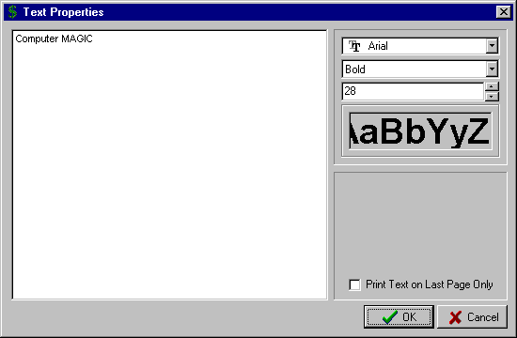
To start entering text, click anywhere inside the “Text Properties” box.

A cursor appears in the top left corner and you start typing the text you require.

This provides a sample of how the settings you have selected
(i.e. Font, Text Effects and Size) will appear in your Design

 TIP : You can set up as many different Text entries in your design as you require. It provides more flexibility having a number of small entries rather than one large entry, as you can then use the “Font” and “Size” facility to set up different effects for each Text entry. You will see this in the example on Page 70.

C6) MAINTENANCE – FORMS LAYOUT

a) DEBTOR STATEMENTS (cont..)

Additional functions included in the “Design” screen are as follows:

- Image - The “Image” icon is used to insert Images into the Design. These Images may be photos, images, company logo, clip art, etc. In the example on Page 70, you will see that a logo has been inserted in the design.

To activate this option, firstly click on the “Image” icon at the top of the screen. Then click on the section of the “Design” screen you want to position the Image. The Windows “Open” screen appears, allowing you to locate the Image you want to insert. Clicking on the “Open” button with the required Image shown will result in the Image being inserted in the “Design” screen.

Use the “Move” option to position the Image in the document, as required.

- Barcode - The “Barcode” icon is used to insert Barcodes into the Design.

To activate this option, firstly click on the “Barcode” icon at the top of the screen. Then click on the section of the “Design” screen you want to position the Barcode. The Windows “Open” screen appears, allowing you to locate the Barcode file you want to insert. Clicking on the “Open” button with the required Barcode shown will result in the Barcode being inserted in the “Design” screen.

Use the “Move” option to position the Barcode in the document, as required.

- Zoom Factor %- This option provides a complete range of “zoom” percentages. It effectively allows you to zoom in and out on the contents of your design, assisting you in viewing and editing the design.

Click on the  button to display the options. Simply select the percentage that is appropriate for you to view your design. The larger the percentage the more magnified is the design. The default setting is 300%.

- File Menu - Selecting the “File” menu at the top of the Design screen displays some further options. The “New”, “Open”, “Save” and “Page Setup” options have been described above.

  - Print - This routine allows you to print the design layout for checking.

  - Exit - This option allows you to exit the routine. Be sure to save your document before exiting.

- Action Menu - This menu lists the functions that have individual icons at the top of the Design screen.
    - Move
    - Field
    - Text
    - Image
    - Barcode
The details of each of these options have been outlined above.

- Zoom Menu - This menu lists the different zoom percentages available to view the design.

 TIP : Once your design has a combination of Fields and Text, it can become confusing as to which is a Field and what is Text. The boxes with a blue outline are Fields and the boxes with a brown outline are Text. Also, as you move your mouse pointer over a Field, the system displays the full Field Description.

C6) MAINTENANCE – FORMS LAYOUT

a) DEBTOR STATEMENTS (cont..)

SETTING UP A DOCUMENT DESIGN

Set out below are the steps you would normally take in designing a Debtors Statement using the “Design” screen. It is assumed you have already read the section above describing the function of each of the icons.

  - Go into “Debtor Statements” from the “Maintenance – Forms Layout” Menu. The system starts with a blank layout.

  - Next, select the “Page” icon or “Page Setup” from the “File” menu, to set up the parameters of the stationery you plan to use for the Debtors Statement.

Refer to the instructions on Page 65, for how to set up the “Page” settings.

  - Expand the Transaction “table” that appears in the blank design to the size and number of lines you require. This effectively is the body of your Debtor Statement and will contain the transactions for each Debtor. You expand the “table” by dragging the “fill handle” on the bottom right corner of the “table”. The system displays the number of lines that you have set for the “table”.

Select the “Move” icon to position the “table” where you require it in the Debtor Statement.

  - Select the “Field” icon and commence selecting the Fields to be included. You can set the Font and Size of the Field at this stage or Edit the settings at a later stage. As you select each Field from the “Field Properties” window, the system returns you to the Design screen to allow you to position the Field. Use the “Move” icon to position the Field, as required. Remember that there are effectively two parts of the form, the Heading section with its own set of Fields and the Transaction section with different Fields.

Refer to the instructions on Pages 66 & 67 for the options with selecting Fields

  - Next, select the “Image” icon and include any image, logo or photo you require in your Debtor Statement. As you select each Image, the system returns you to the Design screen to allow you to position the Image. Use the “Move” icon to position the Image, as required.

Refer to the instructions on Page 68 for the options with selecting Images

  - Once all the required Fields and Images have been inserted and in the correct position, next select the “Text” icon and set up the Text you want to use. As you complete each Text entry from the “Text Properties” window, the system returns you to the Design screen to allow you to position the Text. Use the “Move” icon to position the Text, as required.

Refer to the instructions on Page 67 for the options with selecting Text

  - Use the “Move” option to position all the elements in your document design and change the “Zoom Factor %”, to view the completed design. With the “Move” option selected, you can right click on any Field or Text entry and either edit or delete the entry.

  - Once happy with the Document Design, select the “Save” icon and allocate an appropriate name. (Refer to the instructions on Page 65 for the “Save” routine)

  - If you want to print the layout for checking, then use the “Print” option in the “File” menu.

Refer to the instructions on Page 68 for the “Print” routine.

  - If you need to edit the Document Design then select the “Open” icon and retrieve the file from your data directory. Don’t forget to save your design after making any changes.

Refer to the instructions on Page 65 for the “Open” routine.

C6) MAINTENANCE – FORMS LAYOUT

a) DEBTOR STATEMENTS (cont..)

An example of a completed “Design : Debtors Statements” screen is shown below.

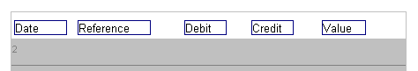
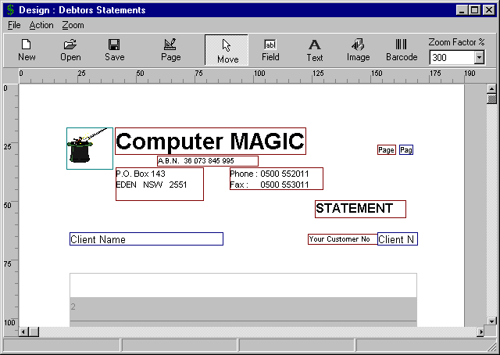
Note the Company Logo as an Image
These are Text boxes with different Font Sizes
This is the Transaction “table”. You will notice that the Fields are different to the Heading section above

b) DEBTOR INVOICES

This routine provides the facility to set up the layout to be used for Debtor's Invoices printed on the system. The Debtor Invoices are printed via the “Transactions – Debtor and Receipts – Debtors Invoicing – Print Invoices” routine as described on Page 36. With the various options to include Fields, Text and Images you are able to design professional looking Invoices without going to the expense of pre-printed forms.

The steps involved in the design of a Form Layout for a Debtor Invoice is very similar to that for a Debtor Statement as detailed on Pages 65 – 69 above. We suggest that you refer to that section of the manual prior to attempting to set up a layout for your Debtor Invoice.

The only difference between the design routine for a Debtor Invoice and a Debtor Statement (as described in detail above) is the number and types of Fields that you can insert in your Debtor Invoice layout.

The Debtor Invoice “Fields” available for insertion in your layout in the Heading section are:

- Page Number | - Reference
- Client Number | - Invoice Date
- Client Name | - Invoice Value

The Debtor Invoice “Fields” available for insertion in your layout in the Transaction section are:
- Description
- Value

All other aspects of the design routine are identical.

C6) MAINTENANCE – FORMS LAYOUT

c) CREDITOR STATEMENTS

This routine provides the facility to set up the layout to be used for Creditor Statements printed on the system. The Creditor Statements are printed via the “Reports – Expenditure / Creditors – Creditor Reports – Print Statements” routine as described on Page 98.

With the various options to include Fields, Text and Images you are able to design professional looking Statements without going to the expense of pre-printed forms.

The steps involved in the design of a Form Layout for a Creditor Statement is very similar to that for a Debtor Statement as detailed on Pages 65 – 69 above. We suggest that you refer to that section of the manual prior to attempting to set up a layout for your Creditor Statement.

The only difference between the design routine for a Creditor Statement and a Debtor Statement (as described in detail above) is the number and types of Fields that you can insert in your Creditor Statement layout.

The Creditor Statement “Fields” available for insertion in the Heading section of your layout are:
- Page Number
- Client Number
- Client Name
- Total Due

The Creditor Statement “Fields” available for insertion in the Transaction section of your layout are:
- Date
- Reference
- Value

All other aspects of the design routine are identical.

d) CREDITOR CHEQUE / REMITTANCE

This routine provides the facility to set up the layout to be used for the Creditor Cheques & Remittance Advices printed on the system. The Creditor Cheques & Remittance Advices are printed via the “Transactions – Creditor and Payment – Immediate Cheque” routine (see Page 17 for details) and “Transactions – Creditor and Payment – Write Cheques Auto” routine (see Page 19 for details).

The steps involved in the design of a Form Layout for a Creditor Cheque & Remittance Advice is very similar to that for a Debtor Statement as detailed on Pages 65 – 69 above. We suggest that you refer to that section of the manual prior to attempting to set up a layout for your Creditor Cheque & Remittance Advice.

The only difference between the design routine for a Creditor Cheque & Remittance Advice and a Debtor Statement (as described in detail above) is the number and types of Fields that you can insert in your Creditor Cheque & Remittance Advice layout.

The Creditor Cheque & Remittance Advice “Fields” available for insertion in your layout are:

- Page Number | - Payee Address
- Cheque Number | - Amount in Figures
- Cheque Date | - Amount in Words
- Payee Name

The Creditor Cheque & Remittance “Fields” available for insertion in the Transaction section of your layout are:
- Transaction Date
- Transaction Reference
- Transaction Value

All other aspects of the design routine are identical.

C6) MAINTENANCE – FORMS LAYOUT

e) TRADING / PROFIT & LOSS / BALANCE SHEET

This routine provides the facility to set up multiple report formats for Trading Statements, Profit & Loss Statement and Balance Sheet. As the reporting requirements vary greatly from one organisation to another, the Cash Management system has been designed to provide the utmost in flexibility as to how the reports are set out. By allowing totally free-form report formats, there is no need to include Heading, Total and Spacing Accounts in your Chart of Accounts.

On entry to the routine, the “Report Designer” screen is displayed. The options available then are as follows:

- New  - On entry to the routine, the system sets up a new Report Design. You may have attempted to set up a Report Design and decided not to save it and start again. Selecting the “New” icon allows you to not save the existing one and to start with a blank design.

- Open  - This option is used to open an existing Report Design previously saved. By clicking on this icon, the “Open” window is displayed allowing you to select the file you require. Highlight the file required and click the “Open” button to retrieve the design to your “Report Designer” screen.

- Save  - This routine allows you to save a new Report Design for future use, or to retain the changes to an existing file. The procedure is similar to saving a file in any Windows product. Once you click on the icon, you are prompted to confirm the location “Save in” (e.g. Data) and then to enter the “File name” that you want to call the Report Design (e.g. Financial Statement, FinStat3, etc.). Click on the “Save” button to finish.

- Add - This option allows you to add another line to your Report Design. By selecting the “Add” option the “Report Designer Line Editor” is displayed. This is the main window you will use to define the Report Design. Refer to the section below titled “Line Editor Options” for complete instructions.

- Insert - This option allows you to insert a line in your Report Design. The line is inserted above the line you have highlighted. By selecting the “Insert” option the “Report Designer Line Editor” is displayed. This is the main window you will use to define the Report Design. Refer to the section below titled “Line Editor Options” for complete instructions.

- Edit - This option allows you to edit an existing line within your Report Design. By selecting the “Edit” option the “Report Designer Line Editor” is displayed. This is the main window you will use to define the Report Design. Refer to the section below titled “Line Editor Options” for complete instructions.

- Delete - This option allows you to delete a line in your Report Design. Simply highlight the line and select the “Delete” button. A “Confirm” prompt is displayed before the deletion.

- Exit - This option allows you to exit the Report Designer screen. Be sure to “Save” your Report Design before exiting.

** LINE EDITOR OPTIONS **

The majority of the Report Design is completed within the “Report Designer Line Editor” and so the following section steps through the various options available from this screen. By selecting either the “Add”, “Insert” or “Edit” options from the Report Designer screen the “Report Designer Line Editor” is displayed.

On entry to the “Report Designer Line Editor” the first field to be selected is the “Type” of line that you want to add to your Report Design. The details that need to be specified depend on the selection you make in this field and so each will be treated separately.

Clicking on the  button accesses the available options within the “Type” field. These are the “Line Types” that effectively define the report. Once you have a clear understanding of each of them, the setting up and maintaining of a report format is a simple task.

C6) MAINTENANCE – FORMS LAYOUT

e) TRADING / PROFIT & LOSS / BALANCE SHEET

** LINE EDITOR OPTIONS (cont..) **

The options within the “Type” field are as follows:

  - Account Formula - This is the default “Type” displayed on entry to the routine. It is used to enter your General Ledger Accounts into the Report Design. It allows for a single Account per line or a combination of Accounts.

With this “Type” selected you set up the Account(s) to be included in the bottom section of the screen. The options then are:

    - Add - selecting the “Add” option opens up the “Account Lookup” screen. Select the Account to be included in the line. The selected Account is then displayed in the bottom section of the screen. If you want to combine Accounts together then repeat the above step as many times as required. In the example below a number of Bar Sales Accounts have been added together and will be displayed as one line on the report.

    - Insert - selecting the “Insert” option allows you to insert another Account in the bottom section of the screen. The system inserts the entry immediately before the highlighted line. Again you select the Account from the “Account Lookup” screen.

    - Edit - selecting the “Edit” option allows you to edit an Account entry in the bottom section of the screen. This is used if the selected Account needs to be changed. Highlight the entry to be changed and click the “Edit” button. Again you select the required Account from the “Account Lookup” screen.

    - Delete - selecting the “Delete” option allows you to remove an Account entry in the bottom section of the screen.

    - + Sign - selecting the “+ Sign” allows you to change the sign in the combination of Accounts in the bottom section of the screen. If you were netting two Accounts on the one line of your report (e.g. Raffle Income and Raffle Expenses) then this option allows you to change the sign relative to the Accounts (i.e. + (plus) to (minus) or vice versa

    - Move - selecting the “Move” option allows you to change the order in which the Accounts appear in the bottom section of the screen. Simply highlight an entry and drag it to the position required. Click the “Move” button again to exit this option.

Once you have set up the required Account(s) to be included in the “Account Formula” you then complete the top section of the screen. The other fields are:

    - Column - the option is provided to print the line in the “left” offset column, the “right” offset column or both offset columns in the report (useful for underlines).

    - Selective - the option is provided to “Always Print” the line even if the result of the
Print Formula is zero, to “Only Print if Positive” (use this option for entries such
as Cash at Bank and Bank Overdraft where you only want the entry to print if a positive value exists) or “Only Print if Not Zero”

    - Font Size - this allows you to select the size of the Font and the Style (Bold, Italic) for
Style this line of the report.

    - Debit or - this allows you to select whether the line will be shown as “Positive if Debit”
Credit (Expenses and Assets section) or “Positive if Credit” (Income and
Liabilities section)

    - Report - this allows you to type the line of text that you want included in the report for
Text this Account Formula.

C6) MAINTENANCE – FORMS LAYOUT

e) TRADING / PROFIT & LOSS / BALANCE SHEET

** LINE EDITOR OPTIONS (cont..) **

  - Account Formula (cont..)

A sample “Report Designer Line Editor” screen for an “Account Formula” is shown below:

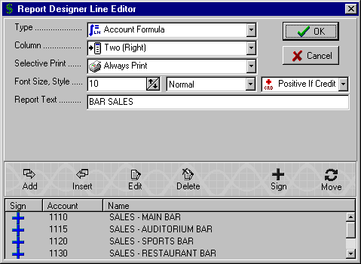

You will note that in the above example there are four Sales Accounts added together under the Report Text of “BAR SALES”. The value will be printed in the right column and will be shown in the report as a positive if the balance of the Account Formula is a Credit. Select the “OK” button to complete the report line and return it to the “Report Designer” screen.

Other options within the “Type” field are as follows:

  - Line Formula - This line “Type” is used to combine different lines of the report that are not consecutive. The lines may be added together or subtracted from each other. It is ideal where you want to consolidate different sections of the report that have been sub-totaled.

With this “Type” selected you set up the Lines to be included in the bottom section of the screen. The options then are:

    - Add - selecting the “Add” option opens up the “Report Designer” screen. Select the lines to be included in the Line Formula. The selected lines are then displayed in the bottom section of the screen.

    - Delete - selecting the “Delete” option allows you to remove an Line entry in the bottom section of the screen.

Once you have set up the required Lines to be included in the “Line Formula” you then complete the top section of the screen. The other fields are:

    - Column - the option is provided to print the line in the “left” offset column or the “right” offset column in the report.

    - Selective - the option is provided to “Always Print” the line even if the result of the
Print Formula is zero, to “Only Print if Positive” or “Only Print if Not Zero”

C6) MAINTENANCE – FORMS LAYOUT

e) TRADING / PROFIT & LOSS / BALANCE SHEET

** LINE EDITOR OPTIONS (cont..) **

  - Line Formula (cont..)

Continuing the fields required in the top section of the screen:

    - Font Size - this allows you to select the size of the Font and the Style (Bold, Italic) for
Style this line of the report.

    - Report - this allows you to type the line of text that you want included in the report for
Text this Line Formula.

A sample “Line Formula” definition is shown below.

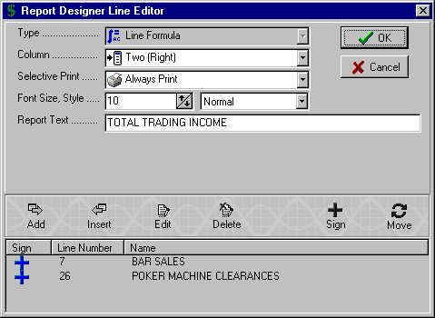

You will note that in the above example there are two Lines added together (Line Numbers 8 and 20) under the Report Text of “TOTAL TRADING INCOME”. The value will be printed in the right column.

Select the “OK” button to complete the report line and return it to the “Report Designer” screen.

Other options within the “Type” field are as follows:

  - Line Percentage - This line “Type” is used to calculate the percentage of one line in the report relative to another (e.g. Bar Wages as a percentage of Bar Sales)

The details required for this line “Type” are as follows:

    - Line 1 - In the bottom section of the screen use the F8 key to display the “Report Designer” screen and select the first line of the percentage formula. The percentage formula is calculated as Line 1 ÷ Line 2 x 100.

    - Line 2 - In the bottom section of the screen use the F8 key to display the “Report Designer” screen and select the second line of the percentage formula. The percentage formula is calculated as Line 1 ÷ Line 2 x 100.

C6) MAINTENANCE – FORMS LAYOUT

e) TRADING / PROFIT & LOSS / BALANCE SHEET

** LINE EDITOR OPTIONS (cont..) **

  - Line Percentage (cont..)

Continuing the fields required in the top section of the screen:

    - Column - the option is provided to print the line in the “left” offset column or the “right” offset column in the report.

    - Selective - the option is provided to “Always Print” the line even if the result of the
Print Formula is zero, to “Only Print if Positive” or “Only Print if Not Zero”

    - Font Size - this allows you to select the size of the Font and the Style (Bold, Italic) for
Style this line of the report.

    - Report - this allows you to type the line of text that you want included in the report for
Text this Line Percentage.

A sample “Line Percentage” definition is shown below.

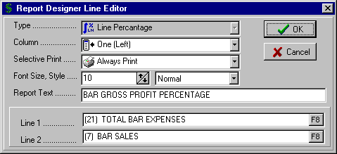

In the above example the figure for “TOTAL BAR EXPENSES” will be divided by “BAR SALES” and multiplied by 100. The result will be represented as a percentage in the report with the text “BAR GROSS PROFIT PERCENTAGE”.

Other options within the “Type” field are as follows:

  - Line Sum Range - This line “Type” is used to add lines on the report that are consecutive (e.g. a range of Expense Accounts).The details required for this line “Type” are as follows:

    - Line 1 - In the bottom section of the screen use the F8 key to display the “Report Designer” screen and select the first line of the Line Sum Range.

    - Line 2 - In the bottom section of the screen use the F8 key to display the “Report Designer” screen and select the last line of the Line Sum Range.

Continuing the fields required in the top section of the screen:

    - Column - the option is provided to print the line in the “left” offset column or the “right” offset column in the report.

    - Selective - the option is provided to “Always Print” the line even if the result of the
Print Formula is zero, to “Only Print if Positive” or “Only Print if Not Zero”

    - Font Size - this allows you to select the size of the Font and the Style (Bold, Italic) for
Style this line of the report.

C6) MAINTENANCE – FORMS LAYOUT

e) TRADING / PROFIT & LOSS / BALANCE SHEET

** LINE EDITOR OPTIONS (cont..) **

  - Line Sum Range (cont..)

    - Report - this allows you to type the line of text that you want included in the report for
Text this Line Sum Range.

A sample “Line Sum Range” definition is shown below.

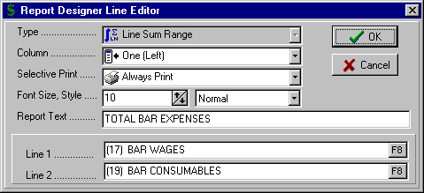

Other options within the “Type” field are as follows:

  - Blank Line - This line “Type” is used to add a blank line in the report. It is helpful in making the report easier to read and for spacing out different sections in the report.

  - Text - This line “Type” is used to add lines of Text in the report. These could be headings, explanatory notes, etc. that are helpful in making the report simpler to read.

The details required for this line “Type” are as follows:

    - Font Size - this allows you to select the size of the Font and the Style (Bold, Italic) for
Style this line of the report.

    - Report - this allows you to type the line of text that you want included in the report for
Text this line.

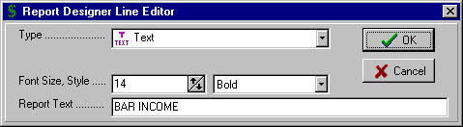

  - Page Break - This line “Type” is used to insert a Page Break at any point in the report. This allows you to set up Notes, Trading Statements, etc and keep them separate from your Financial Reports. It also allows you to dictate the logical point at which the reports should set up a new page with appropriate Headings, etc.

C6) MAINTENANCE – FORMS LAYOUT

e) TRADING / PROFIT & LOSS / BALANCE SHEET

** LINE EDITOR OPTIONS (cont..) **

Further options within the “Type” field are as follows:

  - Single Line - This line “Type” is used to add a single underline in the report. It is helpful in making the report easier to read and for highlighting Totals. The only item to be specified is in which “Column” the underline is to print (i.e. Left or Right).

  - Double Line - This line “Type” is used to add a double underline in the report. It is helpful in making the report easier to read and for highlighting Totals. The only item to be specified is in which “Column” the underline is to print (i.e. Left or Right).

  - Heading Balance - This line “Type” is used to add a Heading for the Balance Sheet part of the report
Sheet

  - Heading Profit & - This line “Type” is used to add a Heading for the Profit & Loss section of the report
Loss

  - Heading Notes - This line “Type” is used to add a Heading for the Notes section of the report

  - Column Heading - This line “Type” is used to dictate where the Heading will print for the Columns containing values for Last Year and the Current Year. The actual text for the Column Headings is entered as you print the report.

A sample “Report Designer” screen is shown below. The option is provided to preview how the report will look by selecting the “File – Preview Report” option.

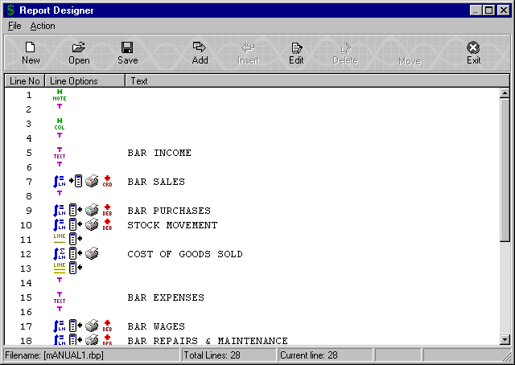

C6) MAINTENANCE – FORMS LAYOUT

f) MANAGEMENT REPORTS ROWS

This routine is the first step in setting up the layout for Management Reports. Complete flexibility in what is included down the report (Rows) and across the report (Columns) is provided by the system. Different report layouts can be saved for subsequent use and edited as required.

It is in this routine that you specify the Rows for the report.

The input of the layout is very similar to the entry of the Row detail for the Profit/Loss and Balance Sheet as described in the section above "Trading / P&L / Bal Sheet". You should refer to that section for complete instructions.

There are some minor differences and these are detailed below:

* No Column Offset - you do not need to enter the “Column” to offset details as all column settings are laid out in the “Management Report Columns” routine described below.

* No Column Heading - column headings for the value columns are specified in the “Management Report Columns” routine described below.

* No Page Headings - whereas the "Trading / P&L / Balance Sheet" layout included Heading types for Notes, Profit/Loss and Balance Sheet, the Management Report layout has a free format Page Heading that is repeated on subsequent pages until replaced by a new Page Heading.

* No Preview Report option - as the Columns at this stage are not defined, the facility for displaying how the report will print is not available.

g) MANAGEMENT REPORTS COLUMNS

This routine is where you specify the Columns for the Management Report.

On entry to the routine, the “Management Report Columns” screen is displayed. The options available then are as follows:

- New  - On entry to the routine, the system sets up a new Report Design. You may have attempted to set up a Report Design and decided not to save it and start again. Selecting the “New” icon allows you to not save the existing one and to start with a blank design.

- Open  - This option is used to open an existing Report Design previously saved. By clicking on this icon, the “Open” window is displayed allowing you to select the file you require. Highlight the file required and click the “Open” button to retrieve the design to your “Management Report Columns” screen.

- Save  - This routine allows you to save a new Report Design for future use, or to retain the changes to an existing file. The procedure is similar to saving a file in any Windows product. Once you click on the icon, you are prompted to confirm the location “Save in” (e.g. Data) and then to enter the “File name” that you want to call the Report Design (e.g. Board Report, Mgt Report 1, etc.). Click on the “Save” button to finish.

Enter the "Report Heading". This will print on each page of the report, e.g. Management Revenue Report.

Select the "Rows Format" for this report by clicking on the Browse  button. The “Rows Formats” are set up in the “Management Reports Rows” routine described above.

The option is provided to “Define Columns”. A “Yes” response allows you to define the columns, a “No” response assumes you want the columns to be the Accounting Periods and so will set this up automatically.

C6) MAINTENANCE – FORMS LAYOUT

g) MANAGEMENT REPORTS COLUMNS (cont..)

The report can have up to 10 columns across the page and these are listed as Column 0 - Column 9. For each column to be used in the layout you specify the following:

- Heading- 1 - will be printed on the first line of the column heading.

- Heading- 2 - will be printed on the second line of the column heading.

- Data-Type - select the F8 option to display the options available for the type of data to be included in this column. They are:

  - Blank Column - for columns not to be used in this report.

  - Actual for Period - prints the Actual balances for the Period. The Period is specified when the report is printed.

  - Budget for Period - prints the Budget for the selected Period.

  - Comparative Period - prints Last Year balances for the selected Period. The system prompts for the Year Number for comparison with 1 = Last Year, 2 = two years ago, etc.

  - Actual for Y.T.D - prints the Actual balances Year to Date for the Current Year.

  - Budget for Y.T.D. - prints the Year to Date Budget for the Current Year.

  - Comparative Y.T.D - prints Last Year balances Year to Date. The system prompts for the Year Number for comparison with 1 = Last Year, 2 = two years ago, etc.

  - Description - this is the column where the Account names, Text, Formula names, etc. are printed. Each layout must have a Description column.

  - Variation - this option allows you to calculate the difference (variation) between two columns, e.g. Actual vs Budget. Enter the first Column number for calculation in the "Col1" column and then the second Column number for calculation in the "Col2" column. The system subtracts the second column from the first. An example is included in the sample layout below.

  - Percentage - this option allows you to represent one column as a percentage of another. Enter the first Column number for calculation in the "Col1" column and then the second Column number for calculation in the "Col2" column. The system divides the first column by the second, with the result shown as a percentage. An example is included in the sample layout below.

  - Annual Budget - prints the total Annual Budget for the Accounts included in the report

  - Comparative Total - prints the total Last Year balance for the Accounts included in the report

  - Last Month Actual - prints the Actual balance for the previous Period in the current year

    - Line-Type - this allows you to specify vertical lines between the columns on your report. The options are:
“None”, “Single” line, “Double” line

Continue to enter the details for each of the columns to be used in the Management Report.

Select the “Save” button to save the “Management Report Columns” layout.

C6) MAINTENANCE – FORMS LAYOUT

g) MANAGEMENT REPORTS COLUMNS (cont..)

A completed “Management Report Columns” layout may appear similar to that shown below.

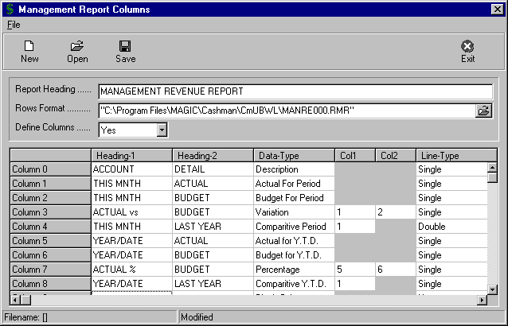

C6) MAINTENANCE – FORMS LAYOUT

h) TILL SUMMARY LAYOUT

This routine is used to set up the layouts for the “Reports - Till Summary” routine as detailed on Page 116.

On entry to the routine the “Till Summary Layout” screen is displayed. The options that are available then are:

- New - allows you to define a new Till Summary Layout
- Edit - allows you to edit an existing Till Summary Layout
- Delete - allows you to delete the highlighted Till Summary Layout

Selecting either the “New” or “Edit” options displays the “Till Summary Layout” screen as shown below.

Enter the “Report Name”. This should be sufficiently descriptive to allow easy selection of the required report layout in the reporting routine.

Enter the “Column Headings” as required. These would typically be the locations of the different Tills.

In the columns (1 – 5), enter the Till Number to be included or use the F8 option to display the Tills on the system and select the required one.

To total the details for a number of Tills (as shown in Columns 3 and 5), simply enter the Tills that are to be included in the total, e.g. in Column 3 the details for Till 1 and Till 2 will be added together. In Column 5, the details for Till 1, Till 2 and Till 3 will be added together.

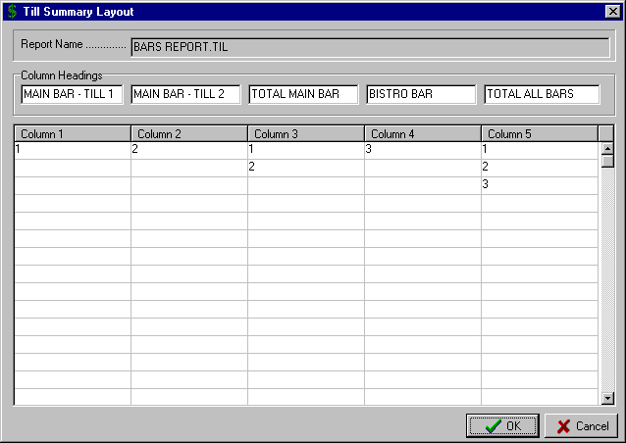
These columns contain the Till Numbers located in the area shown in the Column Headings
To total a number of Tills in the same column, enter the Tills Numbers that are to be included.

C7) MAINTENANCE – SYSTEM

By selecting “Maintenance” from the Main Menu, the menu below is displayed.

Accounts
Creditors
Debtors

Tills
Budgets
Forms Layout
System

Period Dates
Control Accounts
Setup Print Groups
Budget Descriptions
Global Settings General

Selecting “System” from the Maintenance Menu, results in the sub-menu to the right being displayed.

a) PERIOD DATES

This routine allows you to set up the ending dates of the Accounting Periods to be used in the system. It will normally only be used when the system is initially installed. On entry to the routine a screen similar to that below is displayed.

If your Period End dates correspond with the end of the calendar months then enter 12 in the “Number of Periods” field. Then click on the “Amended” field next to “Last Year”. Enter the date of the final Period in your last Financial Year (e.g. 30th September 2001).

You then tick the "Periods = Calendar Months" check box. The system will then automatically fill in the Period End dates for the 12 months of this Financial Year (Periods 1-12) and the first three months of the next Financial Year (Periods 13-15).

If your Accounting Periods do not correspond with calendar months then enter the “Number of Periods” as required (e.g. 13) and then in the “Amended” column, enter the Period End dates that apply to each Period.
The Period End dates currently set up are displayed in the “Current” column.

You can enter the revised Period End dates in the “Amended” column if not the same as the Calendar month.
Periods 13 to 15 relate to the first three Periods in the next Financial Year.

This Period relates to the last period in the previous Financial Year
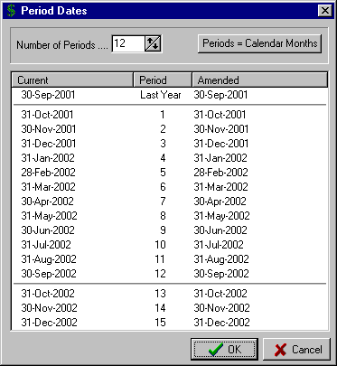
Select the “OK” button to save the settings.

C7) MAINTENANCE – SYSTEM

b) CONTROL ACCOUNTS

This routine sets up the Control Accounts necessary for the operation of the Cash Management system. It should be noted that the system does not allow the posting of transactions to the Control Accounts, however, you are able to post transactions to the three Clearing Accounts at the bottom of the screen.

On entry to the routine, you are prompted to enter the Account Numbers for each of the Control Accounts or use the F8 option to display the “Lookup Account” window and select the required one. A completed screen may appear similar to that below where two Bank Accounts have been set up.

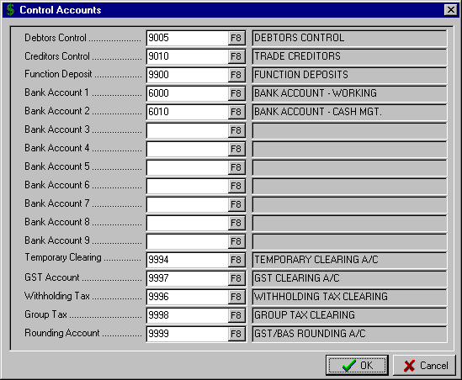

The above Accounts have the following functions:

- Debtors Control - Balance Sheet A/C that is the control for all Debtor transactions.
- Creditors Control - Balance Sheet A/C that is the control for all Creditor and Payment transactions
- Function Deposit - Balance Sheet A/C that is the control for all Function Deposits.
- Bank Account (1 - 9) - is the Balance Sheet Account that is the control for all transactions processed via the Receipts and Payments routines for the individual Bank Accounts
- Temporary Clearing - this is the system Clearing Account and is used by many routines to temporarily store transactions. You can also post transactions to this Account.
- GST Account - is the Account that records all GST components for transactions processed through the Income and Expenditure sections of the system. It is used by the system to record all GST related entries and in the preparation of the BAS.
- Withholding Tax - is the Account where withholding tax is recorded if Creditors / Suppliers do not provide their A.B.N.
- Group Tax - is the Account used to record the “Pay As You Go” (PAYG) deductions processed in the Payroll system, with the amount included in the BAS.
- Rounding Account - allows you to specify a particular Account to store amounts that are the result of rounding calculations completed by the system, e.g. GST/BAS preparation.

Select the “OK” button to save the settings.

C7) MAINTENANCE – SYSTEM

c) SETUP PRINT GROUPS

This routine provides the facility to set up the Print Group headings for use in the Summary Data reports. The system allows up to 255 Print Groups to be defined and then selected in the Summary Data reports, thus providing considerable flexibility in printing only the data that is applicable to your requirements.

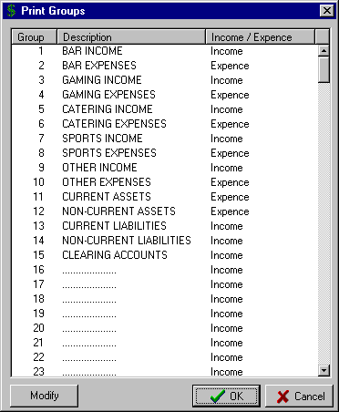
On entry to the routine, the detail stored for each “Group” is displayed.

Select the Group number to be changed and click the “Modify” button.

A window similar to that below is displayed.

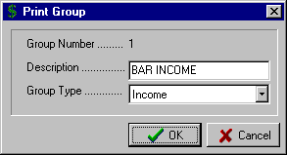

Enter the Print Group "Description", up to 25 characters.

Select the “Group Type” with the options being “Income” or “Expense”

This selection will determine how the system represents Income and Expenditure Accounts in the report.

If the setting is “Income” then Sales or Income Accounts will be shown as positive numbers and Purchases and Expenses shown as negatives. If the setting is "Expense" then Purchases or Expenses will be shown as positive numbers and Sales or Income Accounts as negatives.

d) BUDGET DESCRIPTIONS
This routine is used to set up the “Descriptions” or “Names” of Budgets that are used for comparative reporting in the system (e.g. in Summary Reports, Management reports, etc.)

To enter a “Budget Description” click in the next available text box and enter the name to be used to identify the Budget. Complete the input by selecting the “OK” button.

If you are planning to set up multiple Budgets on the system then it is advisable to make the “Budget Descriptions” as descriptive as is required to clearly identify the one you want to use in the various reporting routines.

A completed “Budget Descriptions” screen with five Budgets set up is shown to the right
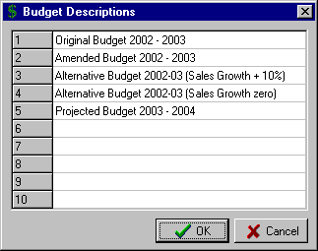

C7) MAINTENANCE – SYSTEM

e) GLOBAL SETTINGS GENERAL

This routine is used to set up the Name & Address for this Client and to specify various options relating to audit trails, debtor statements, remittance advices, etc. On entry, a window similar to that shown below is displayed.

Enter the Client “Name” and “Address” details. You then have the option to customise a number of other options. Simply tick the check box to make your selection.

- Audit Trail for Cheques

By ticking the check box the system will print an audit trail when you process cheques for Creditor invoices already entered on the system. If you choose not to print an audit trail at the time of processing you are still able to print a Cheque Listing from the Reports menu (see Page 103)

- Audit Trail for Cancelled Cheques

By ticking the check box the system will print an audit trail when you cancel cheques.

- Audit Trail for Journals

By ticking the check box the system will print an audit trail when you process Journal entries. If you choose not to print an audit trail at the time of processing you are still able to print a Journal Listing from the Reports menu (see Page 117)

- Print Zero statement if Transactions

By ticking the check box the system will print a Debtor Statement if transactions exist in the specified Period even though the outstanding balance is zero. If you leave the check box unticked, the system will not print Statements for any Debtor with a zero balance.

- Suppress Debtors Audit Trail

By ticking the check box the system will not print an audit trail when you process Debtor Invoices or Credit Notes.

- Prompt for Remittance Advice

By ticking the check box the system will prompt for a Remittance Advice each time you process a Creditor Payment. If you don’t use Remittance Advices then leave this check box unticked.

- ATO Creditor

This is where you set up the Creditor Number for the Australian Taxation Office. This is used in the BAS preparation as the resulting invoice for any tax payable is posted to the Creditor designated in this field.

- BAS Type

This is where you denote whether you prepare your BAS “Monthly” or “Quarterly”.

- Default Layouts

In the bottom section of the screen you select the Forms Layouts to be used for Debtor and Creditor Statements, Debtor Invoices and Cheque & Remittance Advice.

These layouts are set up in the “Maintenance – Forms Layout” routines and are selected by clicking on the “Browse ” button.

Select the “OK” button when you have set up the required settings.

C7) MAINTENANCE – SYSTEM

e) GLOBAL SETTINGS GENERAL (cont..)

A completed “Global Settings” screen is shown below.

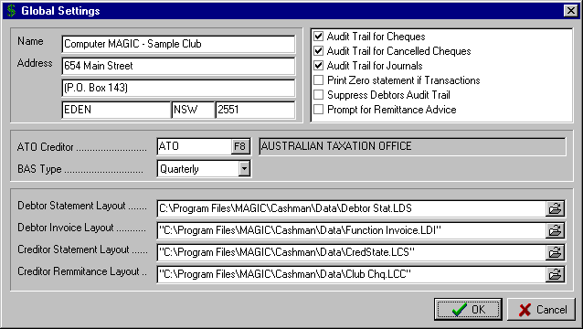

D1) REPORTS – CASH

By selecting “Reports” from the Main Menu, the menu below is displayed.

Cash
General Ledger
Summary Data
Expenditure / Creditors
Income / Debtors
Till Summary
General Journal

Labels / Documents

Bank Reconciliation
Bank Balances

Selecting “Cash” from the Reports Menu, results in the sub-menu above being displayed.

a) BANK RECONCILIATION

This report displays, and optionally prints, the details of the Cash Book and Bank Reconciliation for each of the Bank Accounts on the system.

Enter the required "Bank Account" or use the F8 option to display the Bank Accounts and select the required one. The system displays the Bank Reconciliation for the selected Bank Account.

In the top section, the left side of the report lists the Cash Book details with the Opening balance for the year, plus all Deposits less all Payments and finally the Closing Cash Book balance as of the last input. The right side of the report lists the Statement Balance as at the last Bank Statement input, plus Deposits not Credited less Unpresented Cheques giving the Closing Cash Book balance. The Closing Cash Book Balance for both sides of the report should be the same. As the Cash Management system is self-balancing, after initial set-up, this balance should be maintained automatically by the system.

A sample Bank Reconciliation screen report is shown below: The option is provided to “Print” the report.

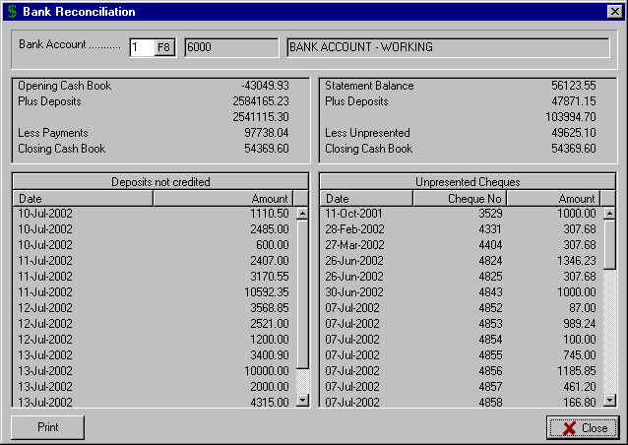

D1) REPORTS – CASH

b) BANK BALANCES

This routine displays or prints the progressive balance for each Period for the Bank Accounts set up on the system. The report sets out the total “Receipts” and “Payments” for each Period and the progressive “Balance”.

It is an excellent tool for audit purposes and allows the checking of prior period Bank Reconciliations

On entry to the routine the details are automatically displayed. Select the “Print” button to produce a hard copy of the report.

D2) REPORTS – GENERAL LEDGER

By selecting “Reports” from the Main Menu, the menu below is displayed.

Cash
General Ledger
Summary Data
Expenditure / Creditors
Income / Debtors
Till Summary
General Journal

Labels / Documents

Trial Balance
Display Summary

Trading / P+L / Balance Sheet
Management Reports

Selecting “General Ledger” from the Reports Menu, results in the sub-menu to the right being displayed.

a) TRIAL BALANCE

This report displays, and optionally prints, the balances for each General Ledger Account on the system as at a specified Period.

On entry to the routine you are prompted to select the Period for the report in the “As at Period” drop-down window. You can specify the Period by clicking on the  button and selecting the required one, or you can simply enter the Period Number once you have the window highlighted.

You can have the report only include those Accounts with a balance by ticking the “Suppress zero values” check box.

To prepare the report, click on the “Calculate” button. Use the scroll bar to move through the report.

Select the “Print” button for a printed copy of the report.

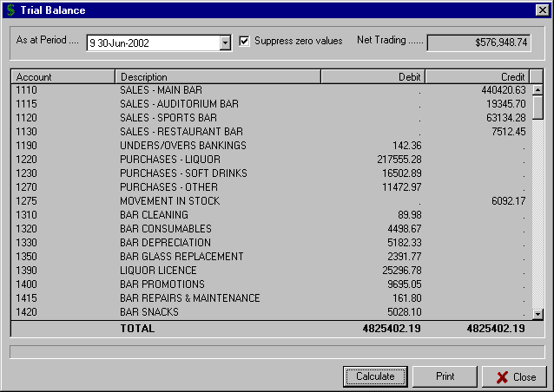

D2) REPORTS – GENERAL LEDGER

b) DISPLAY SUMMARY

This routine allows you to display the details of all transactions for the General Ledger Accounts on the system.
On entry to the routine, you are prompted to enter the “Account” number or use the F8 option to display the “Lookup Account” window and select the required one. The details of the Account are displayed.

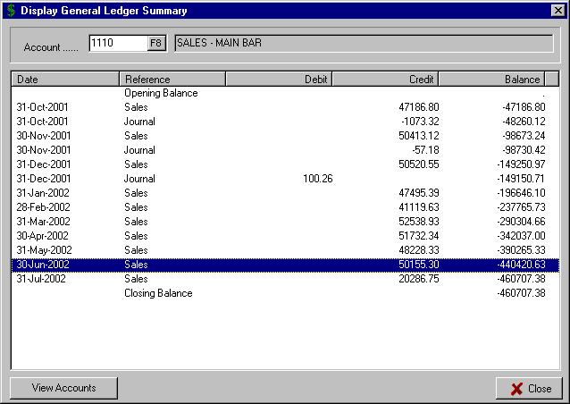

Highlight an entry in the Summary report and then click the “View Accounts” button to display the detailed screen shown below.

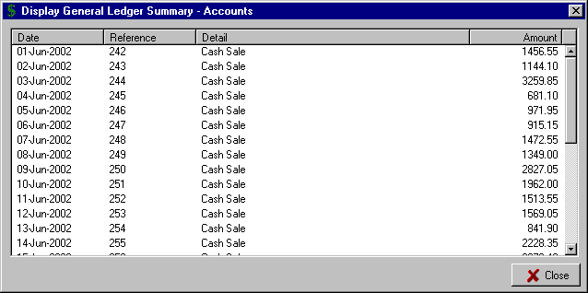

D2) REPORTS – GENERAL LEDGER

c) TRADING / P+L / BALANCE SHEET

This routine prints the Trading Statements, Profit & Loss Statement and Balance Sheet. The format for the reports must already be set up via the routine "Maintenance – Forms Layout – Trading / P+L / Balance sheet" as detailed on Page 72.

On entry to the routine, you are prompted for the following:

- Report File - Select the Report File to be used by clicking on the “Browse ” button.

- As at Period - select the Period for the report by clicking on the  button.

- Sub Heading Last Year - enter the heading for the column in the report for Last Year’s figures. This may be the year number or an alpha description such as LAST YEAR.

- Sub Heading This Year - enter the heading for the column in the report for This Year’s figures. This may be the year number or an alpha description such as THIS YEAR.

- Suppress Zero Values - A “Yes” response will exclude Accounts with a zero balance, “No” will include all Accounts

A sample “Trading / P+L / Balance Sheet” parameter screen is shown below.

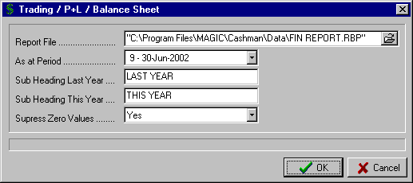

D2) REPORTS – GENERAL LEDGER

d) MANAGEMENT REPORTS

This routine prints the Management Reports set up on the system. The format for the reports must already be set up via the routines "Maintenance – Forms Layout – Management Report Rows" and "Maintenance – Forms Layout – Management Report Columns" as detailed on Page 79.

On entry to the routine, you are prompted for the following:

- Report File - Select the Report File to be used by clicking on the “Browse ” button.

- Period Range - select the Period Range for the report by clicking on the  button. This determines the period used for the Period column in the report. If the Period is for one month, e.g. Period 9 then the Period Range would be from 9 to 9.

Regardless of the Period Range selected, the system will include the Year to Date figures up to the highest specified Period, e.g. Period 9.

- Values - select whether the report is to include “General Ledger” values (Sales, Purchases and Journals) or “Cash Flow” values (Receipts and Payments).

- Report Heading - enter the heading for the report to be printed on each page.

A sample “Management Reports” parameter screen is shown below.

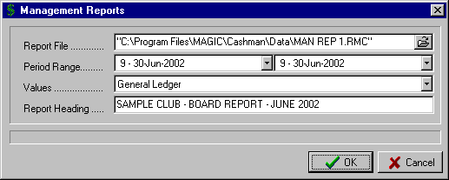

D3) REPORTS – SUMMARY DATA

By selecting “Reports” from the Main Menu, the menu below is displayed.

General Ledger
Receipts - Payments
Payments
Receipts
Purchases
Sales

Blank Budget Form

Display Summary Data

Cash
General Ledger
Summary Data
Expenditure / Creditors
Income / Debtors
Till Summary
General Journal

Labels / Documents

Selecting “Summary Data” from the Reports Menu, results in the sub-menu to the right being displayed.

The Summary Data reports provide an excellent range of options to Display, Print or Export the Summary Data stored for each Account on the system. They provide the option to report only on the Cash Flow figures for the business (Payments & Receipts) or the General Ledger figures (Purchases, Sales & Journals).

With the system able to accommodate multiple budgets, the Summary Data reports can be used for both Cash Flow budgeting and comparative reporting as well as General Ledger budgeting and comparative reporting.

The Export option allows you to export all or selected data in an Excel Spreadsheet format. This allows you to simply set up a working spreadsheet and then have all the options of Excel to customise the formatting, use colour, prepare graphs, etc.

GENERAL INSTRUCTIONS

All the printed Summary Data reports (the top 6 in the above sub-menu) have the same options and hence the same operation. For convenience, the instructions for each of the Summary Data reports have been included at the start of this section.

On entry to any of the first six Summary Data reports, the following options are displayed:

- Actuals ONLY by Period - includes only the Actual balances for the current year in the report.

- Budgets ONLY by Period - includes only the Budget figures as set up for each Account.

- Actuals AND Budgets by Period - uses Actual figures up to the selected Period and then Budget figures to the end of the current financial year.

- Comparative with Variations - provides Actual and Budget figures with Variations for selected periods and Cumulative Year to Date

- Budget above Actual below - lists the Actual figures on the first line for each Account and then the Budget figures directly below them on the second line

If a format using budgets is chosen and there is more than one budget set up on the system then you are prompted to select the one to use.

The system then prompts for the "Period Range”. The first Period for the current Financial Year is displayed as the default. You can specify any range you require for the report by clicking on the  button and selecting the Period From and the Period To.

The option is then provided to specify which Print Groups you want to include in the report. These are the Print Groups set up for each Account in the “Account Maintenance” routine (see Page 49) with the Print Group headings set up in the “Maintenance – System – Setup Print Groups” routine (see Page 85).

D3) REPORTS – SUMMARY DATA

GENERAL INSTRUCTIONS (cont..)

The default setting for the “Print Groups” option is to have all 255 Print Groups selected. To specify selected Print Groups, click on the F8 option. This opens the window shown below with all Print Groups in the “Selected” window.
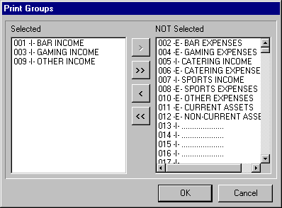
It is suggested that initially you click the >> button to move all the Print Groups to the right window (NOT Selected).

To select a Print Group, highlight the required one in the right window and click the < button. This moves the selected item to the left window (Selected).

Use the > button to move a selected item from the Selected to NOT Selected window.

To move multiple items, select the ones required by using the Ctrl + Mouse buttons. Then select the < or > options to move all the selected items from one window to the other.

Use the << or >> buttons to move all the items in one window to the other window.

In the above example, Print Groups 1, 3 & 9 have been selected.

These then appear in the report shown below

Click the “OK” button when all the required selections are made. This returns you to the Summary Data window shown below. To prepare the report, select the “Calculate” button. This displays the report and allows you to view the full report by use of the side and bottom scroll bars,

Select the “Print” button for a hard copy or the “Export” button to save the report in an Excel compatible format.

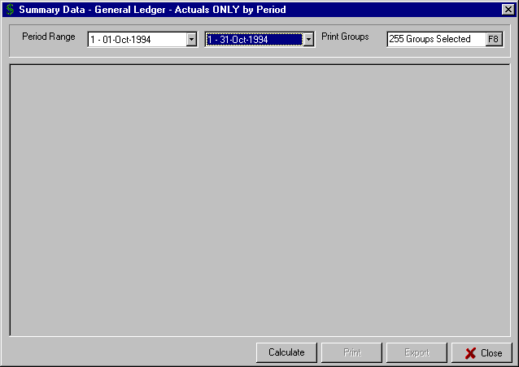
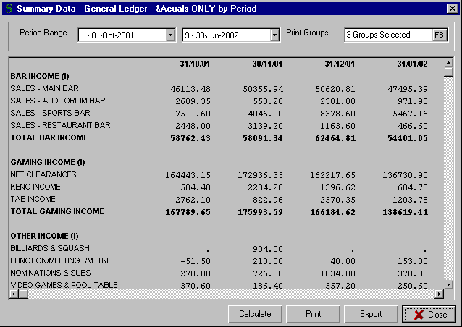

D3) REPORTS – SUMMARY DATA

a) GENERAL LEDGER

The General Ledger - Summary Data reports include for each Account all Purchases, Sales and Journals. They detail the movement in the General Ledger for each selected Account over the specified Period.

Refer to the "General Instructions" listed at the beginning of this section (Page 94) for the options available for these reports.

b) RECEIPTS - PAYMENTS

The Receipts minus Payments - Summary Data reports include for each Account all Receipts and Payments. They detail the movement in Cash Flow for each selected Account over the specified Period.

Refer to the "General Instructions" listed at the beginning of this section (Page 94) for the options available for these reports.

c) PAYMENTS

The Payments - Summary Data reports include for each Account all Payments processed on the system for each selected Account over the specified Period.

Refer to the "General Instructions" listed at the beginning of this section (Page 94) for the options available for these reports

d) RECEIPTS

The Receipts - Summary Data reports include for each Account all Receipts processed on the system for each selected Account over the specified Period.

Refer to the "General Instructions" listed at the beginning of this section (Page 94) for the options available for these reports

e) PURCHASES

The Purchases - Summary Data reports include for each Account all Purchases processed on the system for each selected Account over the specified Period.

Refer to the "General Instructions" listed at the beginning of this section (Page 94) for the options available for these reports

f) SALES

The Sales - Summary Data reports include for each Account all Sales processed on the system for each selected Account over the specified Period.

Refer to the "General Instructions" listed at the beginning of this section (Page 94) for the options available for these reports

g) BLANK BUDGET FORM

This option allows you to print a blank Summary Data report that can be used for the documenting of a budget.

h) DISPLAY SUMMARY DATA

This screen based report displays the Summary Data for individual General Ledger Accounts for each accounting period. The Summary Data is grouped under the broad headings of "Sales", "Receipts", "Purchases", "Payments" and "Journals".

On entry, to the routine you are prompted to enter the "Account" number or use the F8 option to display the “Lookup Account” window and select the required one. The details for the selected Account are displayed.

D4) REPORTS – EXPENDITURE / CREDITORS

By selecting “Reports” from the Main Menu, the menu below is displayed.
Cash
General Ledger
Summary Data
Expenditure / Creditors
Income / Debtors
Till Summary
General Journal

Labels / Documents

Creditors Reports

Purchases by Account
Purchases by Creditor

Cheque Listing
Unpaid Invoices
Unpresented Cheques

Selecting “Expenditure / Creditors” from the Reports Menu, displays the sub-menu to the right.

a) CREDITORS REPORTS

Selecting “Creditors Reports” from the sub-menu displays a further set of reports

a1) Creditor ABNs

This report displays or prints the ABN details entered for the Creditors on the system via Creditor Maintenance.

a2) Trial Balance (Creditors)

This report displays or prints the details of outstanding Creditor invoices as at a selected Period. You specify the Period by clicking the  button in the “As at end of Period” list box. The default is the current Physical Period.

You then select whether you want the report in “Summary” (total outstanding by Creditor) or “Detail” (list all the outstanding invoices as well as the total for each Creditor – this is the option chosen for the report below). Select the “Calculate” button to display the report, then “Print” for a hard copy of the report.

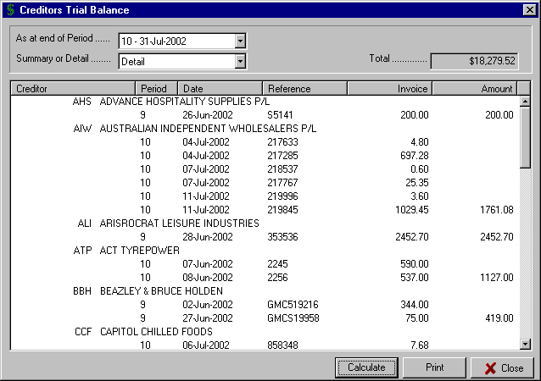

D4) REPORTS – EXPENDITURE / CREDITORS

a) CREDITORS REPORTS (cont..)

a3) Display Statement (Creditors)

This screen-based report is an excellent tool for reconciling the details of invoices, payments and the current balance for individual Creditors. The report shows the Opening Balance as at the start of the specified period and then for each transaction the Date, Reference, Debit or Credit amount and Balance.

You are prompted to enter the “Creditor” number or use the F8 option to display the “Lookup Creditor” window and select the required one.

The system then prompts for the "Period Range”. You can specify any range you require for the report by clicking on the  button and selecting the Period From and the Period To. Click the “Calculate” button to display the details for the selected Creditor for the specified Period Range.

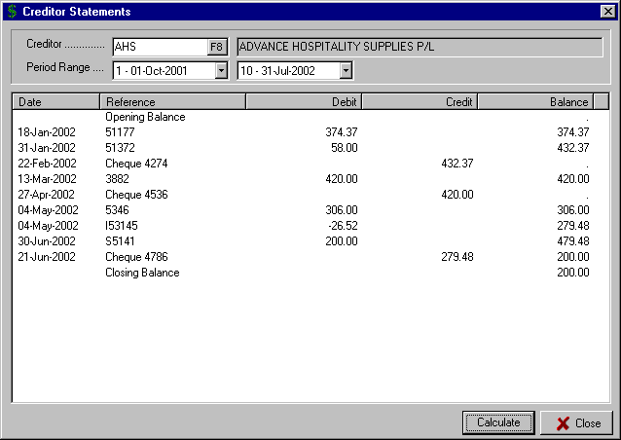

a4) Print Statements (Creditors)

The option is provided via this routine to print statements for selected Creditors for a specified Period Range. The layout for the Creditor Statement is set in the routine “Maintenance – Forms Layout – Creditor Statements” as detailed on Page 71.

On entry to the routine the “Print Creditor Statements” window is displayed. Specify the "Period Range” from the drop-down list boxes. You can specify, within the current Financial Year, any range you require for the report by clicking on the  button and selecting the Period From and the Period To.

The option is then provided to select the Statement “Type” with the options being “Draft” (this would be used for internal copies or checking) and “Statement” (which will use the Statement Layout set up in the Forms Layout routine and selected in the “Global Settings General” routine. This would be the copy sent to the Creditor)

D4) REPORTS – EXPENDITURE / CREDITORS

a) CREDITORS REPORTS (cont..)

a3) Print Statements (cont..)

Enter the “Descriptive Date” to print on the Creditor Statement.

You can choose to select all Creditors or a selection of Creditors from the “Selection Criteria” drop-down list box. Use the  button to select one of the three available options:
- All Creditors - prints a Statement for all Creditors with an outstanding balance

- Creditor Range - prints a Statement for a specified range of Creditors. This then allows you to specify the “Name Range” by selecting the starting and ending Creditors in the two text boxes.

- Selected - prints a Statement for individually
Creditors selected Creditors by clicking the “Include Another” button and selecting the required Creditor from the Lookup window.

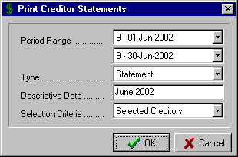

Repeat this process until all required Creditors are included in the “Select Individual Creditors” window. You can remove a Creditor from the selections by highlighting the Creditor and clicking the “Remove Selected” button.

A typical “Print Creditor Statements” selection screen for printing selected Creditor Statements is shown above.

a5) Control Balances (Creditors)

This routine displays a summary of the Creditor Invoices and Payments for each Period and displays the current Creditors Control balance. This balance should equal the total of all unpaid Creditor Invoices and balance with the Creditors Trial Balance for the current Physical Period. It should also balance with the Creditors Control account in the General Ledger.

Select the “Calculate” button to display the report, select the “Print” button to print the report.
This figure should balance with the Creditors Control account in the General Ledger at the end of the last Financial Year
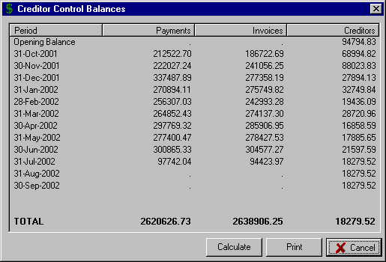
This figure should balance with the Creditors Trial Balance for the current Physical Period and the Creditors Control account in the General Ledger.

D4) REPORTS – EXPENDITURE / CREDITORS

a) CREDITORS REPORTS (cont..)

a6) Monthly Purchases (Creditors)

This report displays, or prints, for each Creditor the total amount of invoices for each Period. All Creditors on the system are included in the report. The report is designed for use by auditors to ensure that all invoices have been posted at the end of an accounting period.

You can produce a hard copy of the report by selecting the “Print” button.

a7) Overdue Payments (Creditors)

This report displays, or prints, the total amount of invoices for each Creditor that are still unpaid and are either Due (Current column) or Overdue (30 Days, 60 Days, etc.) based on the Date Due entered in the “Creditor Invoice” routine.

The only input required is to select the “Calculate” button to display the report. You can produce a hard copy of the report by selecting the “Print” button.

a8) Due for Payment (Creditors)

This report displays, or prints, the invoice amounts by Creditor that fall due in the next four weeks. It is a very helpful report in ensuring that supplier discounts for prompt payments are not missed, or that penalties are not incurred for late payment. It is also useful in planning Cash Flow requirements for the next month.

The only input required is to select the “Calculate” button to display the report. You can produce a hard copy of the report by selecting the “Print” button.

A sample of the displayed “Creditor Due Payments” report is shown below.

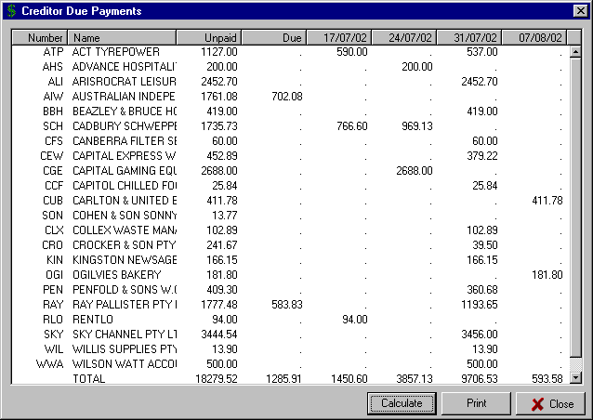

D4) REPORTS – EXPENDITURE / CREDITORS

b) PURCHASES BY ACCOUNT

This report lists the details of all Purchases (Invoices) on the system for selected General Ledger Accounts over a specified date range. The report details the number of the Cheque that paid the invoice (if the invoice is yet to be paid then this column is blank), the accounting Period to which the invoice was applied, the Date of the invoice, the Creditor Name, and the invoice Amount.

Enter the “Account” number or use the F8 option to access the “Lookup Account” window and select the required one.

Specify the "Period Range” from the drop-down list boxes. You can specify, within the current Financial Year, any range you require for the report by clicking on the  button and selecting the Period From and the Period To.

Select the “Calculate” button to display the invoices for the selected Account for the specified date range. Use the scroll bars to the right of the window to view the complete listing.

Select the “Print” button to produce a hard copy of the report.

A sample “Purchases by Account” report for the Account 1230 (Purchases – Soft Drinks) for the Periods 9 (June) and 10 (July) is shown below.

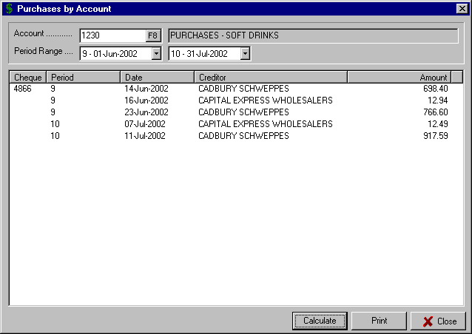
Note the Cheque Number is listed if the Creditor invoice has been paid.

If it is still unpaid, then the column is left blank

D4) REPORTS – EXPENDITURE / CREDITORS

c) PURCHASES BY CREDITOR

This report lists the details of Invoices for selected Creditors over a specified date range. The report includes the number of the Cheque that paid the invoice (if not yet paid, this column is blank), the accounting Period to which the invoice was applied, the Date of the invoice, the invoice Reference, and the invoice Amount. The Account dissection for each invoice is also available.

Enter the “Creditor” number or use the F8 option to access the “Lookup Creditor” window and select the required one.

Specify the "Period Range” from the drop-down list boxes. You can specify, within the current Financial Year, any range you require for the report by clicking on the  button and selecting the Period From and the Period To.

Select the “Calculate” button to display the invoices for the selected Account for the specified date range. Use the scroll bars to the right of the window to view the complete listing.

Select the “Print” button to produce a hard copy of the report.

A sample “Purchases by Creditor” report for Creditor CEW (Capital Express Wholesalers) for the Periods 9 (June) and 10 (July) is shown below.

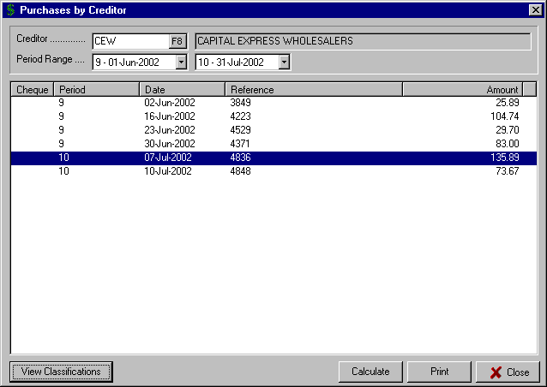

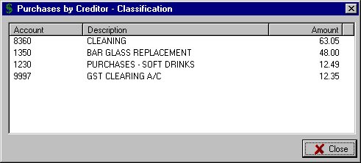

To display the Account dissection for any of the displayed invoices, simply highlight the invoice and click the “View Classifications” button at the bottom left of the screen.

In the example above, the invoice dated 7th July 2002, Reference 4836 for $135.89 has been highlighted and after clicking the “View Classifications” button, the “Classification” window is displayed showing the dissection to the General Ledger Accounts.

D4) REPORTS – EXPENDITURE / CREDITORS

d) CHEQUE LISTING

This report displays, or prints, the details of all Cheques, and Bank Statement expense items, for selected Bank Accounts over a specified date range. It provides the facility to produce a cheque listing in summary form (simply listing the cheque Number, Period, Date, Payee and Amount) or detailed form (where the invoices paid by the cheque are listed and also the Account classifications associated with each of the invoices).

Enter the required "Bank account" – using the F8 option displays the Bank Accounts set up on the system.

You then select either a “Period Range” or “Date Range” by clicking the appropriate option button. The Period Range will include all transactions for a Period and is used when it is important that all payments be included. The Date Range allows you to just report on a part of a Period or reproduce an audit trail for a specific input.

You specify the "Period Range” from the drop-down list boxes. You can specify, within the current Financial Year, any range you require for the report by clicking on the  button and selecting the Period From and the Period To.

Alternatively, you specify the "Date Range" by entering the required dates or by using the Calendar option.

A “Cheque Listing” displayed report is shown below for Period 10 (July) for Bank Account 1 (Working Account). You will notice that the report displays the “Total Amount” of payments for the specified dates.

You will notice that a number of the cheques have an asterisk ( * ) next to the cheque number. This indicates that these cheques have not yet been presented in the “Bank Statement” input routine.

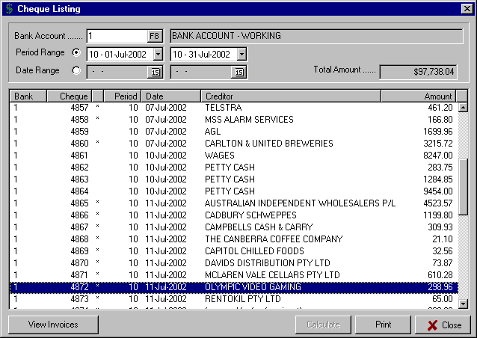

The options at the bottom of the screen, i.e. “View Invoices” and “Print” are described in detail on the following page.

D4) REPORTS – EXPENDITURE / CREDITORS

d) CHEQUE LISTING (cont..)

As seen on the previous page, the option is provided to “View Invoices” for any of the payments listed in the report. You simply highlight the payment (in the above example, cheque 4872 for Olympic Video Gaming has been highlighted). You then click the “View Invoices” button to display the “Cheque Listing – Invoices” screen shown below. This then displays the invoice for Olympic Video Gaming paid for by cheque 4872.

You are then able to highlight this invoice, as shown, and click the “View Classifications” button at the bottom of the screen. This results in the “Cheque Listing – Invoices – Classification” window being displayed showing the Accounts the invoice was dissected to when it was posted.

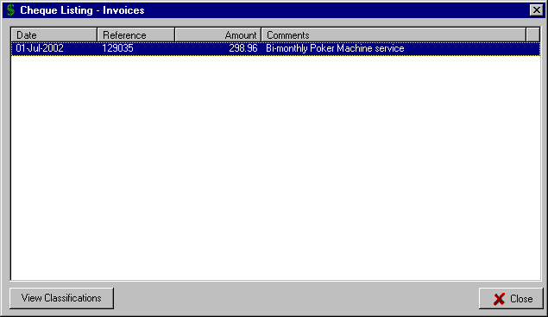

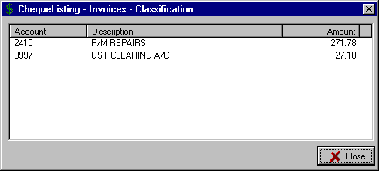

The option is also provided in the “Cheque Listing” screen to “Print”. By selecting this option, the window below is displayed giving you three options for the printed Cheque Listing.

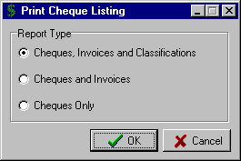

Choose the required “Report Type” by selecting the appropriate option button and “OK”. The three options are:

- Cheques, Invoices and Classifications - this will list each payment for the specified dates and include the details of the invoices included in the payment, along with a full Account dissection for each invoice.

- Cheques and Invoices - this will list each payment for the specified dates and include the details of the invoice(s) included in the payment.

- Cheques Only - this will list each payment for the specified dates with only the payment details included.

D4) REPORTS – EXPENDITURE / CREDITORS

e) UNPAID INVOICES

This report lists the details of unpaid invoices by Creditor. The option exists to print all outstanding invoices or only those at a specified Due Date. It is suggested that this report be printed to assist in deciding which invoices will be paid in the cheque payment or Creditor EFT routines.

On entry to the routine the “Unpaid Invoices” window is displayed.

If you would like to list the Unpaid Invoices for a specific Creditor then enter the “Creditor” Number or use the F8 option to display the “Lookup Creditor” window and select the required one.

If you want to list all Unpaid Invoices for all Creditors then leave the “Creditor” field blank.

The option is provided to specify only those invoices that have a “Due Date Prior to or as at” a specified date by ticking the check box next to the prompt. Enter the date required or use the Calendar option.

To display the report for the selected Creditor or for all Creditors then select the “Calculate” button.

The sample report below shows the “Unpaid Invoices” for all Creditors with a Due Date prior to or as at 31st August 2002. You will notice the “Total” amount of Unpaid Invoices with the specified Due Date is shown here.

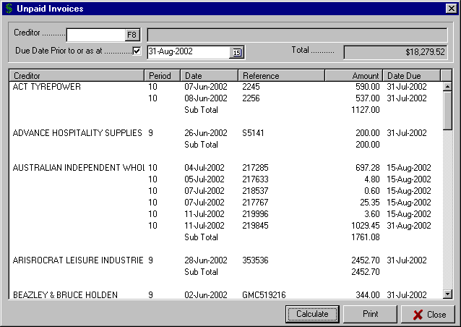

Select the “Print” button for a hard copy of the report.

D4) REPORTS – EXPENDITURE / CREDITORS

f) UNPRESENTED CHEQUES

This report displays, or prints, details of all Unpresented Cheques for a selected Bank Account.

Enter the required "Bank account" or use the F8 option to display the Bank Accounts set up on the system and select the required one.

The system lists the Unpresented Cheques for the selected Bank Account.

The option is provided, as with the “Cheque Listing” routine to highlight a payment and by selecting the “View Invoices” option display the invoices that make up the payment. You can then highlight an invoice and select the “View Classifications” option to display the dissection of Accounts for that invoice. Full instructions on these options are detailed on Page 104.

Select the “Print” button for a hard copy of the report.

D5) REPORTS – INCOME / DEBTORS

By selecting “Reports” from the Main Menu, the menu below is displayed.

Debtors Reports

Sales by Account
Sales by Debtor
Receipts by Debtor

Deposit Listing
Deposits not Credited
Daily Sales
Daily Trading Summary

Outstanding Function Deposits

Cash
General Ledger
Summary Data
Expenditure / Creditors
Income / Debtors
Till Summary
General Journal

Labels / Documents

Selecting “Income / Debtors” from the Reports Menu, displays the sub-menu to the right.

a) DEBTORS REPORTS

Selecting “Debtors Reports” from the sub-menu displays a further set of reports

a1) Aged Trial Balance (Debtors)

The “Debtors Aged Trial Balance” report lists the details of amounts outstanding for each Debtor on the system. The report ages the amounts in "Current", "30 days", "60 days" and "90 days" with a “Total” outstanding for each Debtor. Debtors with a zero balance are not included in the report.

Select the “Calculate” button to display the report. Select the “Print” button to produce a hard copy.

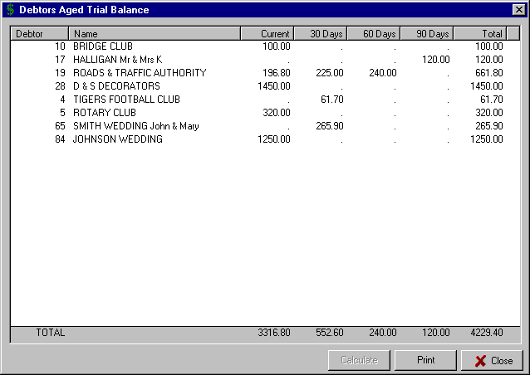

D5) REPORTS – INCOME / DEBTORS

a) DEBTORS REPORTS (cont..)

a2) Display Statements (Debtors)

This screen-based report is an excellent tool for reconciling the details of invoices, receipts and the current balance for individual Debtors. The report shows the Opening Balance as at the start of the specified period and then for each transaction the Date, Reference, Debit or Credit amount and Balance.

You are prompted to enter the “Debtor” number or use the F8 option to display the “Lookup Debtor” window and select the required one.

The system then prompts for the "Period Range”. You can specify any range you require for the report by clicking on the  button and selecting the Period From and the Period To.

Click the “Calculate” button to display the details for the selected Debtor for the specified Period Range.

A sample display “Debtor Statement” report is shown below for Debtor 4 (Tigers Football Club) for the date range of Period 1 (October 2001) to period 10 (July 2002)

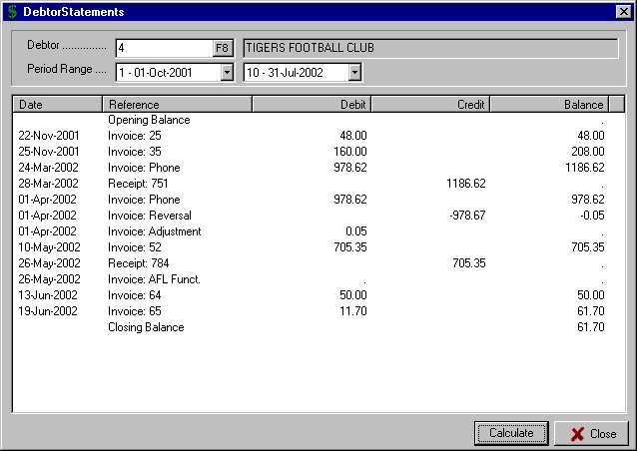
This column contains Credits and Receipts for the Debtor
This column contains Debtor Invoices for the Debtor

D5) REPORTS – INCOME / DEBTORS

a) DEBTORS REPORTS (cont..)

a3) Print Statements (Debtors)

The option is provided via this routine to print statements for selected Debtors for a specified Period Range. The layout for the Debtor Statement is set in the routine “Maintenance – Forms Layout – Debtor Statements” as detailed on Page 65.

On entry to the routine the “Print Debtors Statements” window is displayed. Specify the "Period Range” from the drop-down list boxes. You can specify, within the current Financial Year, any range you require for the report by clicking on the  button and selecting the Period From and the Period To.

The option is then provided to select the Statement “Type” with the options being “Draft” (this would be used for internal copies or checking) and “Statement” (which will use the Statement Layout set up in the Forms Layout routine and selected in the “Global Settings General” routine. This would be the copy sent to the Client).

Enter the “Descriptive Date” to print on the Debtor Statement.

You can choose to select all Debtors or a selection of Debtors from the “Selection Criteria” drop-down list box. Use the  button to select one of the three available options:
- All Debtors - prints a Statement for all Debtors with an outstanding balance

- Debtor Range - prints a Statement for a specified range of Debtors. This then allows you to specify the “Name Range” by selecting the starting and ending Debtors in the two text boxes.

- Selected - prints a Statement for individually
Debtors selected Debtors by clicking the “Include Another” button and selecting the required Debtor from the Lookup window.

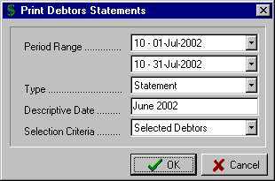

Repeat this process until all required Debtors are included in the “Select Individual Debtors” window. You can remove a Debtor from the selections by highlighting the Debtor and clicking the “Remove Selected” button.

A typical “Print Debtor Statements” selection screen for printing selected Debtor Statements is shown above.

a4) Control Balances (Debtors)

This routine displays a summary of the movements in the Debtor Control Account for the Month to Date and Year to Date. It displays the “Opening Balance”, “Sales”, “Journals”, “Receipts” and the “Current Balance”. The current aging of the Debtors Control Account is also displayed.

The information on this screen should reconcile with the Debtors Control balance in your General Ledger and the Debtors Aged Trial Balance.

a5) Debtors by Month

This report displays, or prints, for each Debtor the total amount of invoices for each Period. All Debtors on the system are included in the report. The report is designed for use by auditors to ensure that all invoices have been posted at the end of an accounting period.

You can produce a hard copy of the report by selecting the “Print” button.

D5) REPORTS – INCOME / DEBTORS

a) DEBTORS REPORTS (cont..)

a6) Debtors with a Balance

This is a fairly specialised report that lists those Debtors that have a balance. In normal circumstances, the Aged Trial Balance would be preferable when checking the situation with your Debtors.

a7) Debtors Date of Last Sale

This report is useful in determining the time that has elapsed since the last time the Debtor has made a sale with your organisation. It can be used to market to those clients that don’t appear to be still trading with your business and allows you to be proactive in following them up.

The report lists the “Debtor Number”, “Debtor Name” and “Last Sale Date”.

On entry to the routine the “Debtors Date of Last Sale” screen is displayed.

Enter the “Date” for the report and select the “Calculate” button to display the report.

The option is provided to select the “Print” button for a hard copy of the report.

D5) REPORTS – INCOME / DEBTORS

b) SALES BY ACCOUNT

This report lists the details of all Sales on the system for selected General Ledger Accounts over a specified date range. The report lists both the sales processed through the Receipts routine (cash sales) and also the sales processed through the Debtor Invoices / Credits routine (credit sales).

You are prompted to enter the “Account” number or use the F8 option to display the “Lookup Account” window and select the required one.

The system then prompts for the "Period Range”. You can specify any range you require for the report by clicking on the  button and selecting the Period From and the Period To.

Click the “Calculate” button to display the Sales for the selected Account for the specified Period Range.

A sample display “Sales by Account” report is shown below for Account 1120 (Sales – Sports Bar) for the date range of Period 10 (July 2002). Select the “Print” button to produce a hard copy of the report.

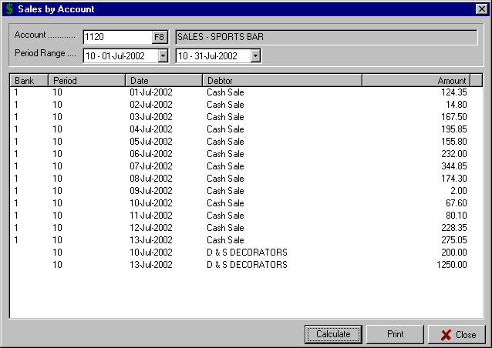
These are Cash Sales posted to this Account via the “Receipts” routine.
These are Credit Sales posted to this Account via the “Invoices / Credits” routine.

c) SALES BY DEBTOR

This report lists the details of Credit Sales for selected Debtors over a specified date range. From the “Sales by Debtor” screen, enter the “Debtor” number or use the F8 option to access the “Lookup Debtor” window and select the required one.

Specify the "Period Range” from the drop-down list boxes. You can specify, within the current Financial Year, any range you require for the report by clicking on the  button and selecting the Period From and the Period To.

Select the “Calculate” button to display the Sales. You are able check the Account dissection for each of the displayed Sales by highlighting the transaction and clicking the “View Classifications” button. Select the “Print” button to produce a hard copy of the report.

D5) REPORTS – INCOME / DEBTORS

d) RECEIPTS BY DEBTOR

This routine displays, or prints, all Debtor Receipts for a specified date range. The report details the Debtor Number, Name, Date of Receipt, Period, Reference and Amount. It is an ideal report for quickly checking what Debtor Receipts have been processed in a particular Period and resolving questions concerning the payment of outstanding accounts by Debtors.

From the “Receipts by Debtor” screen, specify the "Period Range” from the drop-down list boxes. You can specify, within the current Financial Year, any range you require for the report by clicking on the  button and selecting the Period From and the Period To.

Select the “Calculate” button to display the Debtor Receipts, including a “Total” at the top of the screen.

Select the “Print” button to produce a hard copy of the report.

D5) REPORTS – INCOME / DEBTORS

e) DEPOSIT LISTING

This report displays, or prints, the details of all Deposits, and Bank Statement income items, for selected Bank Accounts over a specified date range. It provides the facility to produce a deposit listing in summary form (simply listing the Bank Number, Period, Date and Amount) or detailed form (where the invoices and sales included in the deposit are listed and also the Account classifications associated with each of the sales).

From the “Deposit Listing” screen, enter the required "Bank account" – using the F8 option displays the Bank Accounts set up on the system.

You then select either a “Period Range” or “Date Range” by clicking the appropriate option button. The Period Range will include all transactions for a Period and is used when it is important that all deposits be included. The Date Range allows you to just report on a part of a Period or reproduce an audit trail for a specific input.

You specify the "Period Range” from the drop-down list boxes. You can specify, within the current Financial Year, any range you require for the report by clicking on the  button and selecting the Period From and the Period To.

Alternatively, you specify the "Date Range" by entering the required dates or by using the Calendar option.

A “Deposit Listing” displayed report is shown below for Period 10 (July) for Bank Account 1 (Working Account). You will notice that the report displays the “Total Amount” of deposits for the specified dates.

You will notice that a number of the deposits have an asterisk ( * ) in the column to the left of the Period column. This indicates that these deposits have not yet been presented in the “Bank Statement” input routine.

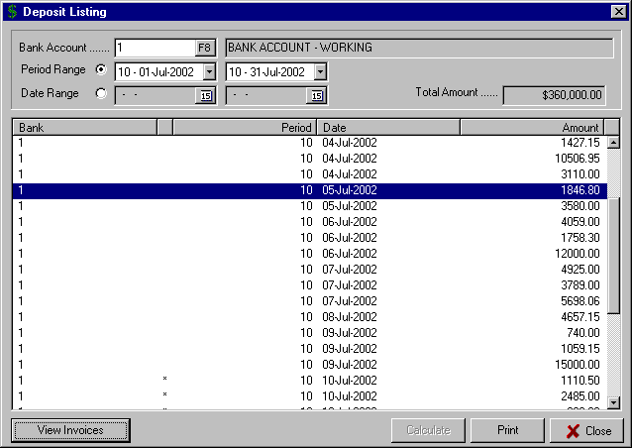
Deposits marked with an asterisk ( * ) are those that are not yet presented
This deposit has been highlighted and then the “View Invoices” button selected to display the entries that make up this deposit. See the result of this on the following page.

The options at the bottom of the screen, i.e. “View Invoices” and “Print” are described in detail on the following page.

D5) REPORTS – INCOME / DEBTORS

e) DEPOSIT LISTING (cont..)

As seen on the previous page, the option is provided to “View Invoices” for any of the deposits listed in the report. You simply highlight the deposit (in the above example, the deposit for the 5th July 2002 has been highlighted). You then click the “View Invoices” button to display the “Deposit Listing – Invoices” screen shown below. This then displays the sales / invoice detail.

You are then able to highlight this invoice, as shown, and click the “View Classifications” button at the bottom of the screen. This results in the “Deposit Listing – Invoices – Classification” window being displayed with the Accounts dissection shown.

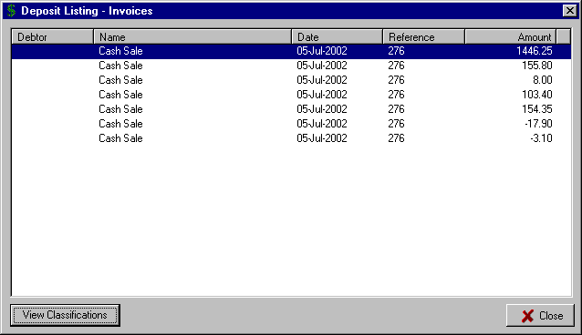

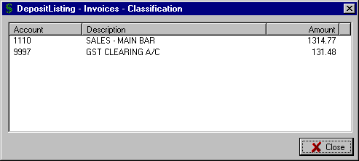

The option is also provided in the “Deposit Listing” screen to “Print”. By selecting this option, the window below is displayed giving you three options for the printed Deposit Listing.

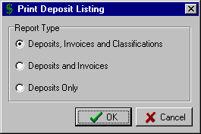

Choose the required “Report Type” by selecting the appropriate option button and “OK”. The three options are:

- Deposits, Invoices and Classifications - this will list each deposit for the specified dates and include the details of the sales included in the deposit, along with a full Account dissection for each sale.

- Deposits and Invoices - this will list each deposit for the specified dates and include the details of the sales included in the deposit.

- Deposits Only - this will list each deposit for the specified dates with only the deposit details included.

D5) REPORTS – INCOME / DEBTORS

f) DEPOSITS NOT CREDITED

This report displays, or prints, details of all Unpresented (not credited) Deposits for a selected Bank Account.

Enter the required "Bank account" or use the F8 option to display the Bank Accounts set up on the system and select the required one.

The system lists the Unpresented Deposits for the selected Bank Account.

The option is provided, as with the “Deposit Listing” routine to highlight a Deposit and by selecting the “View Invoices” option display the sales that make up the Deposit. You can then highlight a sale and select the “View Classifications” option to display the dissection of Accounts for that sale. Full instructions on these options are detailed on Page 114.

Select the “Print” button for a hard copy of the report.

g) DAILY SALES

This report lists the Sales by day for each of the Income related General Ledger Accounts for a 14 day period. It is ideal for tracking peaks and troughs during a month or for checking the extent of trade in a busy Christmas or Easter period.

Enter the "Date Range” for the report or use the Calendar option to specify the dates. Remember, the maximum date range is 14 days.

Select the “Calculate” button to display the report, use the scroll bars at the bottom and right of the report to view additional days and Accounts.

Select the “Print” button for a hard copy of the report.

h) DAILY TRADING SUMMARY

This report provides a Daily Trading summary for a specified date range, up to a maximum of 31 days. For each day, the report lists relevant totals for Debtor Sales, Debtor Receipts, Cash Sales, Total Sales and Total Receipts.

Enter the "Date Range” for the report or use the Calendar option to specify the dates. Remember, the maximum date range is 31 days.

Select the “Calculate” button to display the report, use the scroll bars at the bottom and right of the report to view additional days and Accounts.

Select the “Print” button for a hard copy of the report.

i) OUTSTANDING FUNCTION DEPOSITS

This report displays or prints the outstanding Function Deposits held on the system. The total of this report should reconcile with the Function Deposit Control Account in the General Ledger.

Function Deposits are processed via “Transactions – Debtor and Receipts – Receipts” (see Page 25 for details ) or “Transactions – Debtor and Receipts – Tills Input” (see Page 32).

The report lists the “Debtor Number”, “Debtor Name”, “Date” of the Deposit, “Reference” and “Amount”.

Select the “Print” button for a hard copy of the report.

D6) REPORTS – TILL SUMMARY

This routine prints the Till Summaries for a selected date range. The formats for the Till Summary reports must already be set up via the routine "Maintenance – Forms Layout – Tills Summary Layout" as detailed on Page 82.

You are able to set up multiple Till Summary Report layouts enabling you to have quite detailed reporting for certain areas of the club, e.g. Bars, and then also having Summary reporting for the club overall. Key benefits that this type of reporting provides are:

- the ability to accurately and quickly ascertain the nature and extent of Till discrepancies
- to record and be able to report on the contents of the daily Till Reconciliation sheets

On entry to the routine, the “Till Summary Report” screen is displayed. Enter the "From Date" and "To Date" for the transactions to be included in the report.

The system displays the Till Summary Report layouts set up on the system in the “Available Reports” column. There are then a number of options available to select the Report layouts to print.

If you want to include all the Report Layouts in the print run, then click the >> button. This will move all the Report Layouts to the “Report to Print” window.

If you want to include only selected Print Layouts, then highlight the required one(s) in the left window and click the > button. This moves the selected item(s) to the right window.

Use the < button to move a selected item from the right window to the left window.

To move multiple items, select the ones required by using the Ctrl + Mouse buttons. Then select the < or > options to move all the selected items from one window to the other.

Use the << or >> buttons to move all the items in one window to the other window.

A sample “Till Summary Layout” screen is shown below.

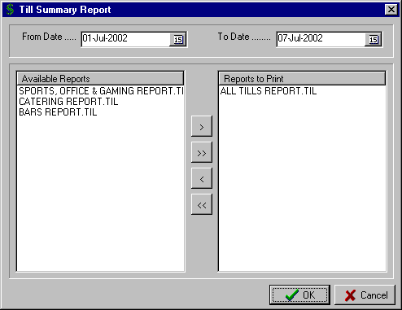
This Till Summary Report Layout is the one that will be included in this print run.
These Till Summary Report Layouts are available but have been excluded from this print run.

D7) REPORTS – GENERAL JOURNAL

This report displays, or prints, the details of all General Journal transactions, entered via the routine "Transactions – Journal – General Journal”, for a selected date range.

From the “General Journals” screen, specify the "Period Range” from the drop-down list boxes. You can specify, within the current Financial Year, any range you require for the report by clicking on the  button and selecting the Period From and the Period To.

Select the “Calculate” button to display the report. Select the “Print” button to produce a hard copy of the report. A sample “General Journals” displayed report is shown below for Period 9 (June).

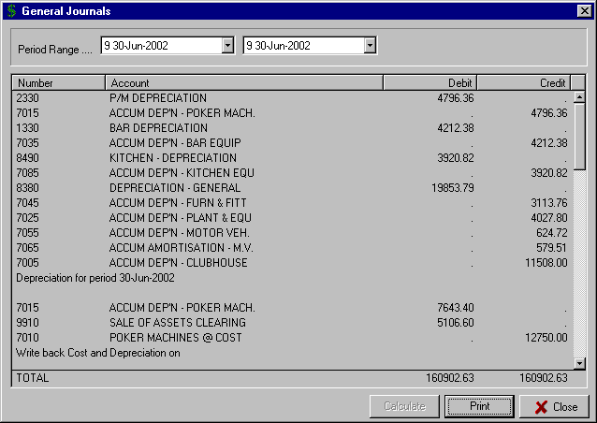

D8) REPORTS – LABELS / DOCUMENTS

Complete instructions for the set up of Labels and Documents in the Computer Magic systems are set out in the Membership manual. If you do not have a copy of this manual then contact Computer MAGIC and a copy of the relevant section will be supplied.

Once the layout has been set up, select the “File – Print Documents” menu option. This allows you to print the labels for either all or selected Debtors and Creditors from the “Print Label / Document” screen as shown below

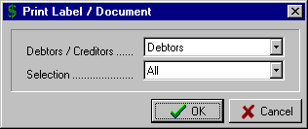
You are able to specify whether the labels are for “Debtors / Creditors” by clicking the  button.

From the “Selection” drop-down list box, select “All”, “Range” or “Individually Select”

Click the “OK” button when selections are completed.

E) STATUS

By selecting “Status” from the Main Menu, and then “Status” again, the following screen is displayed. It details:

- The “Client Name” (e.g. DOWNTOWN RSL CLUB)

- The “Month of Year End” (e.g. September)

- The “Current Stock Period” – this is only relevant if you are running the Computer MAGIC integrated Stock Control system.

- The Summary “Bank Account” details with the current “Statement” and “Cask Book” balances shown for each Bank Account set up on the system. The screen also displays the total cashbook funds available from all Bank Accounts at the bottom of the screen.

- The current “Physical” and “Accounting” Periods.

- The “Period End” dates as set up in the “Maintenance – System – Period Dates” routine as detailed on Page 83.

A typical “System Status” screen is shown below.

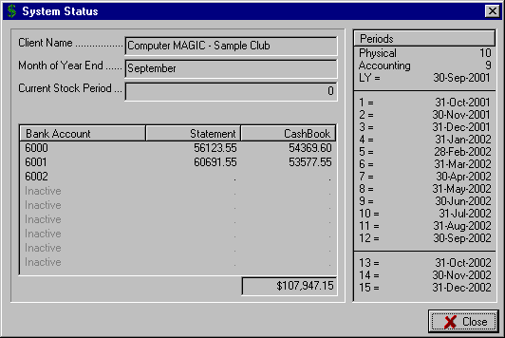
Bank Accounts set up as Control Accounts on the system.
Total Funds available from all Bank Accounts set up as Control Accounts
These Periods relate to the first three Periods in the next Financial Year

F1) SUPERVISION – PASSWORD MAINTENANCE

By selecting “Supervision” from the Main Menu, the menu below is displayed.

Password Maintenance
Rebuild Summary Data
Add old Cheques
Modify Open GL Balances
Untick Cheques
Untick Deposits
Modify Debtor Balances
Modify Prior Years
Function Deposit Maintenance
Modify Bank Balances
Alter Account Dissection

By selecting “Password Maintenance” from the Supervision menu, a screen is displayed similar to that shown below.

This routine allows you to set up users of the system with associated passwords and specific access levels. This provides a high level of security and is ideal for businesses that have different staff members responsible for different aspects of the accounting system.

On entry to the routine the users already set up are displayed in the right window. To edit an existing user, click on the name of the user to be changed – it will then be highlighted as with JOHN in the example below.
You then click on the “Name” text box to change the name or the “Password” text box to change the user’s password.

You can then determine which level of access this user will have by clicking on the check boxes under the heading “Security Level”.

To add a new user to the system, click on a blank line in the right window. In the example shown you would click on the line immediately under JOHN.

Then click on the “Name” text box and enter the required name and the “Password” text box to enter the Password. Finish by checking the Security Level check boxes, as required, and OK to finish.
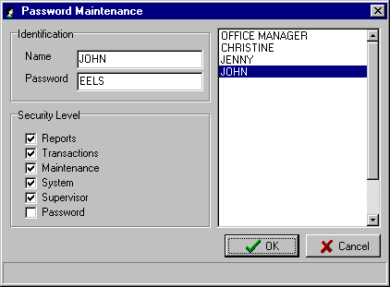

 TIP : When setting up Passwords for users, the password can be 4 characters with either alpha or numeric or a combination, e.g. JE35. When the user types in a Password that contains alpha, it does not matter whether they enter the Password in upper or lower case.

Be sure to set up at least one user with a Security Level ticked for “Password”.

F2) SUPERVISION – REBUILD SUMMARY DATA

This routine scans all transactions and rebuilds the summary data file, which contains the values of Purchases, Payments, Sales, Receipts and Journals, by month by Account. This file is used for a number of the reports in the system including the Summary Data reports.

A rebuild may be necessary as a result of a data corruption on the system, or if modifications are made to the data in certain Supervision routines. You will be prompted when to run this routine in those circumstances.

On entry to the routine, the “Rebuild Summary Data” screen is displayed, Select the “OK” button to complete the routine.

F3) SUPERVISION – ADD OLD CHEQUES

This routine will add unpresented cheques into Period ZERO so that they can be included in the Bank Reconciliation. It is used during initial installation so that a complete Bank Reconciliation can be set up on the system and that cheques from a past financial year can be included without distorting this year's figures.

The instructions for this routine are identical to those for “Transactions – Creditor and Payment – Manual Cheque”, as detailed on Page 15. The only variation is that you do not need to enter the Period to which the transaction applies, as the system will automatically allocate it to Period zero.

To check that you have entered all the old cheques correctly, it is suggested that once you have completed the input that you print a Cheque Listing for the Period Range 0 (zero) to 0 (zero). You can do this via the “Reports – Expenditure / Creditors – Cheque Listing” routine as detailed on Page 103.

F4) SUPERVISION – MODIFY OPEN GL BALANCES

This routine allows the setting up of the opening General Ledger balances for each Account. It is typically used when initially installing the system, as once the system is operational, these balances are set up automatically during the End of Year routine.

You may need to edit these balances if your Accountant/Auditor has independently modified the final figures reported for the previous Financial Year and you want the Opening Balances on the system to be in line with the published figures.

 TIP : The only Accounts that would have an Opening Balance set up in this routine are Balance Sheet (Non-Trading) Accounts. All Profit & Loss (Trading) Accounts are zero at the beginning of each new Financial Year.

On entry to the routine, the system displays the current balances for the Accounts. Use the scroll bar on the right of the window to move up and down through the Chart of Accounts.

Select the box next to the Account in the “Opening” column and:

- enter Debit balances as a positive number
- enter Credit balances as a negative number.

When you have completed the input, select the “OK” button to finish.

F5) SUPERVISION – UNTICK CHEQUES

This routine provides the facility to reverse the "presented" flag on Cheques. In the "Transactions – Bank Statement" input routine, Cheques are marked as presented and the Statement balance is increased or reduced accordingly. If a Cheque was incorrectly marked as presented during Bank Statement input and the error was not picked up before posting the input, then this routine provides the option to "untick" the entry and mark it as unpresented.

Some points to note before using this routine:

- if the Bank Statement input procedure is correctly followed, then the need to use this routine does not exist. If all items on the bank statement are entered progressively down the page and the balance is checked at all times then any errors will be detected before posting the input.

- changing a Cheque to "unpresented" via this routine will automatically adjust the Statement balance stored on the system. This maintains the integrity of the Bank Reconciliation. When you go back into the "Transactions – Bank Statement" routine, the Statement balance will not be the same as accepted during the last input and as printed on the audit trail. As changes via this routine are not printed on audit trails, the facility should only be used in the most exceptional of circumstances.

On entry to the routine you are prompted to select the “Bank Account” and the “Period” for the Cheque to be unticked. Then select the “Calculate” button to display all the Cheques currently presented for the selected Bank Account and Period.

Highlight the cheque to be unticked and click the “Save” button to complete the routine.

F6) SUPERVISION – UNTICK DEPOSITS

This routine provides the facility to reverse the "presented" flag on Deposits. In the "Transactions – Bank Statement" input routine, Deposits are marked as presented and the Statement balance is increased or reduced accordingly. If a Deposit was incorrectly marked as presented during Bank Statement input and the error was not picked up before posting the input, then this routine provides the option to "untick" the entry and mark it as unpresented.

Some points to note before using this routine:

- if the Bank Statement input procedure is correctly followed, then the need to use this routine does not exist. If all items on the bank statement are entered progressively down the page and the balance is checked at all times then any errors will be detected before posting the input.

- changing a Deposit to "unpresented" via this routine will automatically adjust the Statement balance stored on the system. This maintains the integrity of the Bank Reconciliation. When you go back into the "Transactions – Bank Statement" routine, the Statement balance will not be the same as accepted during the last input and as printed on the audit trail. As changes via this routine are not printed on audit trails, the facility should only be used in the most exceptional of circumstances.

On entry to the routine you are prompted to select the “Bank Account” and the “Period” for the Deposit to be unticked. The select the “Calculate” button to display all the Deposits currently presented for the selected Bank Account and Period.

Highlight the deposit to be unticked and click the “Save” button to complete the routine.

F7) SUPERVISION – MODIFY DEBTOR BALANCES

This routine should only be used when initially setting up the system. It is designed for setting up outstanding Debtor Balances when the system is installed. It should not be required once the system is operational as changes via this routine are not recorded on an audit trail.

On entry to the routine, the “Modify Debtors Balances” screen is displayed listing each Debtor and the current balances aged as Current, 30 Days, 60 days, and 90 days.

Click on the fields next to the required Debtor, and enter the balance in the appropriate aging column.

Select the “OK” button when completed.

F8) SUPERVISION – MODIFY PRIOR YEARS

This routine allows you to initially set up, (or later edit), the summary data stored for each Account for prior Financial Years. Once the Cash Management system has been running for a number of years, the need for this routine will diminish.

The summary data is used in the user defined Management Reports where Comparative Periods are specified in the report layout.

On entry to the routine you are prompted to select the “Year Offset” with 1 being one year ago, 2 being 2 years ago, etc.

Enter the “Account” number or use the F8 option to display the “Lookup Account” window and select the required one.

With the correct Account selected, click the “Calculate” button. The system displays the details currently stored for the selected Account for the designated year.

Simply click on the field to be edited and once all the input for the selected Account has been entered, select the “Save” button.

F9) SUPERVISION – FUNCTION DEPOSIT MAINTENANCE

By selecting “Supervision” from the Main Menu, the menu below is displayed.

Password Maintenance
Rebuild Summary Data
Add old Cheques
Modify Open GL Balances
Untick Cheques
Untick Deposits
Modify Debtor Balances
Modify Prior Years
Function Deposit Maintenance
Modify Bank Balances
Alter Account Dissection

Undo Function Transfer
Remove old Transfers

Selecting “Function Deposit Maintenance” from the Supervision Menu, displays the sub-menu to the right.

a) UNDO FUNCTION TRANSFER

The Cash Management system provides for the efficient handling of deposits paid by members for a Function that is to occur in the future (e.g. a wedding). Function Deposits can be processed in the “Receipts” or “Tills Input” routines in the Transactions – Debtor and Receipts menu. The system retains these Function Deposits until the Function occurs and the final amount owing by the Debtor (Member) is calculated. At this point there is a need to transfer the Deposit from Function Deposits and apply it to the Debtor (Member) account. This is done via the “Function Deposits Transfer” routine.

This routine is used when an error has been made in the “Function Deposit Transfer” routine. It allows you to “Undo the Function Transfer”. The error could have occurred because the wrong deposit was applied to a particular Function or Debtor.

On entry to the routine, you are prompted to enter the “Debtor” number or use the F8 option to access the “Lookup Debtor” window and select the required one.

The system then displays the Function Deposits that have been previously transferred in the “Previous Transfers” window. Highlight the Function Deposit that should not have been transferred and click the > button. This moves the Function Deposit to the “Transfers to Undo” window. You can use the > and < button to move selected Function Deposits between the two windows or the >> and << buttons to move all of the entries from one window to the other.

Select the “Save” button when you have completed the input.

b) REMOVE OLD TRANSFERS

The system retains Function Deposit Transfers indefinitely. There will come a time when it is practical to delete old Function Transfers and this routine is designed for that purpose.
On entry to the routine, the screen shown to the right is displayed.

Enter the date prior to which you want Function Deposits removed from the system.

Click the “OK” button when completed.

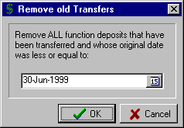

F10) SUPERVISION – MODIFY BANK BALANCES

This routine allows you to enter the opening Statement Balances for the Bank Accounts set up on the system. It is typically used when initially installing the system, as once the system is operational, these balances are updated as part of the Bank Statement Input routine.

On entry to the routine, the system displays the Bank Accounts set up on the system as Control Accounts.

Select the box next to the Period in the “Balance” column and:

- enter Debit balances as a positive number
- enter Credit balances as a negative number.

When you have completed the input, select the “Save” button to finish.

You are able to check that you have set the balances up correctly by running a “Bank Reconciliation” report as detailed on Page 88.

F11) SUPERVISION – ALTER ACCOUNT DISSECTION

This routine provides the option to change the Account Dissection of Creditor Invoices. It should be used in only the most exceptional circumstances by qualified accounting staff as there are no audit trails associated with the routine.

On entry to the routine the “Alter Account Dissection” window is displayed.

Enter the “Creditor” number of the invoice to be changed or use the F8 option to display the “Lookup Creditor” window and select the required one.

The system displays all the invoices for the selected Creditor. Highlight the invoice to be changed and select the “Modify” button.

The current Account Dissection for the invoice is displayed allowing you to change the “Account” for dissection, include additional “Accounts”, change the “GST Flag” or modify the “Value” stored for each Account.

** The system will not let you exit the routine unless the Account Dissection Total is the same amount as the Invoice Total. **

Once the correct Account Dissection has been completed, select the “OK” button. This returns you to the main Creditor window for further modifications. The option is provided from this screen to check the current Account Dissection for an invoice by highlighting the transaction and clicking the “View Classifications” button.

** Once you exit the routine, you must immediately complete the “Supervision – Rebuild Summary Data” routine as described on Page 120. **

G1) END OF PERIOD – ACCOUNTING

By selecting “End of Period” from the Main Menu, the menu below is displayed.

Accounting
Physical

End of Year

By selecting “Accounting” from the End of Period menu, a screen is displayed similar to that shown below.

This routine closes off the Current Accounting Period and prevents the posting of transactions to that period. The Accounting Period will often lag behind the Physical Period (maximum of 1 month) to allow the allocation of Creditor invoices/statements, Journal entries, etc., to the period in which they were incurred.

The Physical Period Reset for a particular month must be run before the Accounting Period Reset. A warning displays if this is not the case.

You should have processed all Creditor Invoices and Journal entries for the Period prior to processing the End of Accounting Period routine.

** It is also strongly suggested that a BACKUP of the Data Files be taken PRIOR to completing the End of Accounting Period routine. **

On entry to the routine, the “Current Physical Period” and “Current Accounting Period” are displayed.

The “New ACCOUNTING Period” is also displayed.

Enter the “Password” (Security Number) for this Cash Management client as supplied by Computer MAGIC.

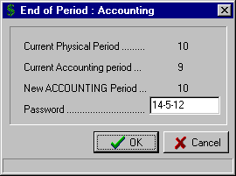

Select the “OK” button to complete the routine.

G2) END OF PERIOD – PHYSICAL

By selecting “End of Period” from the Main Menu, the menu below is displayed.

Accounting
Physical

End of Year

By selecting “Physical” from the End of Period menu, a screen is displayed similar to that shown below.

This is the main End of Period routine as it effectively closes off the Physical (Calendar) Period and enables transactions for the next month. It ages the Debtor files and prevents entry of Cheques or Deposits to the previous month. Debtors Statements must be produced before running this routine. The Debtors Trial Balance and Bank Reconciliation should be printed so that the Debtors and Bank Control Totals can be balanced.

** It is also strongly suggested that a BACKUP of the Data Files be taken PRIOR to completing the End of Accounting Period routine. **

On entry to the routine, the “Current Physical Period” and “Current Accounting Period” are displayed.

The “New PHYSICAL Period” is also displayed.

Enter the “Password” (Security Number) for this Cash Management client as supplied by Computer MAGIC.

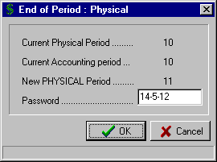

Select the “OK” button to complete the routine.

G3) END OF PERIOD – END OF YEAR

By selecting “End of Period” from the Main Menu, the menu below is displayed.

Accounting
Physical

End of Year

This routine closes off the Financial Year, archives the data files and carries forward appropriate transactions to the new Financial Year. An End of Physical Period for the last period of the Financial Year must be completed before running an End of Year Reset. The BAS for the last Period of the year must also be processed.

** Ensure you have taken a BACKUP of the Data Files PRIOR to running the End of Year Reset routine.**

This Closing Journal entry must be processed prior to running the End of Year routine. It basically allocates the Profit/(Loss) for the year to the appropriate Non-Trading (Balance Sheet) accounts. This is necessary as the values in the Trading (Profit/Loss) accounts are reset to zero during the End of Year routine. The Profit/(Loss) figure is the net of all the Trading Accounts.

On entry to the “End of Year” routine, the “Closing Journal” screen is displayed with an example shown below.
The system calculates the Profit/(Loss) for the year. It scans all the Trading accounts and displays the Profit in the Debit column (or the Loss in the Credit column).

Enter the General Ledger “Account” number or use the F8 option to display the “Lookup Account” window and select the required one. The only accounts that can be selected are Non-Trading (Balance Sheet) accounts.

The cursor moves to the "Debit" column to allow input of the value. Press the Enter key to move to the "Credit" column if the posting is a Credit transaction. Enter the value for this posting. The system returns to the Account column for further dissection of the transaction. Multiple Debit and Credit entries can be entered with the only proviso being that the Debits equal the Credits. The progressive balance of the Debit and Credit values are displayed at the bottom of the screen.

A sample “Closing Journal” screen is shown below where the Profit for the Year has been allocated as a Credit to Account “9924 – ACCUMULATED PROFIT”.

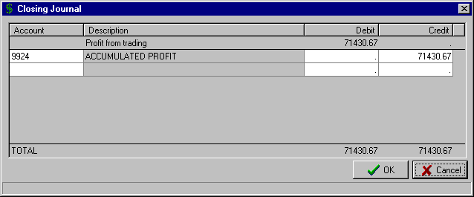
The Profit has been allocated as a Credit to Account 9924 Accumulated Profit
The total Debits and Credits must be the same for the Closing Journal to be posted.

Select the “OK” button to complete the “Closing Journal” and print the audit trail.

The “End of Year” screen is then displayed. Enter your “Password” (Security Number) to complete the routine.

The data files for Last Year are automatically set up in the “Select Dataset” window

BACKUP & RESTORE DATA FILES

The importance of maintaining a good Backup system cannot be over-emphasised. It allows you to recover from a system crash or corrupted files resulting from electrical outages. You can return to a previous point in time when you know the files are correct and re-enter data, as required. A good Backup system will substantially reduce your ongoing support costs.

The Computer MAGIC Cash Management CD that is delivered with the system has a Backup and Restore system included (the program is named CMBakRes.exe). The program uses the WINZIP system and the associated Add-On Utility (both of these modules are included on the CD). During the installation process an icon is added for Backup & Restore that significantly automates these two processes.

a) BACKUP

When you select the Backup/Restore icon from your Cash Management/Stock Control folder, a screen similar to that shown below is displayed. The first step is to select the data files you want to Backup from the “Datasets” window. In the example below the data files for the Downtown RSL Club have been selected for Backup.

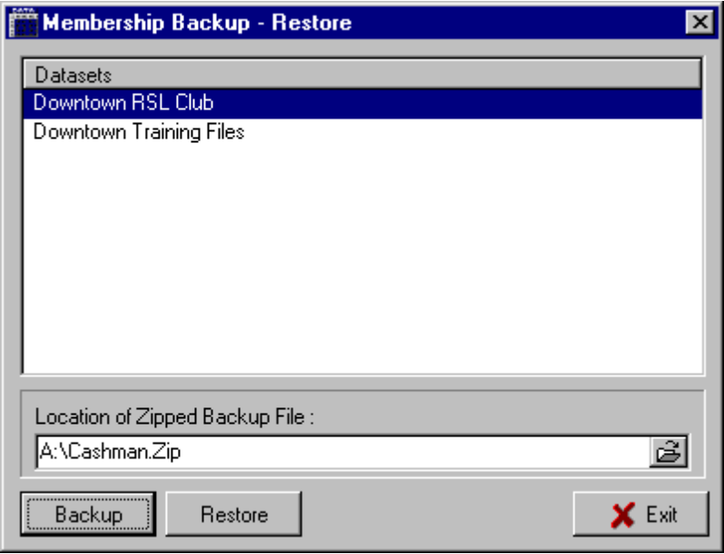

The next step is to edit the location of the Zipped Backup File as displayed by the system. The system displays the last Backup file used for this set of data files. You can edit the entry displayed or select the Browse  button to locate the folder and file that you require. This location could be as simple as A:\CashMan.Zip

The final step is to select the “Backup” button at the bottom of the screen. Follow the prompts as displayed by the WINZIP routine.

b) RESTORE

The Restore function is very similar to the Backup function described above. The first step is to select from the “Datasets” window the data files you want to Restore. The system then displays the path and file name of the last Backup for this set of data files in the “Location of Zipped Backup File” text box. You can edit the entry displayed or select the Browse  button to locate the folder and file that you require.

The final step is to select the “Restore” button at the bottom of the screen. Follow the prompts as displayed by the WINZIP routine.

INITIAL INSTALLATION – GETTING STARTED

The Computer MAGIC Cash Management system is supplied on CD. After inserting the CD in the CD-ROM drive the SETUP.EXE program will automatically execute. If the program does not automatically run, then manually execute SETUP.EXE via the Windows “Start – Run” routine.

a) SYSTEM REQUIREMENTS

The Computer MAGIC Cash Management system has the following minimum hardware and system software requirements:

Windows 95 Operating System
- Pentium I – system processor
- 64Mb RAM memory
- 120Mb free disk space

b) COMPUTER MAGIC - SYSTEM INSTALLATION

If the installation of the Cash Management system is the first Windows-based Computer MAGIC system to be installed at your site, then you will need to initially install the system software and database software.

On the Server, you will need to install the “Borland Database Engine” and the “Computer MAGIC Utilities”.

On each terminal that will be running a Computer MAGIC application (e.g. Cash Management), you need to install the ”Borland Database Engine”.

The steps involved then are as follows:

    - On the Server, ensure that you have installed the “Borland Database Engine” and the “Computer MAGIC Utilities”

    - For each terminal on the network that will be running the Cash Management system, you need to install the “Borland Database Engine”.

    - On the Server, run the Cash Management setup routine - SETUP.EXE (see instructions under the heading “Install Cash Management” below).

    - Edit the Cash Management configuration file (CM.INI), which is in the Programs directory (see the section “Editing the Configuration File” below for details on how to do this).

    - Set up a folder and the shortcuts for the Cash Management programs. The names and locations of the programs and files you should set up shortcuts for are detailed on the following page.

INITIAL INSTALLATION – GETTING STARTED

c) INSTALL CASH MANAGEMENT

After the Cash Management setup routine has been executed, the system steps you through the installation as with a standard Windows Install Wizard.
- The first screen is a “Welcome” screen. This details a warning concerning copyright and unauthorised reproduction or distribution of the software. It should be noted that the system has a number of protection mechanisms built into it, including annual registration numbers and security numbers to access End of Month routines.

Click the “Next” button to continue with the Setup routine.

- The next step in the process is to choose the “Destination Location”. From this screen you determine in which directory the Cash Management system is installed. The Install Wizard will automatically install the system in the C:\Program Files\Magic\Cashman directory.

Select “Next” to install to this directory or select “Change” to choose another directory.

- The system then displays the “Current Settings” screen detailing the settings you have set up during the previous parts of the Install Wizard. Select the “Back” button if you need to go back and edit any settings, select “Install” to continue with the installation using the displayed settings.

- Select the “Finish” button to complete the installation.

- You are then in a position to set up shortcuts to the Cash Management programs with the ones suggested as follows:

TYPICAL LOCATION PROGRAM DESCRIPTION

  - Program Files\Magic\Cashman\Programs CashManagement.exe Main Cash Management program

  - Program Files\Magic\Cashman\Programs CashData.exe Data Rebuild/Update Utility

  - Program Files\Magic\Cashman\Programs CMBakRes.exe Backup & Restore Utility

  - Program Files\Magic\Cashman\Manual Cashman_Manual_V#.doc Cash Management manual in Word with V# designating the version number

  - Program Files\Magic\Cashman\Programs Assets.exe Fixed Asset program (optional module)

  - Program Files\Magic\Cashman\Programs Stock.exe Stock Control program (optional module)

INITIAL INSTALLATION – GETTING STARTED

d) EDITING THE CONFIGURATION FILE

Once the Cash Management system is installed, the next step is to edit the Cash Management configuration file (CM.INI). The CM.INI will be in the Programs directory, a sub-directory of the location selected in the “Install Cash Management” routine described above. Via Explorer, locate the file and edit it, as below.

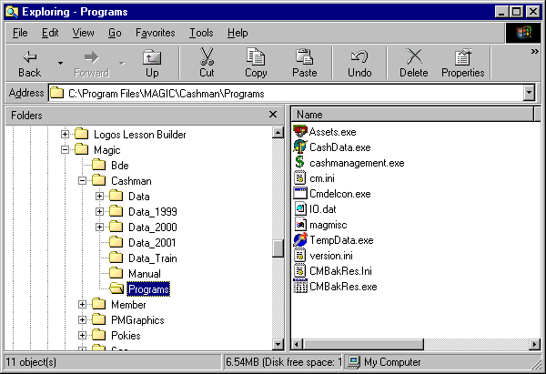

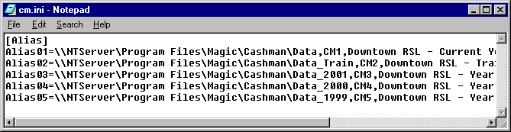

Some points about this CM.INI file:

- The first line must be [Alias]
- The first path must be ‘Alias1’ (the second path ‘Alias2’, etc.)
Followed by an ‘=’ sign
Followed by the UNC path to the data The UNC path always commences with a ‘\\’ An example would be
\\NTServer\Program Files\Magic\Cashman\Data
Followed by a comma ’,’
Followed by ‘CM1’ (if it is data path 1) or ‘CM2’ (if it is data path 2)
Followed by a comma ’,’
Followed by a Description of the data (e.g. the club’s name – Downtown RSL – Current Year)
- There are NO spaces before or after the ‘=’ sign or the commas ‘,’
- It is suggested that you enter your most accessed data files as Alias1, the next most used as Alias2, etc.

INITIAL INSTALLATION – GETTING STARTED

e) MULTIPLE DATA FILES

The system enables the set up of multiple sets of Cash Management data. This may be useful if you want to retain data files for past years or set up data files for training or testing purposes.

In the example of the CM.INI file above, there were five sets of data denoted as ‘Alias1’, ‘Alias2’,‘Alias3’, etc.. These then were given the descriptions of Downtown RSL – Current Year, Downtown RSL – Training Files, etc.

With this setup in your CM.INI file, when you go into the Cash Management system the following screen would be displayed. This then allows you to choose which set of data files you want to access. Just highlight the required set of data and select the “OK” button.

You will notice that this screen is in the order of ‘Alias1’ (Downtown RSL – Current Year), ‘Alias2’ (Downtown RSL – Training Files), etc. Putting the most accessed data files as ‘Alias1’ makes entry to the system more efficient.

INITIAL INSTALLATION – GETTING STARTED

f) GETTING STARTED FOR A NEW INSTALLATION

The steps set out below are for clubs and businesses that are installing the system for the first time and have not upgraded from the Computer MAGIC DOS-based version. Once you have the Cash Management system installed, the procedure for getting the system operational is as follows:

- Set up the Accounting Period End dates for your club or business via the “Maintenance - System – Period Dates” routine as detailed on Page 83.

- Set up the Club or Business name details and the audit trail options in the “Maintenance - System – Global Settings General” as outlined on Page 86.

- Set up the headings for the Print Groups to be used in the Summary Data reports via the routine "Maintenance – System – Setup Print Groups" as detailed on Page 85.

- Enter the General Ledger Account numbers that will be used on the system. These are typically the Chart of Accounts from your General Ledger system. The instructions for entering General Ledger Accounts are set out in the section "Maintenance – Accounts – Account Maintenance” on Page 49.

- Enter the Account numbers for the Bank Accounts, Debtors and Creditors Control Account details along with the other Control and Clearing Accounts via the "Maintenance – System – Control Accounts” routine as detailed on Page 84.

- Enter the Creditors details via the "Maintenance – Creditors – Creditors Maintenance" routine as detailed on Page 52.

- Enter the Debtors details via the "Maintenance – Debtors – Debtors Maintenance" routine as detailed on Page 55.

- Enter the Debtors outstanding balances via the "Supervision – Modify Debtors Balances" routine as detailed on Page 122. Then via the "Reports – Income / Debtors – Debtors Reports – Aged Trial Balance", see Page 107, check the balances, totals and ageing of the debtor input and reconcile with your existing system.

- Enter any cheques that are unpresented on the Bank Reconciliation via the routine "Supervision – Add Old Cheques" as set out on Page 120.

- Enter the Bank Statement balances for each Bank Account via the "Supervision – Modify Bank Balances" routine as detailed on Page 124.

- Print the Bank Reconciliation report to check that all opening details are correct and balance with the current system. This can be done via the "Reports – Cash – Bank Reconciliation" routine on Page 88.

- If either Debtor or Creditor Statements, or Cheques and Remittance Advices are to be printed by the system, then set up the layouts via the appropriate “Maintenance – Forms Layout” routines – see Pages 65 to 71 for detailed instructions.

- If Tills Input is to be used, the set up the Tills for your club via “Maintenance – Tills” (see Page 58), then the layout for the Till reporting via “Maintenance – Forms Layout – Till Summary Layout” – see Page 82.

- If Budgets are to be used then set up the names via The “Maintenance – System – Budget Descriptions” routine (see Page 85) and the details of the budgets via “Maintenance – Budgets” (see Page 60).

- If General Ledger reporting is to be used then set up the financial and management reporting formats via "Maintenance – Forms Layout” routines – see Pages 72 to 79 for full instructions.

17. Commence entry of transactions beginning at the cut-off time for the Cashbook Balance and Statement Balance as entered above.

THE “HOW TO …………..” GUIDE

** How to - Add a new General Ledger Account

The complete instructions for adding a new General Ledger Account are set out in the section "Maintenance – Accounts – Account Maintenance" on Page 49. If there is a need to change the details of a General Ledger Account, then this is covered in the same section.

It should be noted that the option is provided during the input of transactions to add a General Ledger Account not already on the system, via the “Lookup Account” routine.

** How to - Add a new Creditor (Supplier)

The complete instructions for adding a new Creditor are set out in the section "Maintenance – Creditors – Creditor Maintenance" on Page 52. If there is a need to change the details of a Creditor, then this is covered in the same section.

It should be noted that the option is provided during the input of transactions to add a Creditor not already on the system, via the “Lookup Creditor” routine.

** How to - Add a new Debtor (Customer)

The complete instructions for adding a new Debtor are set out in the section "Maintenance – Debtors – Debtor Maintenance" on Page 55. If there is a need to change the details of a Debtor, then this is covered in the same section.

It should be noted that the option is provided during the input of transactions to add a Debtor not already on the system, via the “Lookup Debtor” routine.

** How to - Add a new Bank Account

There are a number of steps associated with adding an extra Bank Account to the system.

1. Enter the Account details for the Bank Account via the routine "Account Maintenance" on Page 49. This step is only required if the Account details have not been previously entered. As part of this process you would set up the reconciled bank balance as the “Opening Balance”.

2. Via the routine "Maintenance – System – Control Accounts”, as detailed on Page 84, select the next available "Bank Account #" (maximum of 9) and Enter the Account number for the Bank Account or Press the F8 key to display the Accounts on the system and select the required one.

3. Set up the opening Bank Statement Balance via the routine "Supervision – Modify Bank Balances" as described on Page 124.

** How to - Enter Creditor (Supplier) Invoices

When you want to enter Creditor invoices that are to be paid at a later date then use the routine "Transactions – Creditor and Payment – Creditor Invoice" as set out on Page 12.

** How to - Pay Creditor Invoices

There are two situations that will involve payment of Creditor invoices.

1. Where the invoice details have already been entered via the routine "Transactions – Creditor and Payment – Creditor Invoices", then payment for these invoices is entered via either "Write Cheques Auto" (see Page 19) or "Write Cheques Manual" (see Page 21). A further option is to pay the Creditors via the “Electronic Funds Transfer – Creditor EFT” as detailed on Page 41.

2. Where you want to enter the details of the Creditor invoice and pay the invoice at the same time, then use either the "Immediate Cheque" routine as described on Page 17 or the "Manual Cheque" routine as detailed on Page 15.

** How to - Enter Debtor Invoices (Credit Sales)

Debtor invoices are entered via the "Transactions – Debtor and Receipts – Invoices / Credits" routine. Full instructions for this routine are detailed on Page 27.

THE “HOW TO …………..” GUIDE (cont..)

** How to - Enter Cash and Debtor Receipts

All Cash Receipts and Debtor Receipts are entered via the "Transactions – Debtor and Receipts – Receipts" routine as detailed on Page 25. This routine is used to enter all Income (Cash, Cheque, etc.) into the system.

** How to - Process Function Deposits

The Cash Management system handles deposits paid for Functions that will be held in the future, as follows:

- When the Function Deposit is received, include it in the banking for the day and mark it as a type "F" entry in the "Receipts" routine as detailed on Page 25.

- Outstanding Function Deposits held by the club can be listed via the "Reports – Income / Debtors – Outstanding Function Deposits" report option as detailed on Page 115.

- Once the Function has been held the deposit is transferred to the Debtors account via the "Transactions – Debtor and Receipts – Function Deposits Transfer" routine as described on Page 31.

** How to – Process the Bank Statement and complete a Bank Reconciliation

The details on the Bank Statement are entered via the routine "Transactions – Bank Statement" as set out on Page 38 This is where all Cheques and Deposits are checked off and Bank Charges, etc. are entered. The procedure is completed by printing the "Reports – Cash – Bank Reconciliation" report as detailed on Page 88.

** How to – Process General and Standing Journal entries

General Journals are processed via the “Transactions – Journal – General Journal” routine as described on Page 44. The option is provided in this routine to denote whether or not these Journal entries are “Reversing”, or not.

Standing Journals are set up and processed as follows:

- Standing journals are set up and then maintained via the “Transactions – Journals – Standing Journal Maintenance” routine as detailed on Page 45.

- Standing Journals are then processed each period via the “Standing Journal Processing” routine as set out on Page 47

Any General Journals that have been set up as “Reversing” Journals are processed via the “Transactions – Journals – Process Reversing” routine with complete instructions set out on Page 47.

** How to - Correct a Payment allocated to the wrong Account

This situation may arise because, when you entered the Creditor invoice details, you allocated the amount to the wrong General Ledger Account. It can also occur if when entering the invoice details you didn't know which Account to allocate the amount to and so you allocated it to a Suspense Account for checking later by the Accountant.

As an example, say an invoice from ABC Stationers was allocated to SUNDRY EXPENSES (Account No. 455) but should have been allocated to PRINTING & STAT. (Account No. 414).

The correction is done via the "Transactions – Creditor and Payment – Creditor Invoice" routine as detailed on Page 12. For the Creditor involved, enter the invoice details again allocating the amount as a negative against the wrong Account (e.g. 455) and the amount as a positive against the correct Account (e.g.414). The net result should be zero.

The above entry will create a zero value invoice in the Creditors file, which can be removed as part of writing cheques by including that invoice in with the ones selected for payment. An alternative method is to use the "Transactions – Creditor and Payment – Creditor Contra Invoice" routine as described on Page 18 and remove the invoice that way. Normally this routine requires multiple entries totaling zero to allow the contra function to work. However, you are able to contra a single invoice as long as it has a zero value.

THE “HOW TO …………..” GUIDE (cont..)

** How to - Correct a Receipt allocated to the wrong Account

This situation can occur when entering the banking for the day via the “Receipts” routine and you allocate an amount to the wrong General Ledger Account. It can also occur if when entering the receipt details you didn't know which Account to allocate the amount to and so you allocated it to a Suspense Account for checking later by the Accountant.

As an example, say a cash receipt was allocated to SALES - SUNDRIES (Account No. 230.07) but should have been allocated to SALES - WINE (Account No. 230.05).

The correction is done via the "Receipts" routine as detailed on Page 25. Enter the cash receipts details allocating the amount as a negative against the wrong Account (e.g. 230.07) and the amount as a positive against the correct Account (230.05). The net result should be zero.

You can do this correction as a new deposit but, ideally, you would make the correction as an addition to an existing deposit, and preferably to the deposit in which the mistake was made (see Page 25 for details on adding to an existing deposit). If you process the correction as a new deposit then the system will add a zero deposit in the unpresented Bank Deposit file and this should be cleared when next doing input via the "Bank Statement" routine as set out on Page 38.

If the mistake in allocation was made on a Debtor sale then the same principle applies in correcting the problem. Use the "Transactions – Debtor and Receipts – Invoices / Credits" routine (instructions on Page 27) to enter the amount as a negative to the wrong Account and the amount as a positive against the correct Account. The net result should be zero.

** How to - Cancel a Cheque

The instructions for how to cancel a cheque are set out in detail under the heading "Transactions – Creditor and Payment – Cancel Cheques" on Page 21.

** How to - Correct a Cheque entered as the wrong Amount

This situation normally arises when entering cheque details from a cheque book using the "Manual Cheque" routine. A mistake is made entering the cheque amount and is not detected until doing the input via the "Bank Statement" routine. Instructions for correcting this situation are set out under the heading "Transactions – Creditor and Payment – Cancel Cheques" on Page 21.

** How to - Correct a Deposit entered as the wrong Amount

This situation may occur where the details for the day's banking were entered incorrectly via the "Receipts" routine and do not match the actual deposit made at the bank.

The error would normally be detected while doing "Bank Statement” input. Once a discrepancy is detected, stop the Bank Statement input at the last logical point prior to the Deposit error, leaving the incorrect Deposit in the unpresented window.

Then via "Receipts" answer YES to the prompt "Do you want to add to an existing Deposit". This displays the window of unpresented Deposits allowing you to select the incorrect Deposit. This brings the balance for the incorrect Deposit into the "Progressive Total" field and allows entry of the corrections necessary to balance the Deposit with that on the Bank Statement.

You would then return to "Bank Statement” to complete the processing of the Bank Statement and Bank Reconciliation.

** How to - Set up the Print Group facility for Reporting

The first step in the use of the Print Groups is to decide, from your Chart of Accounts, which General Ledger Accounts logically should be linked together and what the Groups will be called on the reports.

Via the routine "Maintenance – System – Setup Print Groups", detailed on Page 85, enter the headings for the Print Groups you plan to use.

Via the routine "Account Maintenance (Add or Change)" select the "Print group" number you have allocated to each Account. The system allows up to 256 Print Groups numbered between 0 and 255.

The Print Groups are then selected in the “Reports – Summary Data” routines, see Page 94.

THE “HOW TO …………..” GUIDE (cont..)

** How to - Set up Financial Reporting (P&L, Balance Sheet)

The first step in the set up of Financial Reporting is to enter the balances for all General Ledger Accounts for Last Year via the routine "Account Maintenance" as set out on Page 49.

This will allow you to test your report format with figures that can be checked against a published set of Accounts. You can check that formulas are correct, all Accounts are included and that your format arrives at the same Net Profit in the P&L Statement and that both sides of the Balance Sheet are equal.

Set up the report format via the routine "Maintenance – Forms Layout – Trading / P&L / Balance Sheet” as detailed on Page 72.

Test the accuracy of your report format by printing the reports via “Reports – General Ledger – Trading / P+L / Balance Sheet” as detailed on Page 92.

** How to - Set up Management Reports

If your Management reports are to include Budget figures then it is suggested that the Budget facility be set up first. The steps for creating a Budget and then editing an existing Budget are detailed on Page 64.

If your Management reports are to include comparative data from previous years then the data should already be set up via the routine "Supervision – Modify Prior Years" as set out on Page 122.

Set up the report format for both the rows and columns via the routine "Maintenance – Forms Layout – Management Reports Rows & Columns" as detailed on Page 79.

Test the accuracy and layout of your report formats via the routine “Reports – General Ledger – Management Reports” as described on Page 93.

** How to - Set up Opening Stock, Closing Stock and Cost of Goods Sold

The CASH MANAGEMENT system handles stock in a much simpler way than most General Ledger systems. The steps involved in setting up the recording of Opening and Closing Stock in your Financial Reports are as follows:

1. Via the "Account Maintenance" routine, set up a STOCK ON HAND Account (e.g. 500) and specify the Trading Type as “Non Trading”. This will be the Asset Account to be included in your Balance Sheet. Then set up a STOCK MOVEMENT Account (e.g. 501) and specify as Trading Type as “Trading”.

2. When posting stock movement transactions, select "Transactions – Journals – General Journal”. If the stock increases for the Period, enter the increase as a Debit to 500 - STOCK ON HAND and a Credit to 501 - STOCK MOVEMENT. If the stock decreases for the period, enter the decrease as a Credit to 500 - STOCK ON HAND and a Debit to 501 - STOCK MOVEMENT.

3. In your Financial Report format, the Opening Stock figure is the net of STOCK ON HAND and STOCK MOVEMENT and is calculated as a formula. A typical calculation of Cost of Goods Sold would be as follows:

Opening Stock (Stock on Hand + Stock Movement)
Less: Purchases
Less: Closing Stock (Stock on Hand)
----------------------

COST OF GOODS SOLD

4. You are able to set up as many STOCK ON HAND and STOCK MOVEMENT Accounts as required for Kitchen, Trophies, Stationery, etc. and include in the appropriate Trading Statements.

THE “HOW TO …………..” GUIDE (cont..)

** How to - Set up a Budget

The Cash Management system has the facility to store multiple budgets, which can be accessed at time of reporting. The steps for creating a Budget and then editing an existing Budget are detailed on Page 64.

** How to - Set up the Tills Input facility

The Tills input facility was designed to assist clubs with the tracking of Sales, Expenses and Discrepancies for each Till within the club. Entering the daily takings via this method simplifies the daily banking as all Till input can be accumulated into the daily deposit.

The flexibility is provided for each club to design their own report layout for printing the Till Summaries. Tills can be grouped, totaled in sections, etc., allowing for checking by area or supervisor.

The first step in establishing this facility is to set up the Tills to be used via "Maintenance – Tills" as detailed on Page 58.

Next, you need to set up the layout for the Tills reporting. This is done via the routine "Maintenance – Forms Layout - Till Summary Layout" as laid out on Page 82.

The next step is to begin entering the input for each Till for each day via the routine "Transactions – Debtor and Receipts – Tills Input" as described on Page 32.

Once all the input is completed, you post the Tills input as a Deposit via the routine " Transactions – Debtor and Receipts – Post Tills as Deposit" as set out on Page 34.

Finally, you print your Tills Summary reports, as set up previously, via the routine "Reports – Till Summary" as set out on Page 116.

** How to - Set up Electronic Funds Transfer (EFT) facility

The option exists in the system to pay Creditors via the Bank's EFT facility. This can significantly reduce the Bank charges to your organisation. The four steps in setting up the EFT facility are:

1. Set up the details as required by your bank via the routine "Transactions – Electronic Funds Transfer – EFT Globals" as detailed on Page 42.

2. Set up the Creditors "BSB” number via "Creditor Maintenance" as set out on Page 52.

3. If required, enter the BSB Description as allocated by your Creditors via "Creditor Maintenance”, see Page 52.

4. Test the details as set up in the above two steps by preparing a test run for the bank via the routine "Transactions – Electronic Funds Transfer – Create EFT Test Disk" as detailed on Page 43.

Pay your Creditors then, via the "Transactions – Electronic Funds Transfer – Pay Creditors" routine as described on Page 41.

** How to - Run an End of Month

The system has, in effect, two End of Month routines. The first is the Physical, which relates to the calendar month. The other is the Accounting, which relates to accounting period of the club or business.

Full details of how to run an End of Month (Physical and Accounting) are provided in the section "End of Period” as detailed on 114 and 115.

** How to - Run an End of Year

In the situation when a club has twelve accounting Periods, the system provides another three Periods (13 to 15) that you can continue to use until you are ready to complete the current Financial Year. Once the end of Year routine has been completed, Periods 13 to 15 become Periods 1 to 3 in the new Financial Year.

The End of Year routine is processed via “End of Period – End of Year” as detailed on Page 127.

